­­

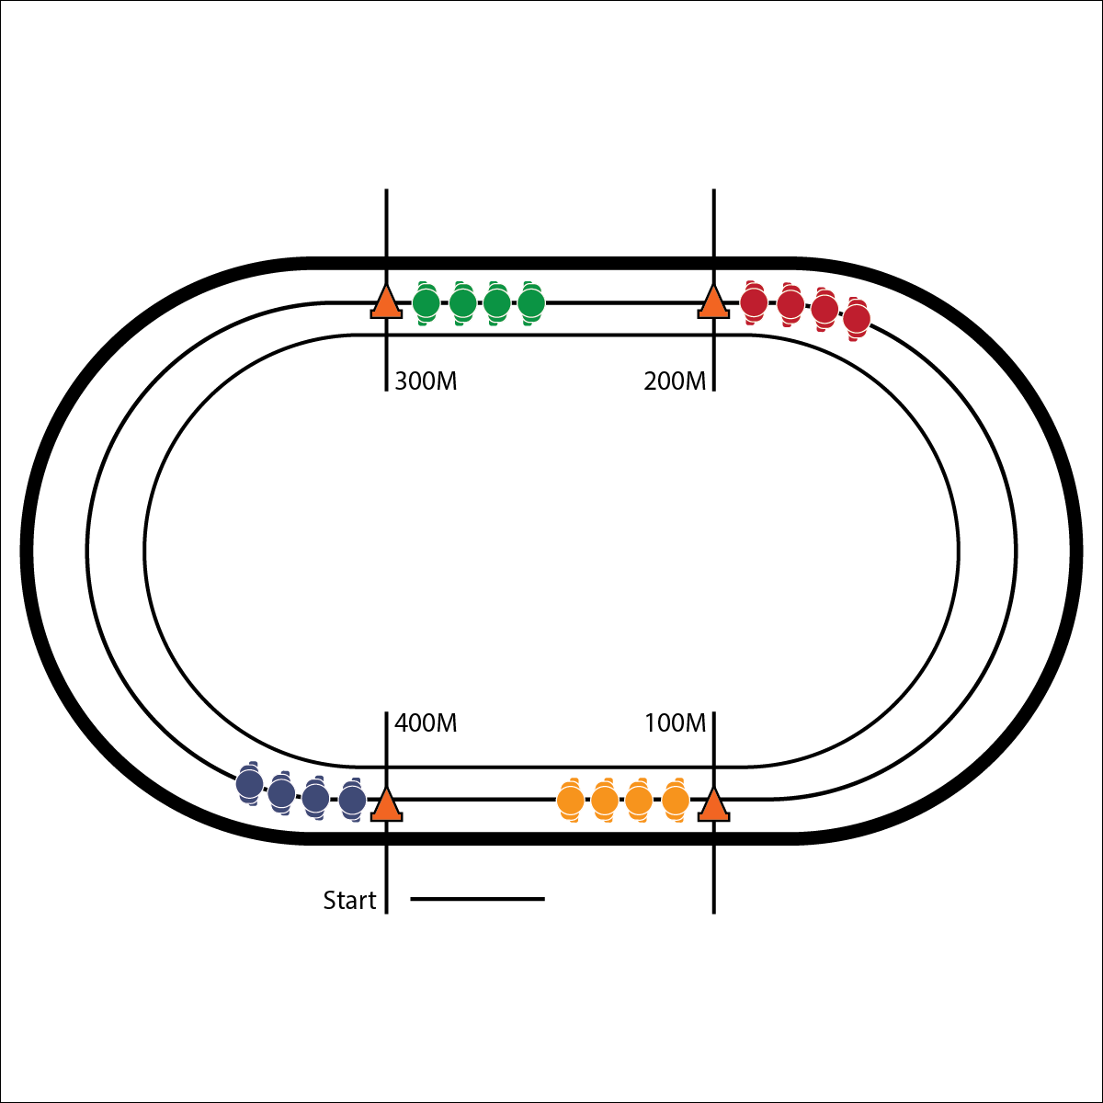

**Activity Procedures:**

1. Today we will begin a training program meant to help us prepare for a 5K community running event. Our plan will focus on running form, pace, and balancing nutrition with training. We’ll look at our Fitness Running Portfolios at the end of today’s lesson. It is a resource that will guide us through our training.
2. The object of Double Line Pursuit is to move each of your teammates (1 at a time) from your line to the line in front of you until your entire team is back together again. It will be important to work with your teammates to find a comfortable pace that everyone can maintain throughout the entire activity.
3. When you hear the start signal, begin running together at a steady pace. When your team gets to the next cone, the 1st person in each line will increase their pace in order to catch up to the line in front of them. The rest of the team will maintain a comfortable pace.
4. As soon as the next person in your line sees that your teammate has reached the team in front of yours, they will increase their pace to move to that line as well.
5. Continue this pattern until all teams are back together in your original lines.

**Grade Level Progression:**

**L1:** Maintain a steady pace with your team members. When it’s your turn to move to the next group, find a pace that’s faster than that of your team but still allows you to maintain a steady breath.

**L2:** Challenge by choice: Increase your pace as you see fit in order to catch up to the line in front of you. Remember to control your breathing.

* **Skill:** I will demonstrate proper running form, focusing on pace and stride.
* **Cognitive:** I will discuss the importance of pacing.
* **Fitness:** I will find a comfortable pace that allows me to remain actively engaged during this activity.
* **Personal & Social Responsibility:** I will communicate with my team to determine and hold a pace that everyone can maintain.

**Equipment:**

* 4 large cones
* [Running Form 101 Videos](https://www.nyrr.org/youth-and-schools/running-start/coaching-videos/high-school/form/form-101-introduction)
* 1 Fitness Running Portfolio for each student

**Set-Up:**

1. Place a cone at each 100M mark on the track.
2. Divide students into groups of 4, each group in a single-file line behind a cone.

* Run Tall
* Head Up (Chin Parallel to Ground)
* Lean Into Your Run

**DOUBLE LINE PURSUIT**

**DOUBLE LINE PURSUIT**



* Prompt students to walk. Focus on arm and leg movements.



Aerobic, Anaerobic, Cardiorespiratory Endurance, Comfortable, Pace, Stamina, Stride



* **Standard 1 [H3.L1-2]:** Demonstrates competency in one or more specialized skills in health-related fitness activities (L1); Demonstrates competency in two or more specialized skills in health-related fitness activities (L2).
* **Standard 3 [H3.L2]:** Applies rates of perceived exertion and pacing (L2).
* **Standard 3 [H5.L1]:** Evaluates risks and safety factors that might affect physical activity preferences throughout the life cycle (L1).



* **DOK 1:** What would you include on a list about pace?
* **DOK 2:** How did the pace of the line runners affect the lead runner’s ability to catch the line ahead of them?
* **DOK 3:** How is pace related to race distance? Give details to support your answer for a variety of distances.



**Help students identify critical content.** The authors of this module have referenced High School development resources provided by the New York Road Runners ([LINK HERE](https://www.nyrr.org/youth-and-schools/running-start/coaching-videos/high-school)). This video series, combined with the SHAPE America Grade-Level Outcomes, identifies the skills and concepts that students and teachers should focus on when learning about and improving overall fitness running performance. Please review all of the NYRR videos and resources during your module planning process and make adjustments based on your students’ prior knowledge and experience.

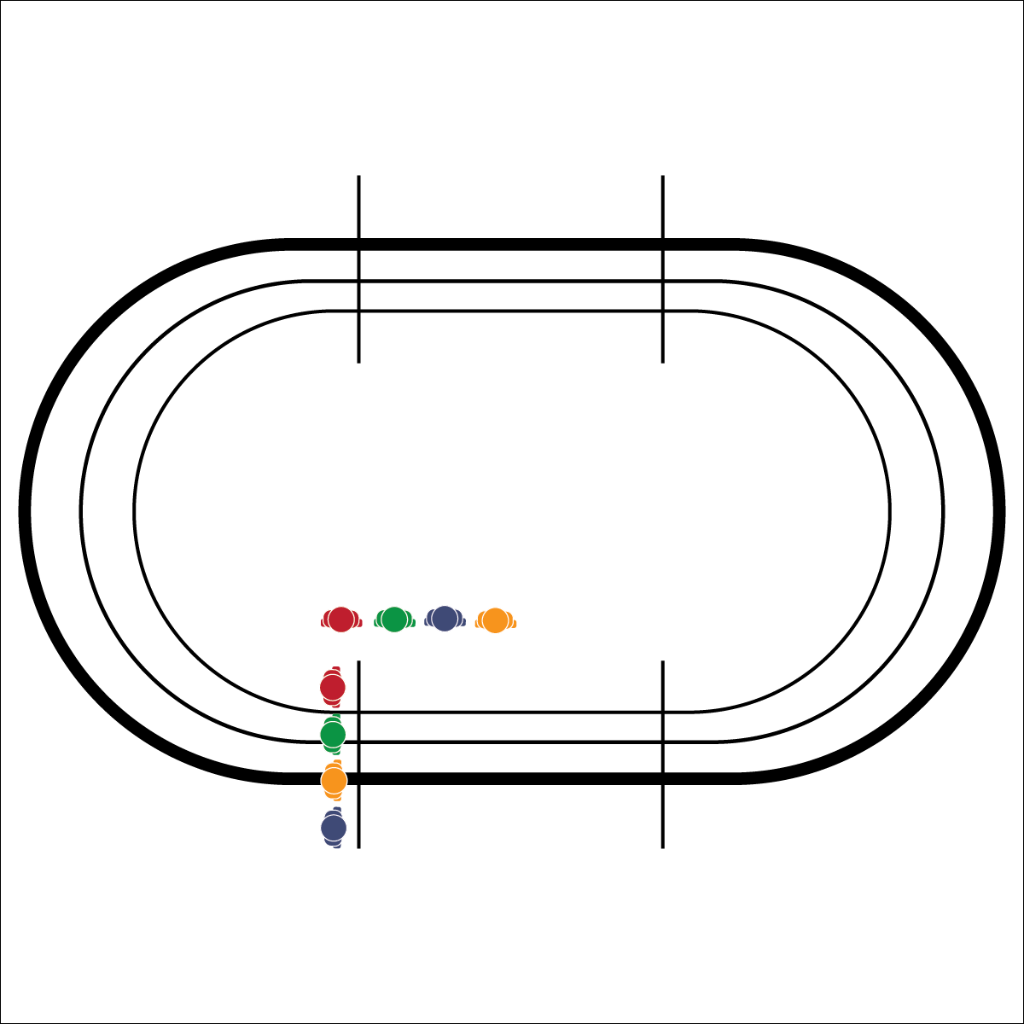

**Equipment:**

* 1 stopwatch
* 1 Prediction Run Improvement Plan (in portfolio) per student
* Pens/Pencils

**Set-Up:**

1. Pair students, each pair with a pencil and 2 Prediction Run Improvement Plans.
2. Send 1 student to the starting line, ready to run. The other student should have a pencil and Prediction Run Improvement Plan at the finish.

**Watch These NYRR Videos:**

* [Time Trials](https://www.nyrr.org/youth-and-schools/running-start/coaching-videos/high-school/pacing/time-trials)
* [Pacing Video Series](https://www.nyrr.org/youth-and-schools/running-start/coaching-videos/high-school/pacing)

**Activity Procedures:**

1. Today we’ll complete a 1600 Meter Prediction Run. We’ll complete this run again in 2 weeks and work toward the goal of improving today’s time.
2. The object of the activity is to accurately predict and then record how fast you run 1600M. Setting a challenging but realistic pace to complete the full 1600M run will be critical to your success.
3. Write your name and prediction on your Prediction Run Improvement Plan. Your partner will listen for and record your time when you cross the finish line. Then you’ll switch roles with your partner and record her/his time. When both pairs are finished, the class will take time to discuss and then set goals and create plans for improvement. We will complete this run again in a few weeks to see if you can beat the personal best time that you establish today.

**Grade Level Progression:**

**L1:** Complete the activity as described above.

**L2:** Allow students to choose their level of challenge: 400M, 1600M, or 3K.

* **Skill:** I will adjust my pacing based on cues and feedback from my body.
* **Cognitive:** I will create a plan to improve my 1-mile run time.
* **Fitness:** I will discuss perceived exertion and how it relates to my run performance.
* **Personal & Social Responsibility:** I will focus on my goals and embrace the challenge of improving my run time.

**1600 METER PREDICTION RUN**

* Set a Challenging Pace
* Focus on Form and Breathing
* Give Your Best Effort

**1600 METER PREDICTION RUN**



* **DOK** **1:** What is perceived exertion?
* **DOK 2:** How did perceived exertion affect your pace?
* **DOK 3:** How is perceived exertion related to your improvement plan and goal?
* **DOK 4:** Identify areas of opportunity and design a plan for personal improvement.



* Shorten the distance of the run.
* Students run the event as a relay with 2–4 teammates working together.



Challenge, Desire, Fitness Portfolio, 5K Race, Pace, Perceived Exertion



* **Standard** **3 [H3.L2]** Applies rates of perceived exertion and pacing (L2).
* **Standard 3 [H6.L1-2]** Creates a plan, trains for, and participates in a community event with a focus on physical activity (e.g., 5K, triathlon, tournament, dance performance, cycling event) (L2).
* **Standard 3 [H11.L2]** Develops and maintains a fitness portfolio (e.g., assessment scores, goals for improvement, plan of activities for improvement, log of activities being done to reach goals, timeline for improvement) (L2).
* **Standard 5 [H2.L2]** Chooses an appropriate level of challenge to experience success and desire to participate in a self-selected physical activity (L2).



**Help students process content.** By providing students with the time and guidance needed to complete an improvement plan, you’re setting the expectation that students will work with and elaborate on fitness running content that is relevant to their own experiences and applicable to their own health. Be sure you schedule enough time for students to think about their work, ask questions, and revise their thinking.

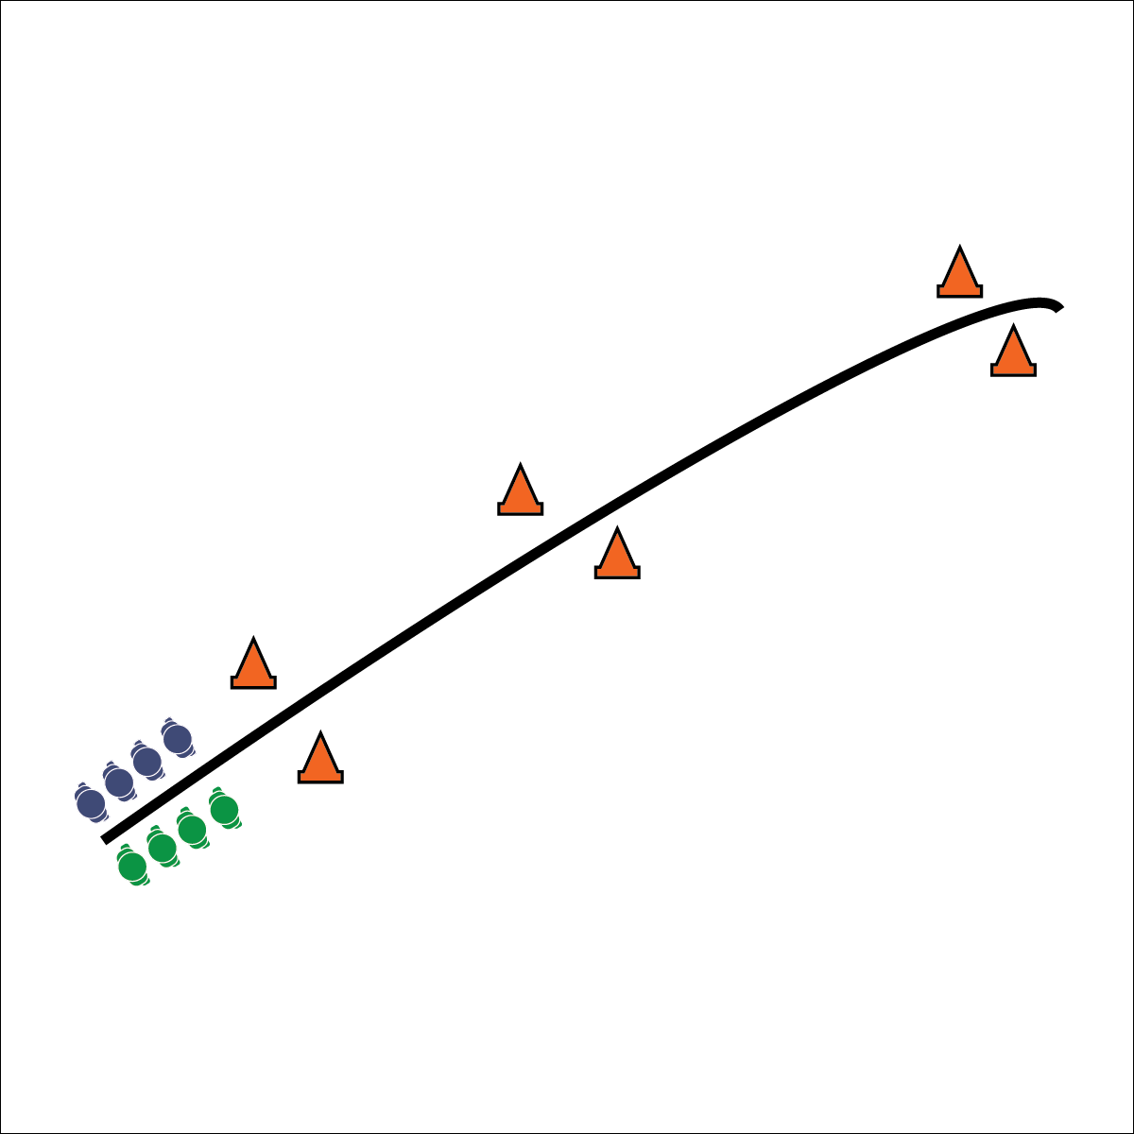

**Activity Procedures:**

1. Today’s activity is called Uphill Challenge, and it will help us practice proper running form, especially arm swing and power. The object of the activity is to run to the top of the hill (or stairs) without dropping the tennis balls (or bean bags) balanced on your palms.
2. When you hear the start signal, the first person in each line will run up the hill with the equipment balanced on the palm of each hand. Then they will move to the outside of the running lanes and walk safely back down.
3. When the first group gets halfway to the top of the hill, the next group will begin to run. Continue this pattern until you hear the stop signal.
4. Do not grip the equipment; the object is to balance it on the flat surface of your palm.
5. After a 2 or 3 runs, have students set the equipment to the side. Demonstrate proper running form (both arms and legs), and then have students run up the hill without the equipment.

**Grade Level Progression:**

**L1:** Use a flat surface or moderate hill with a focus on arm movement.

**L2:** Use a steep hill.

**Equipment:**

* 2 tennis balls or bean bags per student
* 6 large cones
* Moderate hill (or safe, stable, and wide bleacher steps)
* [Uphill Challenge Video](https://www.nyrr.org/youth-and-schools/running-start/coaching-videos/high-school/form/the-uphill-challenge)
* 1 Fitness Running Portfolio for each student

**Set-Up:**

1. Place 2 cones at the bottom of the hill to mark the starting line, 2 cones at the top to mark the finish line, and 2 cones in the middle to mark the halfway point.
2. Arrange students into single-file lines at the bottom of the hill, each student with 2 tennis balls or bean bags.

* Maintain Good Posture
* Drive Arms Powerfully
* Elbows Bent Swing at Shoulder
* Arms Front to Back
* Shoulders and Hands Relaxed

**UPHILL CHALLENGE**

* **Skill:** I will demonstrate proper arm movements.
* **Cognitive:** I will discuss the importance of a proper arm swing as it relates to running form.
* **Fitness:** I will maintain good posture and balance while running uphill or up the stairs.
* **Personal & Social Responsibility:** I will use positive language to actively encourage my peers.

**UPHILL CHALLENGE**



* **DOK** **1:** How would you describe the way you felt while running with the balanced equipment?
* **DOK 1:** How would you describe proper arm movements for running up a hill?
* **DOK 2:** How did balancing the equipment affect your posture as you ran? How did it affect your running form?
* **DOK 2:** What did you notice about your form when you were able to use proper arm swing instead of balancing the equipment?



* **Standard** **1 [H1.L1-2]:** Demonstrates competency and/or refines activity-specific movement skills in two or more lifetime activities (outdoor pursuits, individual-performance activities, aquatics, net/wall games, or target games) (L1); Refines activity-specific movement skills in one or more lifetime activities (outdoor pursuits, individual-performance activities, aquatics, net/wall games, or target games) (L2).
* **Standard 5 [H1.L1]:** Analyzes the health benefits of a self-selected physical activity (L1).



* Use a flat surface or moderate hill before progressing to a steeper hill.
* Do not balance an object; simply hold arms behind the back.
* Run/walk in place while focusing on form.



Agility, Arm Swing, Balance, Posture, Refine



**Help students practice skills, strategies, and processes.** One of the main outcomes of this module is helping students refine running-specific skills and practice strategies for refining movement skills for other activity choices. In order to do that effectively, students must practice the skill and then reflect on their practice in a way that focuses on self-improvement. Use the Depth of Knowledge (DOK) question sets to promote student reflection and provide time for Fitness Running Portfolio exercises at the end of each lesson.

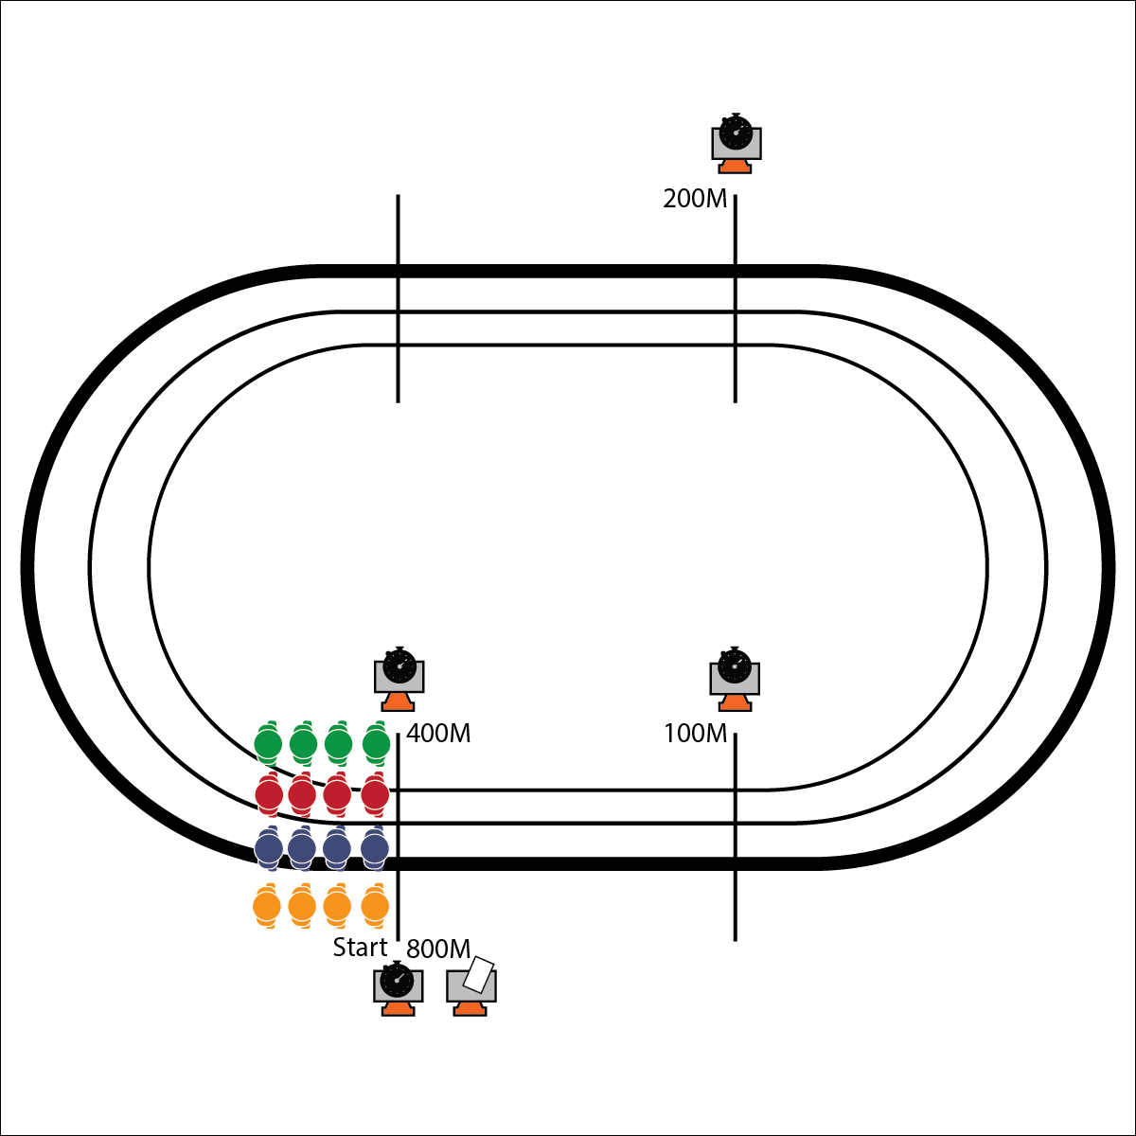

**Equipment:**

* 5 large cones
* 5 task tents
* 4 Checkpoint Pattern Worksheets
* Track Meter Interval Signs
* 4 stopwatches
* 1 Fitness Running Portfolio for each student

**Set-Up:**

1. Set up cones at a starting point and checkpoints 100M, 200M, 400M, and 800M away.
2. Give each team a Checkpoint Pattern Worksheet and place pencils in task tents with Interval Signs.
3. Place a stopwatch at each checkpoint.
4. Split students into 4 groups, all groups together at the starting point.

* **Skill:** I will demonstrate proper form and steady pacing while running.
* **Cognitive:** I will discuss the heart’s role in aerobic capacity.
* **Fitness:** I will record pacing and aerobic intensity with my group.
* **Personal & Social Responsibility:** I will work cooperatively with group members to maintain a pace we can run at together.

**CHECKPOINT DESTINATION**

* Groups Stay Together
* Adjust the Pace
* Focus on Form

**Activity Procedures:**

1. Today’s activity is called Checkpoint Destination.
2. The object of the activity is to make your way to each checkpoint, record your heart rate, and then work as a group to correctly answer the questions on the worksheets.
3. Each group will be assigned a checkpoint pattern and run to a different check point. Give students a short time to decide as a group on a comfortable pace for each distance and a communication strategy for modifying the pace, if necessary, during the run.
4. When you hear the start signal, jog to the first assigned checkpoint together. On your worksheets, record your heart rates and then answer the question corresponding to that check point. When you’re finished, jog back to the start point, discuss your pace for the next checkpoint, and continue.
5. Continue until all groups have visited all checkpoints.

**Grade Level Progression:**

**L1:** Complete the activity as described above.

**L2:** Calculate target heart rate zones for the activity. Use heart rate monitors to self-monitor intensity and adjust pacing accordingly.

**CHECKPOINT DESTINATION**



* **DOK** **1:** What is aerobic capacity?
* **DOK 2:** What do you know about training to improve aerobic capacity?
* **DOK 3:** How is pacing related to aerobic capacity?



* **Standard 2 [H1.L1-2]:** Applies the terminology associated with exercise and participation in selected individual-performance activities, dance, net/wall games, target games, aquatics, and/or outdoor pursuits appropriately (L1).
* **Standard 3 [H10.L1-2]:** Calculates target heart rate and applies HR information to personal fitness plan (L1); Adjusts pacing to keep heart rate in the target zone, using available technology (e.g., pedometer, heart rate monitor), to self-monitor aerobic intensity (L2).



* Shorten the distance to each checkpoint.
* Place a teammate at each checkpoint. 1–2 students run from checkpoint to checkpoint, while the other teammates complete exercises at each point, waiting for their teammates to arrive and answer questions.



100M, 200M, 400M, 800M, Dehydration, Electrolytes, Hydration, Lactate Threshold, Lactic Acid, Water



**Help students process content.** This activity is rich with opportunities to teach students about the importance of aerobic fitness and strategies for training to improve their aerobic capacity. Use the debrief questions above to help students process the terminology and concepts behind what they’re feeling physiologically during their running practice.

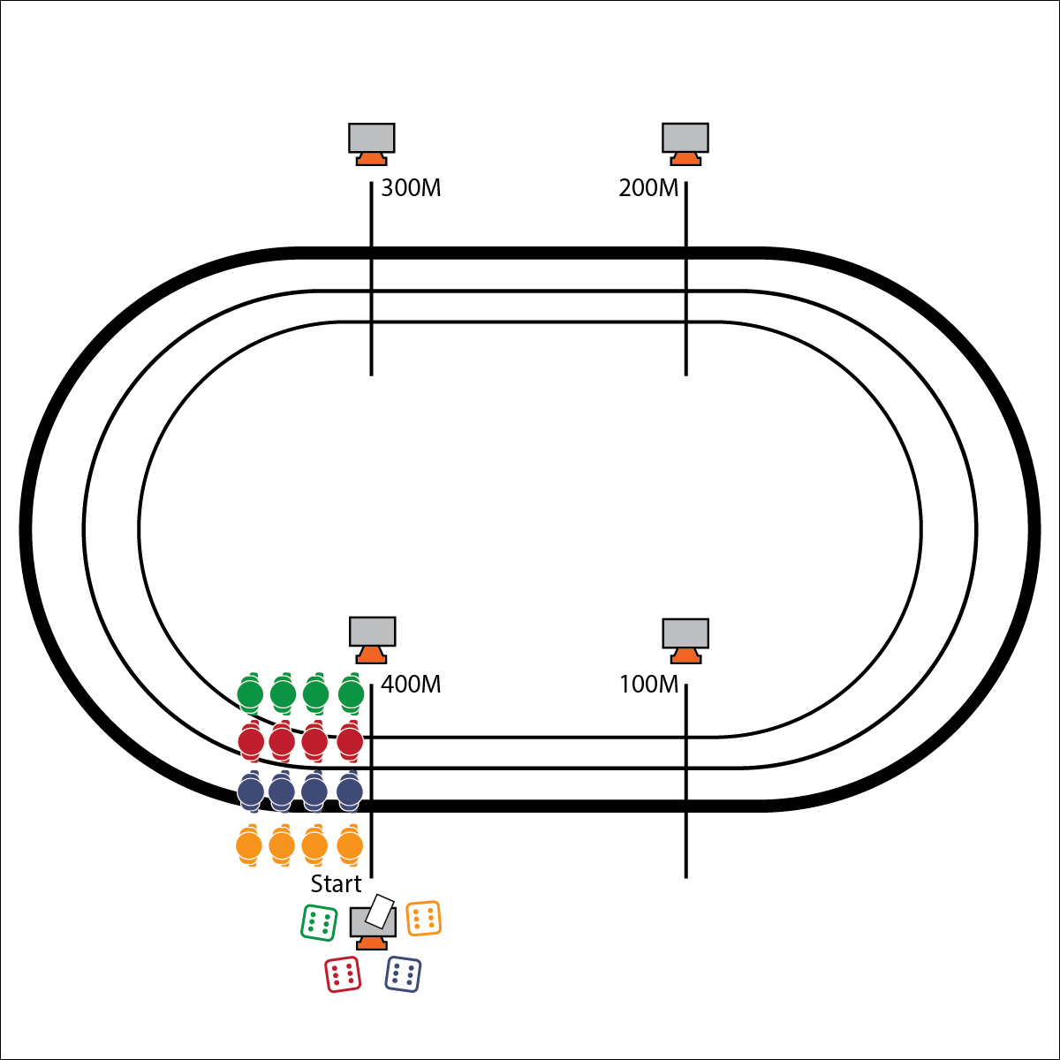

**Equipment:**

* 1 die per team
* 7 cones with task tents
* Track Meter Interval Signs
* 1 Casino Royale Scorecard per team
* 1 Fitness Running Portfolio for each student

**Set-Up:**

1. Place cones/task tents and meter-marker signs at each 100M interval.
2. Create teams of 3–6 students.
3. Give each team a die and a scorecard.

* Focus on Form
* Adjust Speed and Effort
* Stay Controlled and Consistent

**CASINO ROYALE**

* **Skill:** I will adjust my pacing to maintain a target heart rate.
* **Cognitive:** I will calculate, track, and adjust my heart rate using a heart rate monitor.
* **Fitness:** I will improve my aerobic capacity by maintaining my target heart rate.
* **Personal & Social Responsibility:** I will discuss the health benefits of fitness running.

**Activity Procedures:**

1. Today’s activity is called Casino Royal.
2. The object of the activity is to collect the greatest number of points as a group. Every 100M interval your group runs is worth 100 points.
3. When you hear the start signal, 1 person from your group will roll the die and then run that number multiplied by 100M. For example, if you roll a 4, run 400M. This will earn your group 400 points.
4. As soon as that group member begins running, the next person in your group will roll the die and take a turn. Continue rotating group members, 1 after the other, until you hear the stop signal. When you’ve finished your running interval, jog at a slow pace back to the starting line, record your score, and then roll again.
5. Continue rolling the die quickly so that all group members are running at the same time.

**Grade Level Progression:**

**L1:** Each teammate will earn 1,000 heart rate points for working in their target zones for more than 50% of the activity time (Heart Health Zone 120–180 BPM).

**L2:** Adjust pace to work at the low end of the target zone for 300M–600M intervals, and at the high end of the zone for 100M–200M intervals.

**CASINO ROYALE**



* **DOK** **1:** What would you include on a list about pace?
* **DOK 2:** How does pace affect heart rate?
* **DOK 3:** What facts would you select to support the importance of pacing when participating in a 5K fitness running event?
* **DOK 1:** Can you remember the cues for running?
* **DOK 2:** How does running form affect exercise intensity?
* **DOK 3:** How is form related to maintaining running pace?



* **Standard 3 [H10.L1-2]** Calculates target heart rate and applies HR information to personal fitness plan (L1); Adjusts pacing to keep heart rate in the target zone, using available technology (e.g., pedometer, heart rate monitor), to self-monitor aerobic intensity (L2).
* **Standard 5 [H1.L1]** Analyzes the health benefits of a self-selected physical activity (L1).



* Roll odds/evens, with odd numbers representing a 100M run and the even numbers representing a 200M run. As students progress, make these distances longer.



Fitness Plan, Heart Rate, Heart Rate Monitor, Intensity, Pace, Target Heart Rate Zone



**Help students elaborate on content.** Simply defining pace, form, and intensity should be easy for students. Guide them through the process of elaborating on how these concepts are related and how they impact their running performance. This knowledge can help students understand and work toward improving their form and using a more mindful approach to pacing.

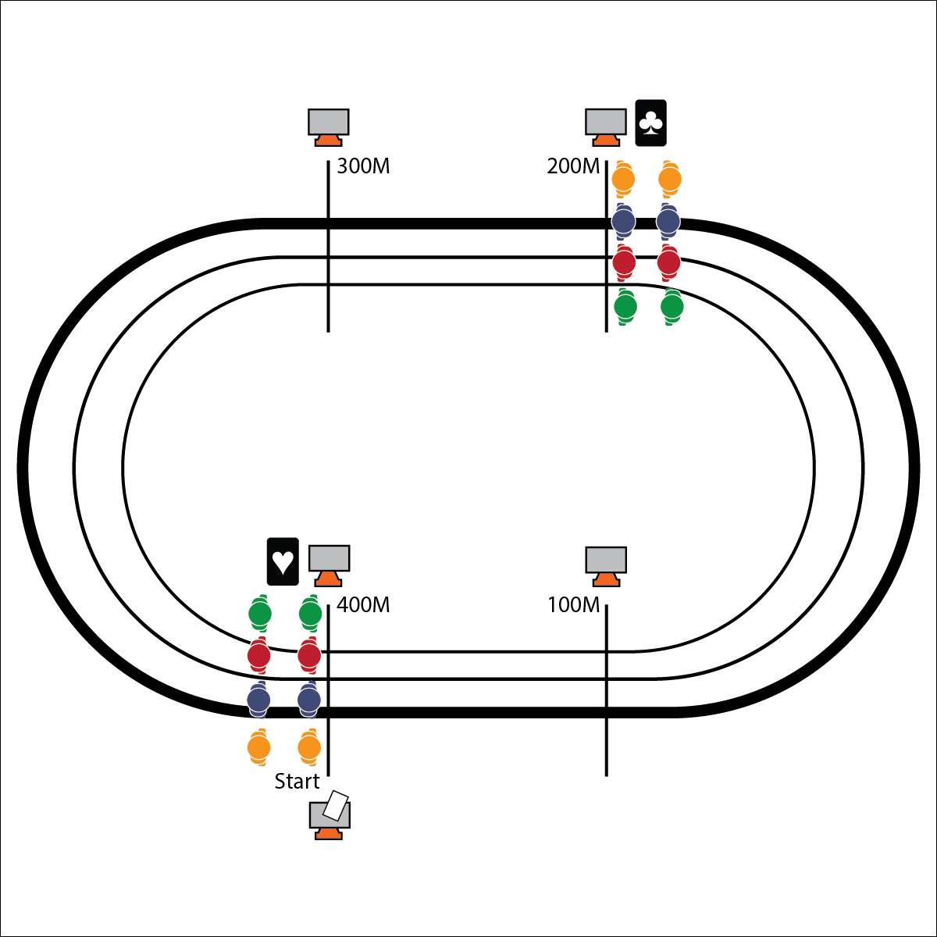

**Equipment:**

* 2–4 decks of playing cards
* 1 Fitness Running Portfolio for each student

**Set-Up:**

1. Split the class into teams of 3. Give each teammate a number from 1 to 3.
2. Send teammates 1 and 3 to the starting line. Send teammate 2 to the 200M mark.
3. Place 1 stack of cards at the 200M mark and 1 at the starting line.

* Form
* Pace
* Teamwork

**RENEGADE OUTLAWS**

* **Skill:** I will demonstrate proper running technique.
* **Cognitive:** I will use breathing strategies for mindfully decreasing my heart rate during rest intervals.
* **Fitness:** I will discuss heart rate recovery as it relates to my personal fitness.
* **Personal & Social Responsibility:** I will use positive language and communication to encourage my teammates.

**Activity Procedures:**

1. Today’s activity is called Renegade Outlaws. The object of the activity is to score points by collecting as many playing cards as possible from each interval mark. Your team receives points based on the card you draw (3s are worth 3 pts, 10s worth 10 pts, Queens worth 12 pts, etc.).
2. When you hear the start signal, runner 1 will take off from the starting line and run to the 200M mark. S/he will stop there to collect a card and rest.
3. As soon as runner 1 reaches the 200M mark, runner 2 will run from the 200M mark to the starting line, collect a card, and rest. At this point, runner 3 will run to the 200M mark where runner 1 is waiting.
4. Continue running and collecting cards in this pattern until you hear the stop signal. At that time your team will add up the points from all of your cards.

**Grade Level Progression:**

**L1:** Run at a moderate pace, focusing on form rather than speed.

**L2:** Run at a more vigorous pace and add an additional member per team. During each round, designate 1 teammate as the form coach, analyzing form and providing feedback to teammates.

**RENEGADE OUTLAWS**



**Help students record and represent knowledge.** Take one lesson to allow students to complete DOK 4 above. Begin the process with only a blank sheet of paper, pencil, and ideas. Push students to design the entire experiment, including data collection and reporting design. This process will give students an opportunity to focus on their own personal physiological response to exercise while analyzing the feedback that their body is providing.



* Split students into groups of 5. 2 students will start at the starting line, 1 at the 100M mark, 1 at the 200M mark, and 1 at the 300M mark. Students will run shorter distances with similar amounts of rest.



Encourage, Heart Rate Recovery, Mindfulness, Personal Fitness, Positive Language, Technique



* **Standard** **1 [H1.L1-2]** Demonstrates competency and/or refines activity-specific movement skills in two or more lifetime activities (outdoor pursuits, individual-performance activities, aquatics, net/wall games, or target games) (L1); Refines activity-specific movement skills in one or more lifetime activities (outdoor pursuits, individual-performance activities, aquatics, net/wall games, or target games) (L2).
* **Standard 3 [H8.L1-2]** Relates physiological responses to individual levels of fitness and nutritional balance (L1).
* **Standard 4 [H3.L1-2]** Uses communication skills and strategies that promote team/group dynamics (L1); Assumes a leadership role (e.g., task or group leader, referee, coach) in a physical activity setting (L2).



* **DOK** **1:** What do you know about heart rate recovery? How is it calculated?
* **DOK 2:** How did your breathing affect your heart rate recovery?
* **DOK 3:** Can you formulate a theory for why controlled breathing can affect heart rate recovery? How would you test this theory?
* **DOK 4:** Let’s design and conduct an experiment to help examine our theories about breathing’s effect on heart rate recovery.

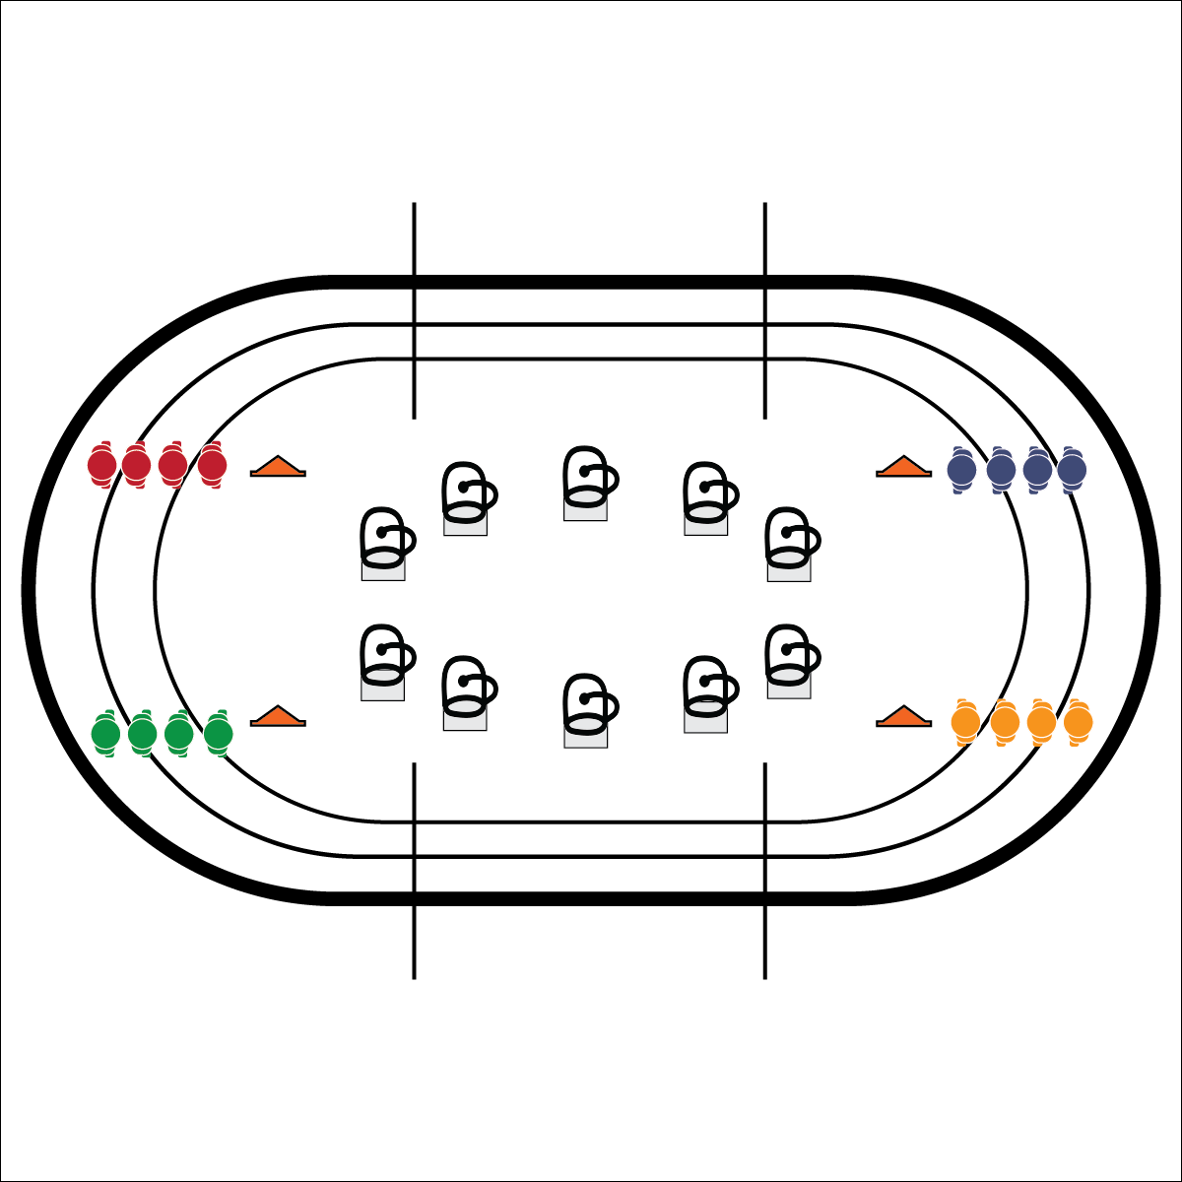

**Equipment:**

* 8 buckets
* 1 low-profile cone per team
* Scavenger Hunt Academic Language Sheets
* Academic Language Sheet Definition Key
* Scavenger Hunt Score Card
* 1 Fitness Running Portfolio for each student

**Set-Up:**

1. Place buckets upside-down at various locations around the infield of the track. The greater the distance between buckets, the more vigorous the workout.
2. Place 1 Scavenger Hunt Academic Language Sheet under each bucket.
3. Place cones around the perimeter of the track.
4. Create teams of 2–4 students, each at a cone.

**VOCAB SCAVENGER HUNT**

* **Skill:** I will demonstrate proper running technique.
* **Cognitive:** I will identify and utilize the academic language of running.
* **Fitness:** I will calculate target HR and adjust my pacing to work within a target zone.
* **Personal & Social Responsibility:** I will support my teammates with positive language.
* Pace
* Eyes Up
* Arm and Leg Opposition

**Activity Procedures:**

1. Today we will be doing a scavenger hunt.
2. The object of the activity is to earn the most points as a team by quickly finding the academic language word that matches the definition that I read.
3. I will read a definition and then say, “GO!” Then 1 of your teammates will run out and flip over buckets to search for the academic language word that matches the definition that I read. Be sure to replace the bucket after you see what’s under it.
4. As soon as you’ve found the word, remember the card number you found it on, run back to your team, and record the card number on your team’s score card.
5. We’ll check answers when all teams are back. The 1st team to return with a correct answer receives 5 points; the 2nd receives 4 points; the 3rd will receive 3 points. We’ll continue for 6 rounds before totaling our team’s final score.

**Grade Level Progression:**

**L1:** Play the activity as described above.

**L2:** Give bonus heart rate points to teams who are able to adjust their pacing and maintain their HRs within the target zone.

**VOCAB SCAVENGER HUNT**



**Organize students to interact with content.** The Vocab Scavenger Hunt provides students with rich opportunities to engage with the content of fitness running while interacting with their peers in a team environment. When implemented in its full form, this activity gives students a vigorous dose of exercise, provides an opportunity for them to analyze and use their bodies’ feedback to adjust intensity, and reinforces the use of academic language.



* **Standard** **1 [H1.L1-2]** Demonstrates competency and/or refines activity-specific movement skills in two or more lifetime activities (outdoor pursuits, individual-performance activities, aquatics, net/wall games, or target games) (L1); Refines activity-specific movement skills in one or more lifetime activities (outdoor pursuits, individual-performance activities, aquatics, net/wall games, or target games) (L2).
* **Standard 2 [H1.L1-2]** Applies the terminology associated with exercise and participation in selected individual-performance activities, dance, net/wall games, target games, aquatics, and/or outdoor pursuits appropriately (L1).
* **Standard 3 [H10.L1-2]** Calculates target heart rate and applies HR information to personal fitness plan (L1); Adjusts pacing to keep heart rate in the target zone, using available technology (e.g., pedometer, heart rate monitor), to self-monitor aerobic intensity (L2).
* **Standard 5 [H4.L1-2]** Identifies the opportunity for social support in a self-selected physical activity or dance (L1); Evaluates the opportunity for social interaction and social support in a self-selected physical activity or dance (L2).



Encourage, Personal Fitness, Positive Language, Social Interaction, Social Support, Target Heart Rate, Technique



* Decrease the distance between cones and buckets.
* Allow 2 teammates to go out and look at the same time.



* **DOK** **1:** What is target heart rate?
* **DOK 2:** What do you know about target heart rate zones?
* **DOK 3:** How is target heart rate related to personal fitness and personal fitness planning?
* **DOK 1:** What would you include on a list about social support?
* **DOK 2:** How would you summarize your role in providing social support to others?
* **DOK 3:** How is social support related to physical activity and personal fitness?

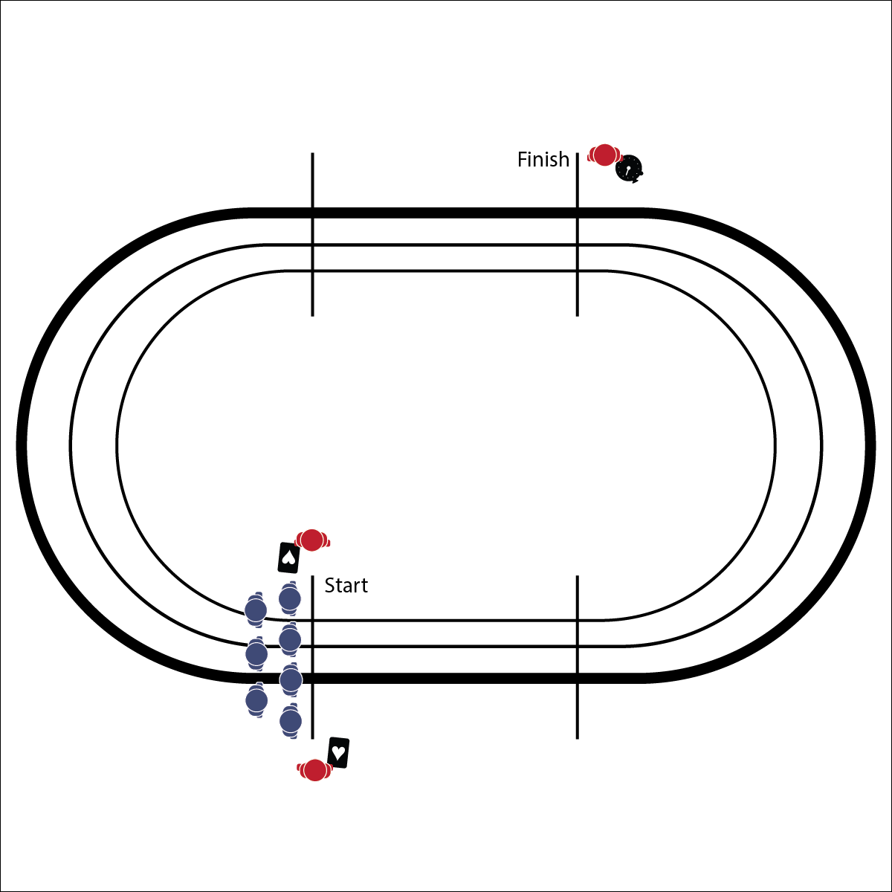

**Equipment:**

* 3–5 decks of cards (enough for each student to receive 7 cards)
* Stopwatch
* 3K Time Record Sheets (in portfolio)

**Set-Up:**

1. Students begin at the starting line.
2. Lap monitors (teachers and/or students) are positioned with playing cards.

* Set a Steady Pace
* Focus on Form and Breathing
* Give Your Best Effort
* **Skill:** I will demonstrate proper running form while maintaining a steady and challenging pace.
* **Cognitive:** I will use correct fitness running terminology when completing fitness portfolio pages.
* **Fitness:** I will use a fitness portfolio to record performance times and set future goals.
* **Personal & Social Responsibility:** I will discuss the health benefits of fitness running as a lifetime physical activity.

**3K: THE ONE WITH THE MOST**

**Activity Procedures:**

1. Today’s 3K activity is called The One with the Most. In this activity, you will run a 3K (3000M, or 7.5 laps on a 400M track). As you run, you will collect playing cards from the lap monitors for each lap. The cards will determine your points, and they’ll also help you count your laps.
2. The object of the activity is to receive cards that beat the teacher’s hand (face cards=10, aces=1, 2s=2, and so on). I will draw my 7 cards when everyone has finished the run, and we’ll add up our points.
3. When finished, everyone will walk 1 cool-down lap. Next, everyone will record their run time on the 3K Time Record Sheet. The first time on the sheet will set a baseline for your personal best. I will announce future run opportunities throughout the school year (mornings, lunches, afterschool) to give you the opportunity to improve your personal best.
4. Running this 3K time trial will give you distance experience and give you the confidence for a real 5K running event.

**Grade Level Progression:**

**L1:** Complete the activity as described above.

**L2:** Select advanced running students to be peer coaches. They act as lap monitors but also take notes on feedback that can be provided to their classmates to help improve and refine form and performance.

**3K: THE ONE WITH THE MOST**



**Help students practice skills, strategies, and processes.** Creating and then executing a personal fitness plan is a process in which students will use the skills and knowledge they’ve developed to build a strategy for personal well-being. Use the Fitness Running Portfolio and worksheets to guide students through this process. Take the time to read and provide feedback on the reasoning and logic for their work.



* **Standard** **1 [H1.L1-2]** Demonstrates competency and/or refines activity-specific movement skills in two or more lifetime activities (outdoor pursuits, individual-performance activities, aquatics, net/wall games, or target games) (L1); Refines activity-specific movement skills in one or more lifetime activities (outdoor pursuits, individual-performance activities, aquatics, net/wall games, or target games) (L2).
* **Standard 2 [H1.L1-2]** Applies the terminology associated with exercise and participation in selected individual-performance activities, dance, net/wall games, target games, aquatics, and/or outdoor pursuits appropriately (L1).
* **Standard 3 [H11.L2]** Develops and maintains a fitness portfolio (e.g., assessment scores, goals for improvement, plan of activities for improvement, log of activities being done to reach goals, timeline for improvement) (L2).
* **Standard 5 [H1.L1]** Analyzes the health benefits of a self-selected physical activity (L1).



3K, 5K, Competency, Cool-Down, Fitness Portfolio, Health Benefits, Performance, Refine



* Allow students to run this race as a relay, with teammates splitting the distance.
* Allow students to choose the distance of the run with a focus on setting a personal best for that distance and then creating goals for improvement.



* **DOK** **1:** What would you include on a list about the health benefits of fitness running?
* **DOK 2:** How would you apply what you know about the health benefits of fitness running when creating a personal fitness plan in your portfolio?
* **DOK 3:** What facts would you use to persuade someone to try fitness running as a routine personal fitness activity?
* **DOK 4:** Use the Fitness Running Portfolio pages to create a personal fitness running plan that you can follow outside of class.