­­­

­

* Fitness Running Portfolio
* DOK Questions
* Aerobic
* Cardiorespiratory Endurance
* Comfortable
* Pace
* Stamina
* Stride
* **Skill:** I will demonstrate proper running form, focusing on pace and stride.
* **Cognitive:** I will discuss the importance of pacing.
* **Fitness:** I will find a comfortable pace that allows me to remain actively engaged during this activity.
* **Personal & Social Responsibility:** I will communicate with my team to determine and hold a pace that everyone can maintain.
* **Standard 1 [H3.L1-2]:** Demonstrates competency in one or more specialized skills in health-related fitness activities (L1); Demonstrates competency in two or more specialized skills in health-related fitness activities (L2).
* **Standard 3 [H3.L2]:** Applies rates of perceived exertion and pacing (L2).
* **Standard 3 [H5.L1]:** Evaluates risks and safety factors that might affect physical activity preferences throughout the life cycle (L1).

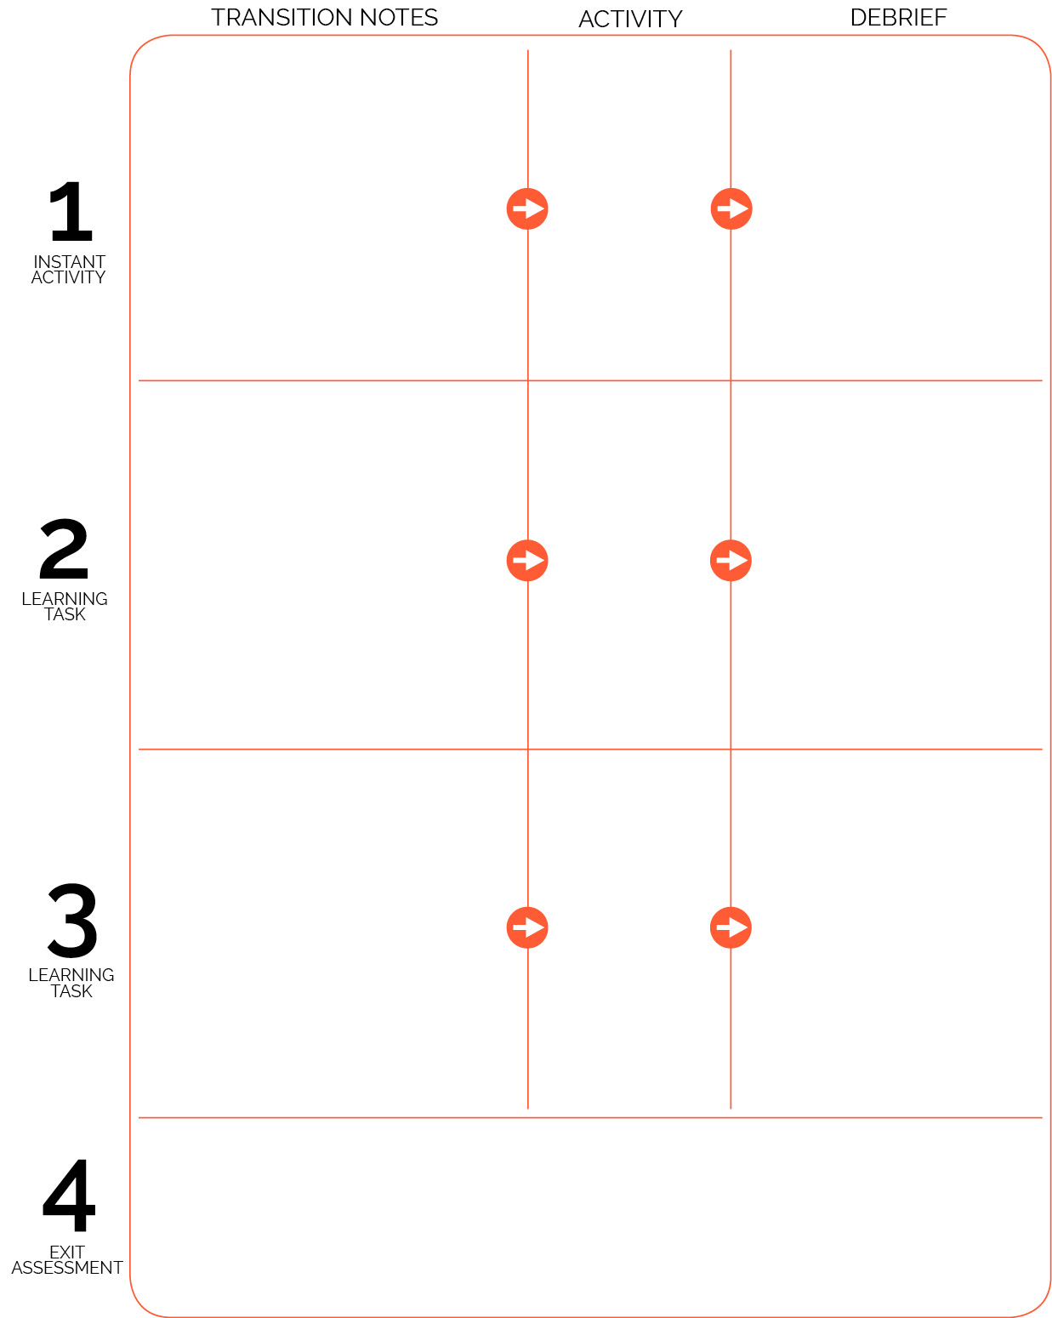

**DOK 1:** What is a cool-down?

**DOK 2:** What can you notice about your body’s reaction to the cool-down walk?

**DOK 3:** Why is a cool-down important when you finish exercising?

Fitness Running Portfolio (Day 1)

Walk/Talk Cool Down

**DOK 1:** What do you know about pace?

**DOK 2:** How did the pace of the line runners affect the lead runner’s ability to catch the line ahead of them?

**DOK 3:** How is pace related to race distance? Give details to support your answer for a variety of distances.

Line Pursuit

RPS

Victory Lap

**DOK 1:** What is a warm-up?

**DOK 2:** What can you notice about your body’s reaction to the warm-up activity?

**DOK 3:** Why is a warm-up important when you begin exercising?

Provide students with the DOK questions for the cool-down debrief. Prompt them to walk the first 200 meters with a focus on controlled breathing and heart rate recovery. During the second 200 meters, they will discuss the DOK questions with partners.

When the cool-down is complete introduce the Fitness Running Portfolio.

Victory Lap activity area is set up. As students arrive, they immediately begin the warm-up activity. Continue for 5 minutes and then transition to the track.

Introduce Fitness Running to students with an explanation of running form. Explain and demonstrate the activity over a 100M distance. Then discuss the distance markers and group students at each marker.