­­

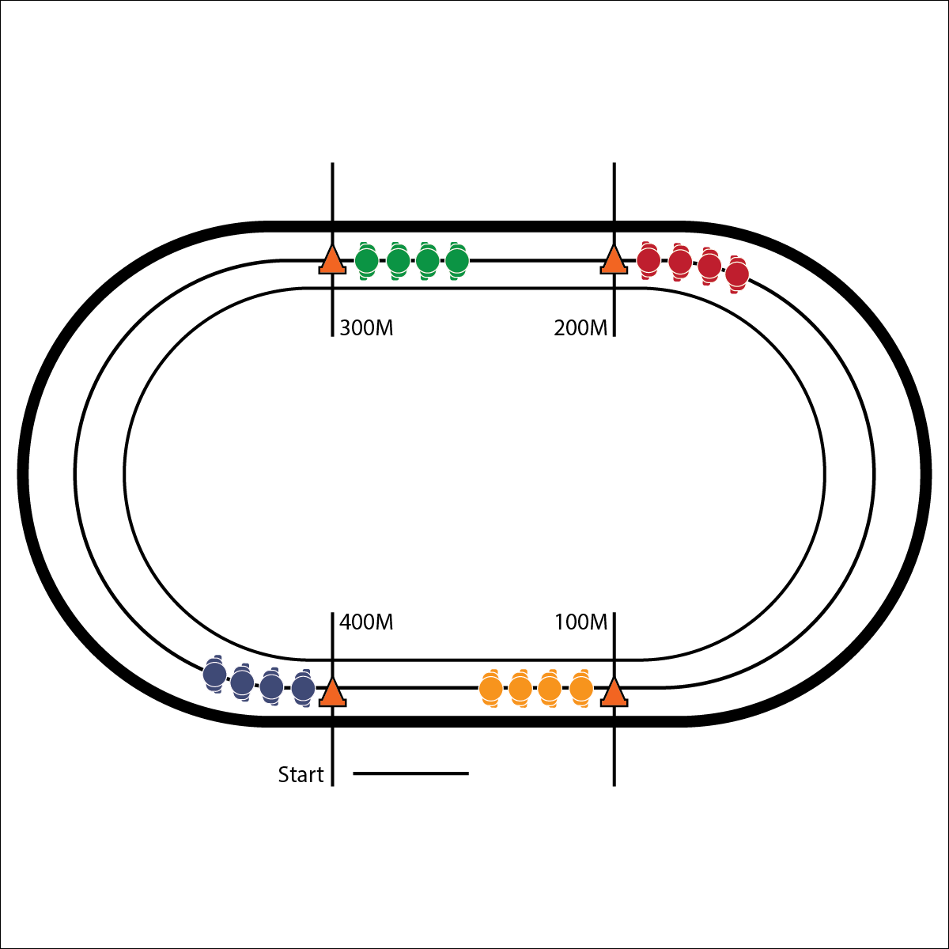

**Activity Procedures:**

1. Today’s activity is. The object of the activity is.
2. On the start signal.
3. On the stop signal.

**Grade Level Progression:**

**L1:** Progression 1.

**L2:** Progression 2.

* **Skill:** I will….
* **Cognitive:** I will…
* **Fitness:** I will…
* **Personal & Social Responsibility:** I will…

**Equipment:**

* Equip 1
* Equip 2

**Set-Up:**

1. Set up activity area.
2. Set up equipment.
3. Create groups.

* CUE 1
* CUE 2
* CUE 3

**ACTIVITY NAME**

**ACTIVITY NAME**



* UDA 1
* UDA 2



Words, Words, Words



* **Standard X [HX.LX]:** Outcomes
* **Standard X [HX.LX]:** Outcomes
* **Standard X [HX.LX]:** Outcomes



* **DOK 1:** Question 1
* **DOK 2:** Question 2
* **DOK 3:** Question 3



**Strategy Overview.** Strategy Details