

The Ninja Warrior obstacle course movement has been broadcast into American living rooms since 2009, although the movement dates back to 1997 and Japan’s Ninja Warrior show called Sasuke Rising. On average, over 5 million American viewers tune in to each episode of American Ninja Warrior, and the show has inspired many to embrace a fitness lifestyle. Physical educators can use this excitement and inspiration to engage students in meaningful movement and fitness lessons.

­­­

|  |  |  |
| --- | --- | --- |
| **RESOURCES** | **FOCUS OUTCOMES & STANDARDS** | **PAGE** |
| Module Overview |  | **1** |
| Required Materials List |  | **5** |
| **Activity Plans** |  |  |
| Ninja Warrior Training Tag | Standard 1, 2, 3, 4 | **7** |
| Agility Ninja Tag | Standard 1, 2, 3, 4 | **9** |
| Ninja Warrior Tabata | Standard 2, 3, 4 | **11** |
| Hometown Hero Challenge | Standard 2, 3, 4 | **13** |
| Regional Heart Challenge | Standard 2, 3, 4 | **15** |
| National Heart Challenge | Standard 2, 3, 4 | **17** |
| Student Ninja Challenges | Standard 2, 3, 4, 5 | **19** |
| Sample First Lesson Plan |  | **21** |
| Academic Language Posters |  | **37 pages** |
| Universal Design Adaptations |  |  |
| Tabata Warm-Up Routine Task Cards |  | **3 pages** |
| Ninja Challenge Station Cards |  | **30 pages** |
| **Student Assessment Tools** |  |  |
| Self-Assessment Worksheet |  |  |
| Holistic Performance Rubric |  |  |
| Academic Language Quiz |  |  |
| SEL Reflection Guide |  |  |
| Teacher Self-Eval & Reflection Guide |  |  |

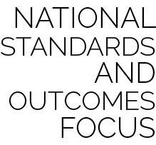

* **Standard** **1 [E1.3-5]** Leaps using a mature pattern (3); Uses various locomotor skills in a variety of small-sided practice tasks, dance, and educational gymnastics experiences (4); Demonstrates mature patterns of locomotor skills in dynamic small-sided practice tasks, gymnastics, and dance.
* **Standard 1 [E2.3 & 5]:** Travels showing differentiation between sprinting and running (3); Uses appropriate pacing for a variety of running distances (5).
* **Standard 2 [E3.3-5]** Combines movement concepts (direction, levels, force, time) with skills as directed by the teacher (3); Applies the movement concepts of speed, endurance, and pacing for running (4a); Applies movement concepts to strategy in game situations (5a); Analyzes movement situations and applies movement concepts (e.g., force, direction, speed, pathways, extensions) in small-sided practice task/game environments, dance, and gymnastics (5c).

*More standards listed on the next page.*

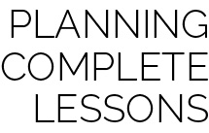

Each skill-building activity in this module is meant to be one part of a complete lesson. The authors recommend the following formula for creating a 30- to 45-minute lesson:

Instant Activity (not on block plan) *5–10 minutes*

+ Skill Activity with Debrief *10–15 minutes*

+ Skill Activity with Debrief *10–15 minutes*

+ Check for Understanding *5 minutes*

**Important:** Suggestions are what they say they are: *suggestions*. All OPEN materials are offered in MS Word format so that you can easily modify our suggestions to meet the needs of your students.



*Standards continued…*

* **Standard 2 [E5.3-5]** Applies simple strategies/tactics in chasing activities (3a); Applies simple strategies in fleeing activities (3b); Applies simple offensive strategies/tactics in chasing and fleeing activities (4a); Applies simple defensive strategies/tactics in chasing and fleeing activities.
* **Standard 3 [E2.3-5]** Engages in the activities of physical education class without teacher prompting (3); Actively engages in the activities of physical education class, both teacher-directed and independent (4); Actively engages in all the activities of physical education (5).
* **Standard 3 [E3.3-5]** Describes the concept of fitness and provides examples of physical activity to enhance fitness (3); Identifies the components of health-related fitness (4); Differentiates between skill-related and health-related fitness (5).
* **Standard 4 [E5.3-5]** Recognizes the role of rules and etiquette in physical activity with peers (3); Exhibits etiquette and adherence to rules in a variety of physical activities (4); Critiques the etiquette involved in rules of various game activities (5).
* **Standard 4 [E6.3-5]** Works independently and safely in physical activity settings (3); Works safely with peers and equipment in physical activity settings (4); Applies safety principles with age-appropriate physical activities (5).



Three types of assessment are provided as a part of this module. However, there are many different ways for teachers and students to assess and evaluate student learning and skill development.

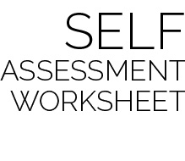

This simple self-assessment provides each student with a structure for reflecting on current skill level, setting a goal for growth and development, and then reassessing progress toward that goal.

The authors recommend that students complete this form as a pre-assessment on the day when skills are first introduced. For example, during the module’s first lesson, students participate in Agility Ninja Tag. At the end of this activity, students would complete the Pre and Goal columns for Agility (and possibly Safety). Other skills would not be completed until a future lesson introduces those them. A post-assessment for all skills would then be completed during the module’s final lesson.

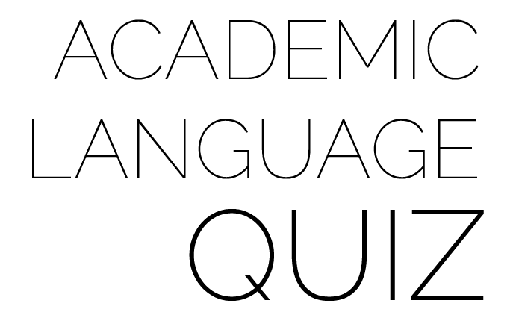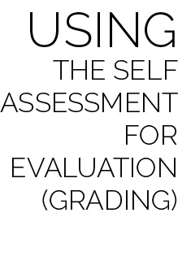

When evaluating a student’s performance in using the Self-Assessment Worksheet, the student’s score should be based on the process and quality of self-reflection, not the student’s ability to score a full column of smiles or stars. Here is a sample rating scale for Self-Assessment evaluation:

* Well Below Competence (1): Was present, but refused to complete self-assessment.
* Lacks Competence (2): Completed each assessment with little effort. Student pre- and post-assessments do not match teacher-observed skill performance.
* Competent (3): Most skill assessments match the student’s skill level with a goal for improvement and an accurate post-assessment. Evidence of reflection is present.
* Proficient (4): All skill assessments match the student’s skill level with a goal for improvement and an accurate post-assessment. Evidence of reflection and a regard for quality of work is present.

*NOTE: The evaluation scale suggested for the Self-Assessment Worksheet is consistent with the scale used for the holistic rubrics discussed below. This consistency allows teachers to average several scores for the sake of a final evaluation or grade.*

The holistic rubric can be used as both a formative and summative assessment within the module. Providing students with the rubric’s criteria early in the module will allow for discussion and formative evaluation throughout activities and lessons.

Two rubrics are given for teachers to choose from based completely on preference. The Single Holistic Rubric provides one set of criteria, including both skill and personal and social responsibility (PSR) characteristics. The Dual Holistic Rubric separates skill and PSR characteristics, providing two sets of criteria to be evaluated separately. Either rubric can be completed in full on the module’s station day, providing a final holistic evaluation of each student’s performance.

Assess student knowledge with a short quiz focused on the academic language of Ninja Warrior Skills. Use the quiz as-is or as a template for creating a custom quiz.



|  |  |  |
| --- | --- | --- |
| **Lesson** | **Skill Activity** | **Suggested Academic Language** |
| 1 | Ninja Warrior Training Tag, Ninja Warrior Tabata, and Hometown Hero Challenge | Agility, Avoid, Chase, Flee, Jump, Pathway, Run, Skill-Related Fitness, Appropriate, FITT, Guidance, Identify, Independent, Safe, Set, Specific, Vigorous |
| 2 | Ninja Warrior Training Tag, Ninja Warrior Tabata, and Hometown Hero Challenge | Challenging, Cooperate, Grit, Etiquette, Health-Related Fitness, Levels, Pathway, Respect, Skill-Related Fitness, Traverse, Weight Transfer |
| 3 | Agility Ninja Tag, Ninja Warrior Tabata, and Regional Heart Challenge | Agility, Challenge, Cooperate, Encouragement, Grit, Health-Related Fitness, Level, Pathway, Respect, Skill-Related Fitness, Traverse, Weight Transfer |
| 4 | Ninja Tag Choice, Ninja Warrior Tabata, and National Heart Challenge | Agility, Challenging, Cooperate, Encouragement, Grit, Health-Related Fitness, Improve, Level, Pathway, Respect, Skill-Related Fitness, Traverse, Weight Transfer |
| 5 | Ninja Tag Choice, Ninja Warrior Tabata, and Student Ninja Challenges | Agility, Challenging, Cooperate, Encouragement, Grit, Health-Related Fitness, Improve, Level, Pathway, Respect, Skill-Related Fitness, Traverse, Weight Transfer |
| 6 | Ninja Tag Choice, Ninja Warrior Tabata, and Student Ninja Challenges | Agility, Challenging, Cooperate, Encouragement, Grit, Health-Related Fitness, Improve, Level, Pathway, Respect, Skill-Related Fitness, Traverse, Weight Transfer |