­­

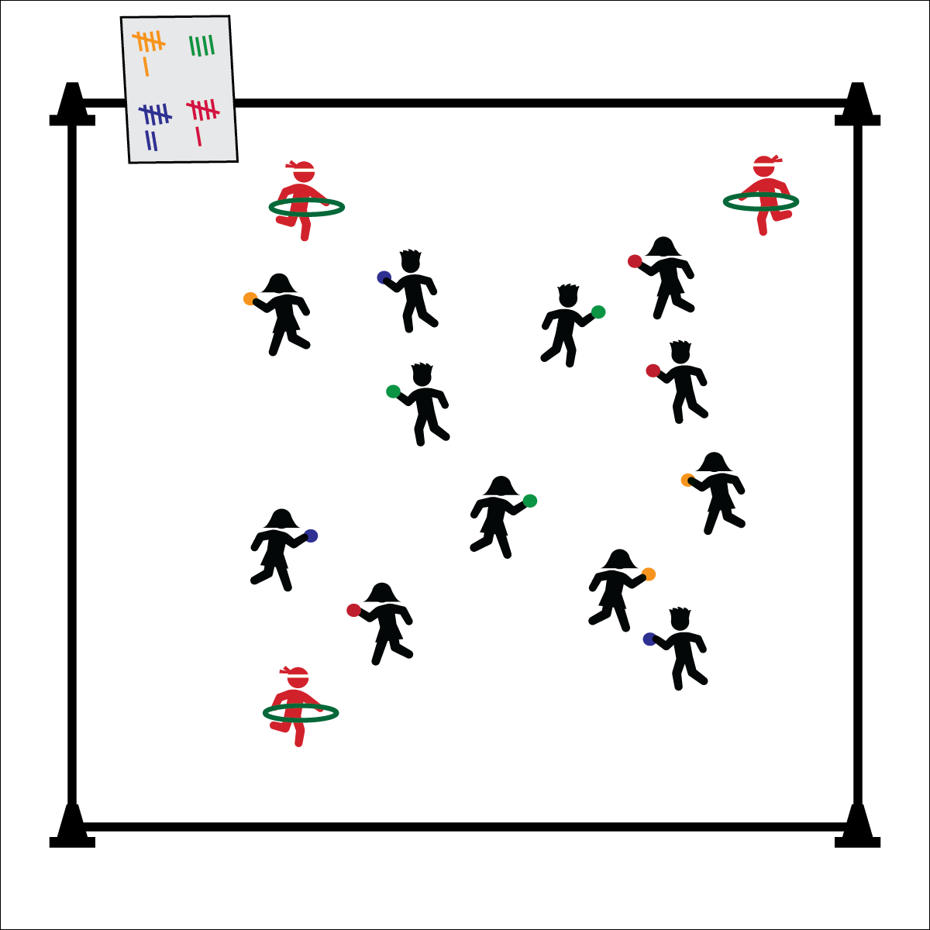

* **Skill:** I will demonstrate locomotor movements in combination with throwing and shooting at a target.
* **Cognitive:** I will discuss the importance of moving to open space while playing Agility Ninja Tag.
* **Fitness:** I will work to increase my heart rate.
* **Personal & Social Responsibility:** I will follow class rules and etiquette so that everyone is safe and has fun.
* Use Various Pathways to Move
* Move Safely
* Watch Out for Other Students

**Equipment:**

* 3 hula hoops
* 1 yarn/fleece ball per student
* 1 whiteboard or paper for tally marking with 3–5 markers

**Set-Up:**

1. Select 3 students to be the agility masters. They use 2 hands to hold hoops parallel to the ground at waist level.
2. All other students holding 1 yarn ball.
3. Place the whiteboard where it will be visible to the whole class.

**Activity Procedures:**

1. Today’s activity is called Agility Ninja Tag. The object of the activity is to use your agility to change direction quickly and dunk your yarn ball into one of the agility masters’ hoops. (Throwing through the hoop doesn’t count.) Be sure to remember the color of your yarn ball!
2. Agility masters will move throughout the gym, changing directions and moving their hoop in order to prevent their classmates from dunking the yarn balls into their hoop.
3. If you successfully dunk into an agility master’s hoop, mark a tally on the whiteboard. After the class gets a total of 20 tallies, we’ll switch agility masters.

**Grade Level Progression:**

**3rd:** Play at a walking or galloping pace.

**4th–5th :** Play the game using a variety of locomotor skills.

**AGILITY NINJA TAG**

**AGILITY NINJA TAG**



Agility, Avoid, Chase, Flee, Jump, Run



* **Standard** **1 [E1.3-5]** Leaps using a mature pattern (3); Uses various locomotor skills in a variety of small-sided practice tasks, dance, and educational gymnastics experiences (4); Demonstrates mature patterns of locomotor skills in dynamic small-sided practice tasks, gymnastics, and dance.
* **Standard 2 [E5.3-5]** Applies simple strategies/tactics in chasing activities (3a); Applies simple strategies in fleeing activities (3b); Applies simple offensive strategies/tactics in chasing and fleeing activities (4a); Applies simple defensive strategies/tactics in chasing and fleeing activities
* **Standard 3 [E2.3-5]** Engages in the activities of physical education class without teacher prompting (3); Actively engages in the activities of physical education class, both teacher-directed and independent (4); Actively engages in all the activities of physical education (5).
* **Standard 4 [E5.3-5]** Recognizes the role of rules and etiquette in physical activity with peers (3); Exhibits etiquette and adherence to rules in a variety of physical activities (4); Critiques the etiquette involved in rules of various game activities (5).
* **Standard 4 [E6.3-5]** Works independently and safely in physical activity settings (3); Works safely with peers and equipment in physical activity settings (4); Applies safety principles with age-appropriate physical activities (5).



* **DOK** **1:** What is agility?
* **DOK 2:** How does agility apply to Agility Ninja Tag?
* **DOK 3:** How is agility related to chasing and fleeing?
* **DOK 1:** How can you recognize open space?
* **DOK 2:** How does being in open space affect your chances of being tagged?
* **DOK 3:** How is open space related to fleeing strategy?



**Organize students to interact with content:** Using Agility Ninja Tag as a warm-up provides an opportunity to introduce and then review the concept of agility and skill-related fitness. This activity also highlights agility as a skill concept that applies to activities and games that the students know and enjoy, laying the foundation for the introduction of skill transfer as an important aspect of physical literacy.



* Decrease the speed of the game by having the students walk during the first round of play. If students are having trouble completing the agility drills, have them walk through the progressions.
* Play the activity with different locomotor speeds.
* Have the students track their heart rates throughout the activity to see how their bodies respond to exercise.