­­

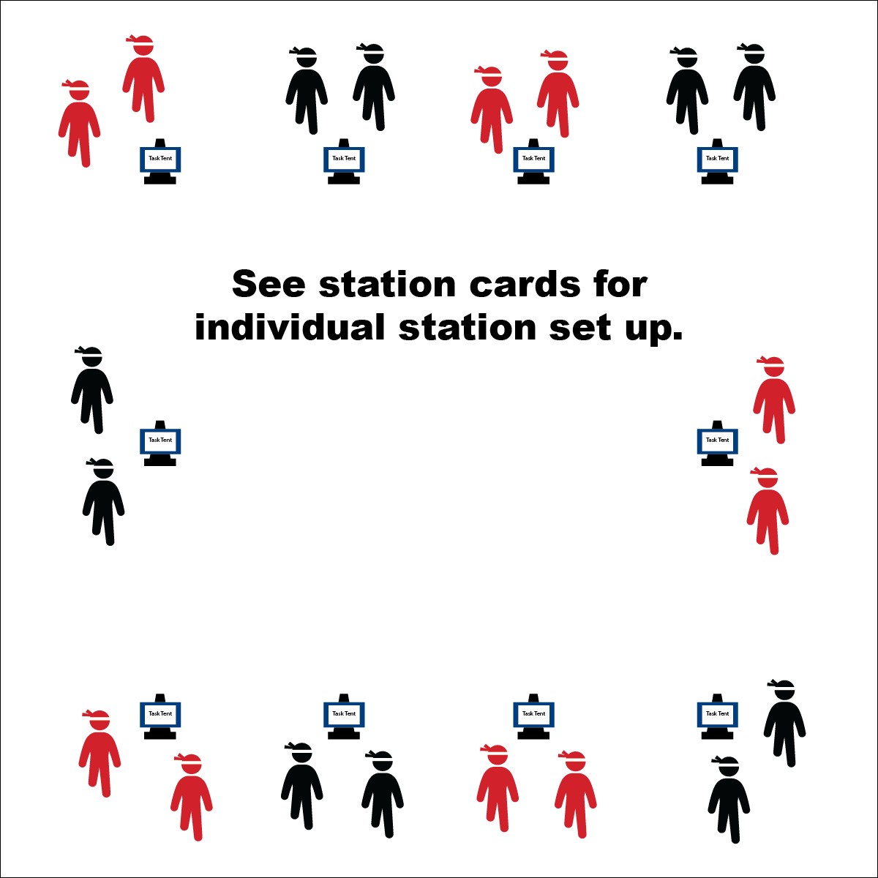

* **Skill:** I will demonstrate components of health- and skill-related fitness while traveling through the Ninja Warrior Hometown Hero Challenge course.
* **Cognitive:** I will discuss skill-related fitness and give examples of when its components are applied in activity.
* **Fitness:** I will find my pulse after each challenge and calculate my heart rate.
* **Personal & Social Responsibility:** I will follow the rules and etiquette of Hometown Hero Challenge stations.
* Focus on the Challenge
* Try Your Best
* Be Heart Healthy

**Equipment:**

* 10 station cards (choose hometown-level cards)
* 10 tall cones
* 10 task tents
* 10 timers/stopwatches
* 24 low-profile cones
* See station cards for equipment needs
* Station music and music player

**Set-Up:**

1. Use low-profile cones to create 10 grids (your number may vary based on the size of your class and the activity area).
2. Use task tents to set station cards on tall cones in each grid.
3. Set up each station according to its station card.
4. Create groups of 2–4 students, each group at a different station.

**Activity Procedures:**

1. Today we will begin training to be a Ninja Warrior. We’ll complete each challenge for 3 (or 4) minutes. The goal of today’s training session is to develop our agility, coordination, and balance.
2. Teacher: Talk through and/or demonstrate each challenge. Emphasize expectations at each challenge station and the importance of working independently with a group/partner.
3. When the music starts, begin working at your station. When it stops, you’ll have 1 minute to clean up the station equipment and rotate to the next station. Wait until the music begins again before you start the activity at the new station.
4. While we’re learning this station format, I’ll pause the music for a longer period of time so that every team is able to clean up their area and rotate.

**Grade Level Progression:**

**3rd–4th:** Complete the challenges as written on the task cards.

**5th:** Time students as they complete the station task as written on the task card. Identify the component of fitness you’re trying to improve, and describe how you feel about their progress at each station.

**HOMETOWN HERO CHALLENGE**

**HOMETOWN HERO CHALLENGE**



Challenging, Cooperate, Grit, Etiquette, Health-Related Fitness, Levels, Pathway, Respect, Skill-Related Fitness, Traverse, Weight Transfer

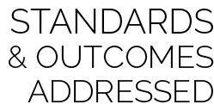

* **Standard** **2 [E3.3-5]** Combines movement concepts (direction, levels, force, time) with skills as directed by the teacher (3); Applies the movement concepts of speed, endurance, and pacing for running (4a); Applies movement concepts to strategy in game situations (5a); Analyzes movement situations and applies movement concepts (e.g., force, direction, speed, pathways, extensions) in small-sided practice task/game environments, dance, and gymnastics (5c).
* **Standard 3 [E2.3-5]** Engages in the activities of physical education class without teacher prompting (3); Actively engages in the activities of physical education class, both teacher-directed and independent (4); Actively engages in all the activities of physical education (5).
* **Standard 4 [E2.3-5]** Works independently for extended periods of time (3); Reflects on personal social behavior in physical activity (4); Participates with responsible personal behavior in a variety of physical activity contexts, environments, and facilities (5a); Exhibits respect for self with appropriate behavior while engaging in physical activity (5b).
* **Standard 4 [E6.3-5]** Works independently and safely in physical activity settings (3); Works safely with peers and equipment in physical activity settings (4); Applies safety principles with age-appropriate physical activities (5).



* **DOK 1:** What is skill-related fitness?
* **DOK 2:** What do you know about skill-related fitness components?
* **DOK 3:** How is skill-related fitness related to becoming a Ninja Warrior?
* **DOK 1:** What would you include on a list about working independently with a group or with a partner?
* **DOK 2:** What do you notice about working with a partner that is different from working independently by yourself?

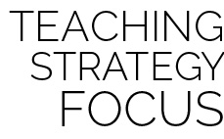

**Organizing students to interact with content:** The use of grids to organize students into learning stations is an effective way to manage activity, assessment, and cooperative learning opportunities. Practice using this format several times, especially with young children, before attempting to facilitate an assessment experience. Students need time to master the management aspects of station work. However, once this routine is learned, it often becomes an essential management tool in physical education.



* Develop modifications to meet your students’ needs. Adapt the equipment or level of complexity of each challenge station.
* Have the students develop their own stations using the equipment after they’ve completed the beginner challenge stations.