­­

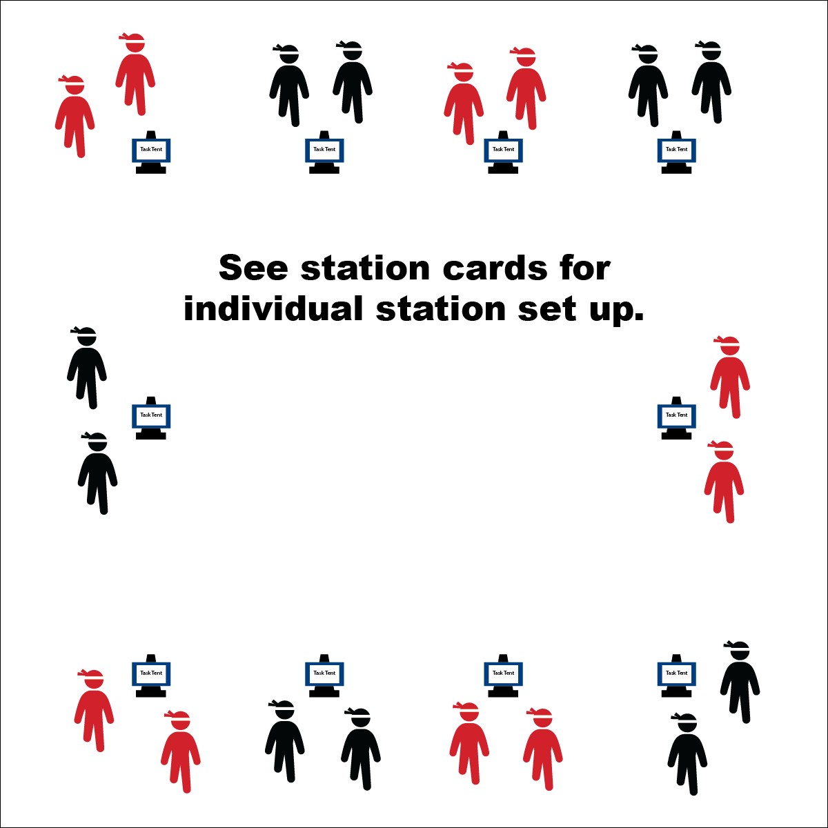

**STUDENT NINJA CHALLENGES**

* **Skill:** I will demonstrate components of health- and skill-related fitness while traveling through the courses.
* **Cognitive:** I will discuss which components of skill-related fitness are tested/developed in the course that I selected.
* **Fitness:** I will find my pulse after each challenge and calculate my heart rate.
* **Personal & Social Responsibility:** I will discuss the positive interactions that I experienced with both peers and adults during the Ninja Warrior module.
* Focus on the Challenge
* Try Your Best
* Be Heart Healthy

**Equipment:**

* 30 station cards (choose hometown-, regional-, and national-level task cards)
* 10 tall cones
* 10 task tents
* 10 timers/stopwatches
* 24 low-profile cones
* See station cards for equipment needs
* Station music and music player

**Set-Up:**

1. Use low profile cones to create 10 grids (your number may vary based on the size of your class and the activity area).
2. Use task tents to set station cards on tall cones in each grid.
3. Set up each station according to its station card.
4. Create groups of 2–4 students, each group at a different station.

**Activity Procedures:**

1. Today, you will choose your level of experience from our Hometown Hero, Regional Warrior, or National Warrior Challenge courses. You can showcase your ninja skills at a pace and challenge level that you’re comfortable with, or you can attempt to complete all three levels in 3 minutes.
2. Teacher: Talk through and/or demonstrate each challenge. Emphasize expectations at each challenge station and the importance of working independently with a group/partner.
3. When the music starts, begin working at your station. When it stops, you’ll have 1 minute to clean up the station equipment and rotate to the next station. Wait until the music begins again before you start the activity at the new station.

**Grade Level Progression:**

**3rd–4th:** Complete the challenges as written on the task cards.

**5th:** Time students as they complete the station task as written on the task card. Identify the component of fitness you’re trying to improve, and describe how you feel about their progress at each station.

**STUDENT NINJA CHALLENGES**



Agility, Challenging, Cooperate, Encouragement, Grit, Health-Related Fitness, Improve, Interaction, Levels, Pathway, Respect, Skill-Related Fitness, Traverse, Weight Transfer



* **Standard** **2 [E3.3-5]** Combines movement concepts (direction, levels, force, time) with skills as directed by the teacher (3); Applies the movement concepts of speed, endurance, and pacing for running (4a); Applies movement concepts to strategy in game situations (5a); Analyzes movement situations and applies movement concepts (e.g., force, direction, speed, pathways, extensions) in small-sided practice task/game environments, dance, and gymnastics (5c).
* **Standard 3 [E3.3-5]** Describes the concept of fitness and provides examples of physical activity to enhance fitness (3); Identifies the components of health-related fitness (4); Differentiates between skill-related and health-related fitness (5).
* **Standard 4 [E2.3-5]** Works independently for extended periods of time (3); Reflects on personal social behavior in physical activity (4); Participates with responsible personal behavior in a variety of physical activity contexts, environments, and facilities (5a); Exhibits respect for self with appropriate behavior while engaging in physical activity (5b).
* **Standard 5 [E4.3-5]** Describes the positive social interactions that come when engaged with others in physical activity (3); Describes/compares the positive social interactions when engaged in partner, small-group, and large-group physical activities (4); Describes the social benefits gained from participating in physical activity (e.g., recess, youth sport) (5).



* **DOK 1:** Which components of skill-related fitness would you put on a list of components tested by the courses you selected?
* **DOK 2:** Why did you choose these courses? What things did you consider as you made your choices?
* **DOK 3:** What other types of decisions do you make each day that have an impact on your health- and skill-related fitness?
* **DOK 1:** How can you recognize a positive interaction?
* **DOK 2:** How do positive interactions affect our enjoyment of physical activity?
* **DOK 3:** What facts or experiences can you select to support the importance of social interaction to physical activity experiences?



**Help students process content:** As students come to the conclusion of the Ninja Warrior module, it’s important to help them reflect on their experience and draw conclusions from what they learned. Focus on student viewpoints and interpretations of what they experienced and guide them through meaningful discussion with their peers. Resist the tendency adults often have to interpret student experience for them.



* Develop station-specific modifications to meet your students’ needs.
* Adapt the equipment or level of complexity of each challenge station.