­­­

­

* Challenging
* Cooperate
* Grit
* Etiquette
* Skill-Related Fitness
* **Skill:** I will demonstrate fitness activities with proper form and attention to safety.
* **Cognitive:** I will discuss the importance of skill-related fitness.
* **Fitness:** I will pace my activity so that I increase my heart rate.
* **Personal & Social Responsibility:** I will follow the rules and etiquette of Hometown Hero Challenge stations.
* **Standard** **1 [E1.3-5]** Uses various locomotor skills in a variety of small-sided practice tasks, dance, and educational gymnastics experiences (4); Demonstrates mature patterns of locomotor skills in dynamic small-sided practice tasks, gymnastics, and dance.
* **Standard** **2 [E3.3-5]** Combines movement concepts (direction, levels, force, time) with skills as directed by the teacher (3); Applies the movement concepts of speed, endurance, and pacing for running (4a); Applies movement concepts to strategy in game situations (5a); Analyzes movement situations and applies movement concepts (e.g., force, direction, speed, pathways, extensions) in small-sided practice task/game environments (5c).
* **Standard 3 [E2.3-5]** Engages in the activities of physical education class without teacher prompting (3); Actively engages in the activities of physical education class, both teacher-directed and independent (4); Actively engages in all the activities of physical education (5).
* **Standard 4 [E5.3-5]** Recognizes the role of rules and etiquette in physical activity with peers (3); Exhibits etiquette and adherence to rules in a variety of physical activities (4); Critiques the etiquette involved in rules of various game activities (5).
* DOK Questions, Rubric, Self-Assessment

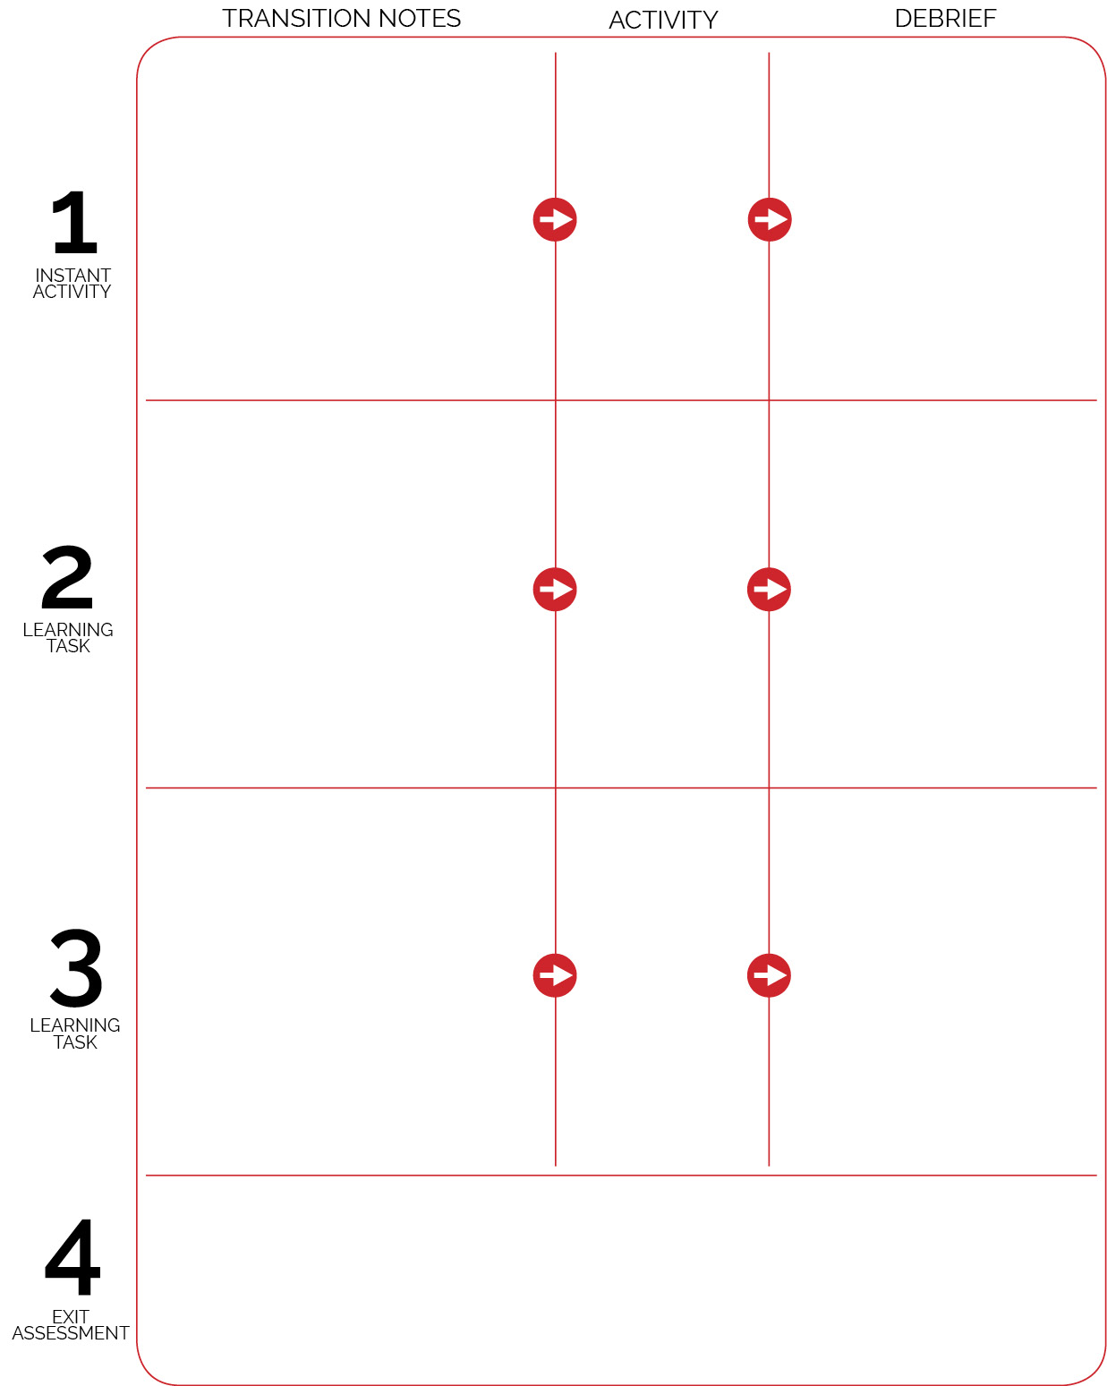

Discuss Training Tag DOK questions. Student equipment leaders quickly set up Tabata stations while each student gets a resistance band. Group students around cones/Tabata cards. Begin Tabata music.

Discuss rubric criteria at the end of class. Students then have 5 minutes to complete the self-assessment for Agility, Chase, and Flee.

Activity area is set up for Training Tag. Tabata cards and resistance bands are in each of the gym’s 4 corners, safely out of the way. Hometown Hero cards/equipment sets are organized on 1 end of the gym, safely out of the way. Students enter the gym and read/discuss DOK questions posted on wall. Begin tag game when all arrive and are ready.

**DOK 1:** What would you include on a list about working independently with a group or with a partner?

**DOK 2:** What do you notice about working with a partner that is different from working independently by yourself?

**DOK 1:** What would you include on a list about exercise warm-up routines?

**DOK 2:** How should we apply warm-up routines in physical education?

**DOK 3:** How is warming up related to safety?

**DOK 1:** What is skill-related fitness?

**DOK 2:** What do you know about skill-related fitness?

Hometown Hero Challenge

Ninja Warrior Tabata

Ninja Warrior Training Tag

Discuss Tabata DOK questions. Student equipment leaders coordinate equipment change. Introduce and demonstrate Hometown Hero Challenge.