­­

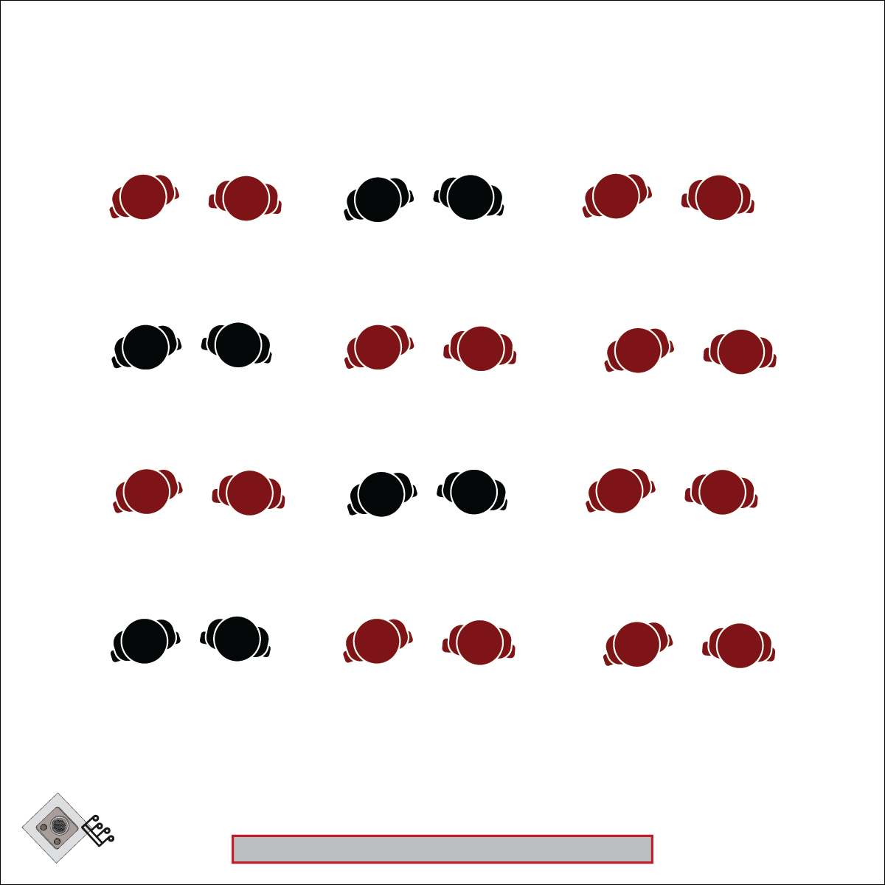

**SAMOA SASA**

* **Skill:** I will demonstrate the movements of this dance with the correct rhythm and in the correct pattern.
* **Cognitive:** I will identify the cultural significance of the movements as I learn them.
* **Fitness:** I will try to stay actively engaged while I perform this dance.
* **Personal & Social Responsibility:** I will use this activity to learn something new about a classmate.
* Verbal Choreography Cues: Pati, Po, Flick, Snap
* Listen and Count with the Beat

**Equipment:**

* Music player and 1 of the following songs:
  + *The Bongo Song* by Safri Duo ([iTunes](https://itunes.apple.com/us/album/played-a-live-the-bongo-song/87047?i=87026))
  + *Watsui Warrior Drums* by Van Kampen [(iTunes](https://itunes.apple.com/cy/album/watusi-warrior-drums/170876883?i=170881397))
  + *On The Drums (Sascha Krohn Remix)* by Eric Sneo ([iTunes](https://itunes.apple.com/bs/album/on-the-drums-single/128297482))
* Alternatively, use a hand drum and keep a steady beat for the students.
* Samoa Sasa Choreo Cards
* Samoa Sasa Activity Card ([YouTube](https://youtu.be/tFIxb8_oGX8))

**Set-Up:**

1. Activity 1: Students are seated cross-legged next to a partner or in a group.
2. Activity 2: Students are seated cross-legged in even rows.
3. Display dance patterns on a wall or projector screen for students to follow.

**Activity Procedures:**

1. Today’s activity is called Samoa Sasa. We will use this dance to focus on the “E” element of dance: Energy.
2. A Sasa is a group dance that uses hands movements, such as claps and gentle slaps, and can be performed sitting or standing.
3. The hand movements in this dance are used to show aspects of everyday life. This dance is quite fast and accompanied by rapid drumming and singing.
4. Teachers: Use the Samoan Sasa Choreo Cards to teach the movements of this dance, and then use the Samoa Sasa Activity Card to teach the full routine.

**Grade Level Progression:**

**6th:** Try this activity by just teaching the hand movements of the dance.

**7th & 8th:** Perform the activity as described above.

**SAMOA SASA**



Action, Beat, Choreography, Cues, Polynesian, Dance, Culture, 8-count

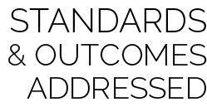

* **Standard 1 [M1.6-8]** Demonstrates correct rhythm and pattern for one of the following dance forms: folk, social, creative, line, or world dance (6); Demonstrates correct rhythm and pattern for a different dance form from among folk, social, creative, line, and world dance (7); Exhibits command of rhythm and timing by creating a movement sequence to music as an individual or in a group (8).
* **Standard 4 [M4.6-8]** Accepts differences among classmates in physical development, maturation, and varying skill levels by providing encouragement and positive feedback (6); Demonstrates cooperation skills by establishing rules and guidelines for resolving conflicts (7); Responds appropriately to participants’ ethical and unethical behavior during physical activity by using rules and guidelines for resolving conflicts (8).

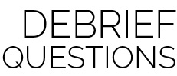

* **DOK** **1:** What were the different movements we performed in this dance called?
* **DOK 2:** How did the number and sequence of the movements affect our performance of the dance?
* **DOK 3:** What importance do you think this dance has to the cultures that learn, practice, and perform it?

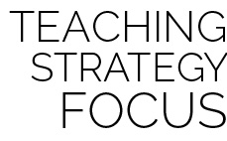

**Dance Strategy:** When teaching cultural dances, it is important to provide context. Read the excerpt in [the link provided](http://users.rowan.edu/~conet/rhythms/CulturalDances/samoansasa.html) and use it to talk to students about the cultural significance of and meaning behind the movements. As students learn and successfully perform the steps, add additional movements that provide a richer story. Using cue cards or projecting the steps can help students see what is coming next and anticipate that movement. Begin by teaching the dance slowly, piece by piece. Add music and additional steps as you observe that the students are ready.



* Pair students together to practice each movement pattern with a peer coach.
* Provide a video demonstration in slow motion and in real time.