­­­

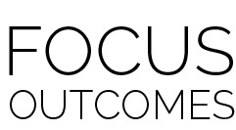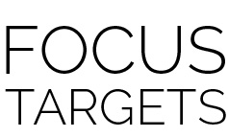­

* Holistic Performance Rubric
* Academic Language Quiz
* Action, Beat, Choreography, Cues, Dance, 8-Count, Grapevine, Locomotor Skills, Non-Locomotor Skills, Pivot
* **Skill:** I will perform movements with the beat and tempo of music in a 1-wall or 4-wall dance.
* **Cognitive:** I will perform the order and sequence of the dance from memory.
* **Fitness:** I will increase and sustain my heart rate for the duration of the dance.
* **Personal & Social Responsibility:** I will demonstrate perseverance and share the dance space with those around me.
* **Standard 1 [M1.6-8]** Demonstrates correct rhythm and pattern for one of the following dance forms: folk, social, creative, line, or world dance (6); Demonstrates correct rhythm and pattern for a different dance form from among folk, social, creative, line, and world dance (7); Exhibits command of rhythm and timing by creating a movement sequence to music as an individual or in a group (8).
* **Standard 3 [M5.6-8]** Participates in a variety of lifetime recreational team sports, outdoor pursuits, or dance activities (6); Participates in a variety of lifetime dual and individual sports, martial arts, or aquatic activities (7); Participates in a self-selected lifetime sport, dance, aquatic, or outdoor activity outside of the school day (8).
* **Standard 4 [M1.6-8]** Exhibits personal responsibility by using appropriate etiquette, demonstrating respect for facilities, and exhibiting safe behaviors (6); Exhibits responsible social behaviors by cooperating with classmates, demonstrating inclusive behaviors, and supporting classmates (7); Accepts responsibility for improving one’s own levels of physical activity and fitness (8).

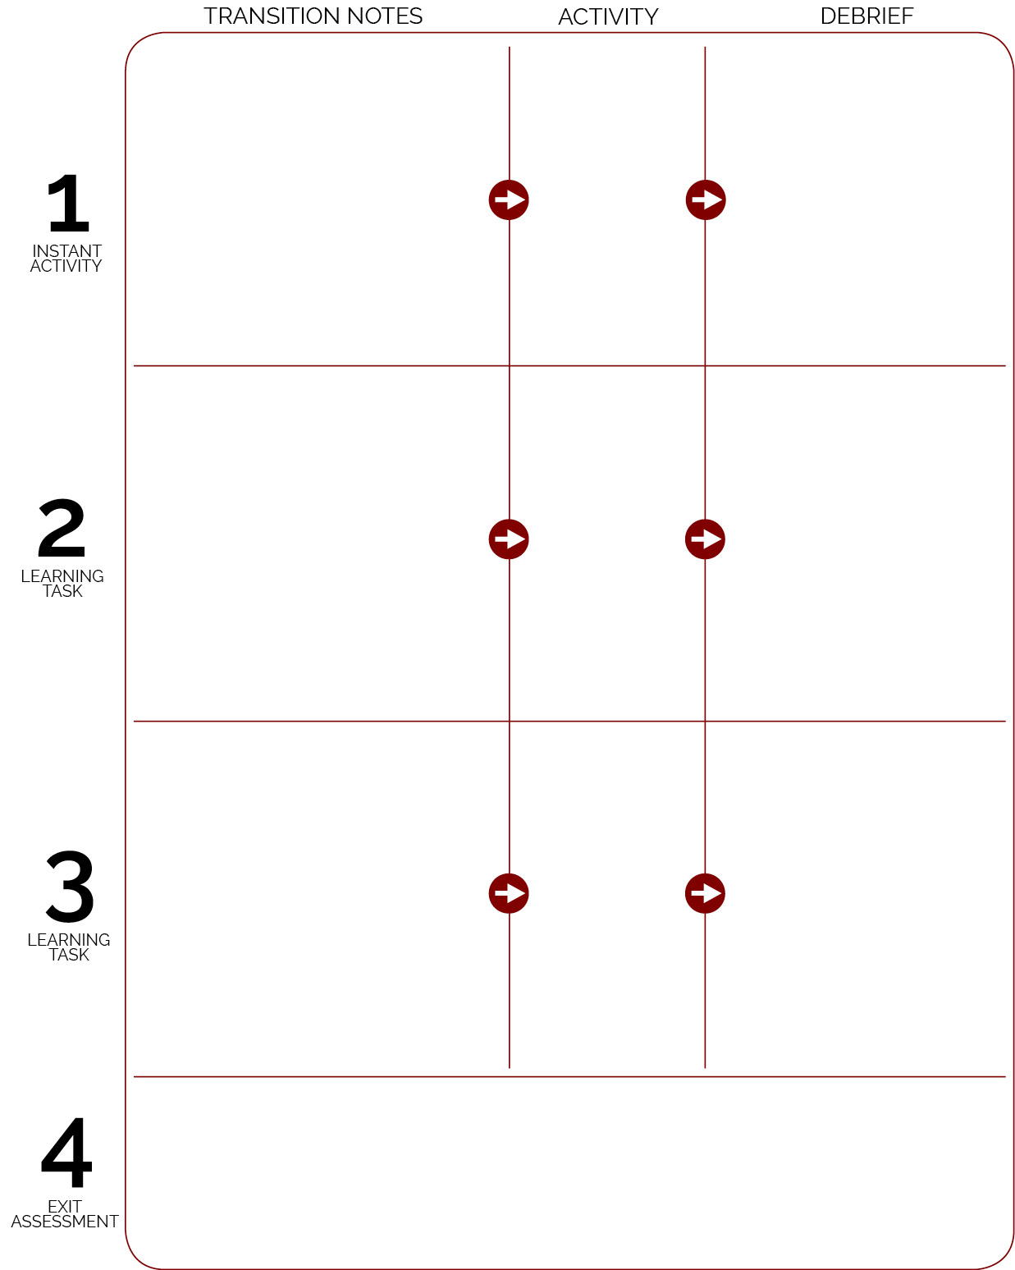

* Review Holistic Performance Rubric for the Crazy Bird Dance
* Debrief with DOK questions

Introduce the 4-wall dance definition. Walk through the steps on the activity card without the music. Then introduce the music when students have had a chance to practice each part. As the class progresses, students can replace the teacher as the lead.

Play the Crazy Bird music and prompt students to practice counting 8-counts to the beat. Then learn the steps in a 1-wall direction. Allow students to follow the teacher/video instruction in a way that is appropriate and safe within their personal space.

Music is playing as students enter the activity area. Prompt students to bounce to the music as they read the academic language words for the day. When all students are present, scatter in open space and face the teacher for instruction.

Cones are set up for Safety Dance.

Safety Dance

Crazy Bird;

teacher leads 4-wall dance step

Crazy Bird introduction; 8-count practice with choreography

**DOK 1:** How can you recognize whether a dance or activity will elevate your heart rate?

**DOK 2:** How can the tempo of the music affect your heart rate?

**DOK 3:** How might you change this game to make it more (or less) vigorous?

**DOK 1:** What was the choreography we used to perform this dance?

**DOK 2:** How does the sequence of the choreography affect how the dance is performed?

**DOK 3:** Does proficiency of dance performance have any effect on the social dynamics of a class or event?