­­­­­



* Follow Exercise Cues
* Listen for Start/Stop Signals
* Maintain a Warm-Up Exercise Intensity Level

**Equipment:**

* 12 cones
* 12 task tents
* Coach D’s FITTness Warm-Up Cards

**Set-Up:**

1. Use cones and task tents to designate 6 lines for student activity. Each line is a different activity. *(Tip: If you use a basketball court, use each baseline as 2 of your lines and space the other 4 evenly across the court.)*
2. Place FITTness Cards in task tents.
3. Create groups of 6. Each member in a group is on a different activity line, creating a team line that is perpendicular to the activity lines.

* **Skill:** I will demonstrate fitness activities with proper form and attention to safety.
* **Cognitive:** I will identify and discuss each of the components of the FITT formula.
* **Fitness:** I will complete the FITT formula activity log to plan for and track my physical activity.
* **Personal & Social Responsibility:** I will stay focused on safe and appropriate participation while working cooperatively with my classmates.

**COACH D’S FITTNESS WARM-UP**

**Activity Procedures:**

1. Today’s activity is called Coach D’s FITTness Warm-Up. You will work together with your team to rotate through and complete Coach D’s FITTness routine. (Teachers: Take a few minutes to introduce or review each component of the FITT formula.)
2. When the music starts, everyone will begin the appropriate exercise and continue for 40 seconds. Then the music will stop, and everyone will have 10 seconds to move forward to the next line. If you are in the front line, pick a sideline and jog safely down to get back to the other baseline. We will continue until everyone has completed all the activities.
3. After our warm-up, we’ll take a few minutes to complete the FITT formula activity log.

**Grade Level Progression:**

**6th–7th:** Play the activity as described above.

**8th:** Allow students to create their own FITTness routines using the blank FITTness Routine Cards. For each exercise, students will identify a component of health-related fitness to focus on.

**COACH D’S FITTNESS WARM-UP**



**Help students process content.** The debrief questions above will help students to begin thinking about how the FITT formula and overload principle apply to fitness as a general concept. In order to truly help students to process this information and apply it to their personal experience, use the FITT Formula Activity Log and then take time to review the questions and content in order to stimulate further discussion.



* **DOK** **1:** What are the 4 components of the FITT formula?
* **DOK 2:** What do you know about the overload principle?
* **DOK 3:** How is the overload principle related to the FITT formula?
* **DOK 4:** Complete the FITT Formula Activity Log and create a plan to apply the overload principle to your physical activity routine.

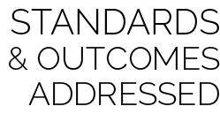

* **Standard** **3 [M7.6-8]** Identifies the components of skill-related fitness (6); Distinguishes between health-related and skill-related fitness (7); Compares and contrasts health-related fitness components (8).
* **Standard 3 [M6.6-8]** Participates in moderate to vigorous aerobic physical activity that includes intermittent or continuous aerobic physical activity of both moderate and vigorous intensity for at least 60 minutes per day (6); Participates in moderate to vigorous muscle- and bone-strengthening physical activity at least three times a week (7); Participates in moderate to vigorous aerobic and/or muscle- and bone-strengthening physical activity for at least 60 minutes per day at least five times a week (8).
* **Standard 4 [M7.6-8]** Uses physical activity and fitness equipment appropriately and safely, with the teacher’s guidance (6); Independently uses physical activity and exercise equipment appropriately and safely (7); Independently uses physical activity and fitness equipment appropriately and identifies specific safety concerns associated with the activity (8).



Health-Related Fitness, Skill-Related Fitness, Frequency, Intensity, Time, Type, FITT Formula, Overload Principle, Physical Activity, Moderate, Vigorous



* Modify routine cards and exercises to meet the needs of all students.
* Decrease the intensity of this activity by providing a longer rest interval.

**EMOTIONAL HEALTH WARM-UP**

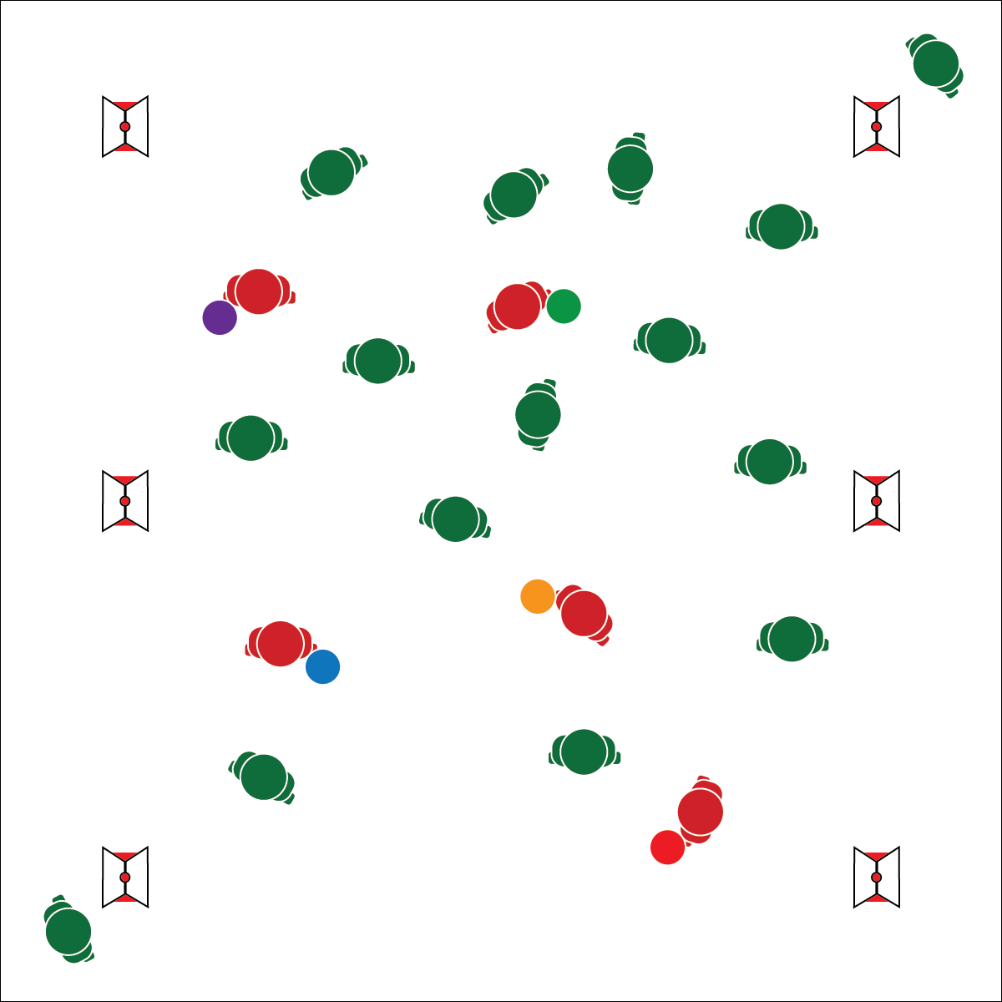

**Activity Procedures:**

1. Today’s activity is called Emotional Health Tag. Physical activity and exercise are great ways to release stress and improve overall emotional health. Plus, warming up before vigorous activity helps you prevent injury and perform your best.
2. The object of this activity is to avoid being tagged while taggers try to tag you with a Tuff Ball. Taggers may not throw the ball.
3. When I say “GO!” begin playing at a speed-walking pace. Taggers will do 10 jumping jacks to give everyone else time to spread out. Notice that each Tuff Ball has an emoji face and color. The activity cards provide information that match the emoji.
4. If you are tagged, move to the cone that matches the color of the ball you were tagged with and perform the dynamic warm-up exercise on the card. Once you have completed the activity, re-enter the game.
5. Freeze when you hear the stop signal and we’ll change taggers.

**Grade Level Progression:**

**6th:**Play the activity as described above.

**7th:**Allow students to choose from a collection of activity cards to be used as re-entry stations.

**8th:**Give students time to create activity cards to be used as re-entry stations. As a class, develop cool-down routines with dynamic and static stretches to be used at the end of class.

* Move at a Safe Pace
* Watch Where You Are Going
* Taggers: Tag with Tuff Balls, Shoulders Only, No Throwing

**Equipment:**

* 4–6 Face ‘Em Tuff Balls (or colored foam balls)
* 4–6 cones
* 4–6 task tents
* 4–6 Emotional Health Activity Cards

**Set-Up:**

1. Create boundaries by placing cones and task tents around the perimeter of a large activity area.
2. Scatter students in the activity area.
3. Give Face ‘Em Tuff Balls to 4–6 students to identify them as taggers.

* **Skill:** I will perform each dynamic warm-up exercise safely and with correct form.
* **Cognitive:** I will define emotional health and discuss ways to enhance personal emotional health.
* **Fitness:** I will participate in (and/or design) a warm-up routine that prepares my heart and muscles for movement.
* **Personal & Social Responsibility:** I will discuss the connections between personal fitness and  
  emotional health.



* Use balloons (or other object) instead of foam balls and draw emojis before playing.
* Create activity cards based on student needs and abilities.

**EMOTIONAL HEALTH WARM-UP**



* **Standard** **3 [M12.6-8]** Describes the role of warm-ups and cool-downs before and after physical activity (6); Designs a warm-up/cool-down regimen for a self-selected physical activity (7); Designs and implements a warm-up/cool-down regimen for a self-selected physical activity (8).
* **Standard 3 [M18.6-8]** Identifies positive and negative results of stress and appropriate ways of dealing with each (6); Practices strategies for dealing with stress, such as deep breathing, guided visualization, and aerobic exercise (7); Demonstrates basic movements used in other stress-reducing activities such as yoga and Tai Chi (8).
* **Standard 5 [M2.6-8]** Identifies components of physical activity that provide opportunities for reducing stress and for social interaction (6); Identifies positive mental and emotional aspects of participating in a variety of physical activities (7); Analyzes the empowering consequences of being physical active (8).



Cool-Down, Design, Emotional Fitness, Fitness Planning, Stress, Warm-Up



* **DOK** **1:** What would you include on a list about warm-ups and cool-downs?
* **DOK 2:** How would you apply warm-ups and cool-downs in personal fitness planning?
* **DOK 1:** What is emotional health?
* **DOK 2:** How does physical activity affect emotional health?
* **DOK 3:** What personal experiences would you select to support physical activity’s effect on emotional health? Can you elaborate on why you chose that experience?



**Help students elaborate on content.** In order to understand how to apply acquired fitness knowledge to personal warm-up and cool-down routines, students must first understand the importance of each. This is also true as students learn how physical activity can improve personal emotional health. Help students make inferences about the information that they’ve learned in class and ask them to provide support for their inferences. Then, in the activities that follow throughout this module, prompt students to apply their understanding to enhance personal fitness planning and physical activity routines.

**AMRAP TEAMWORK**

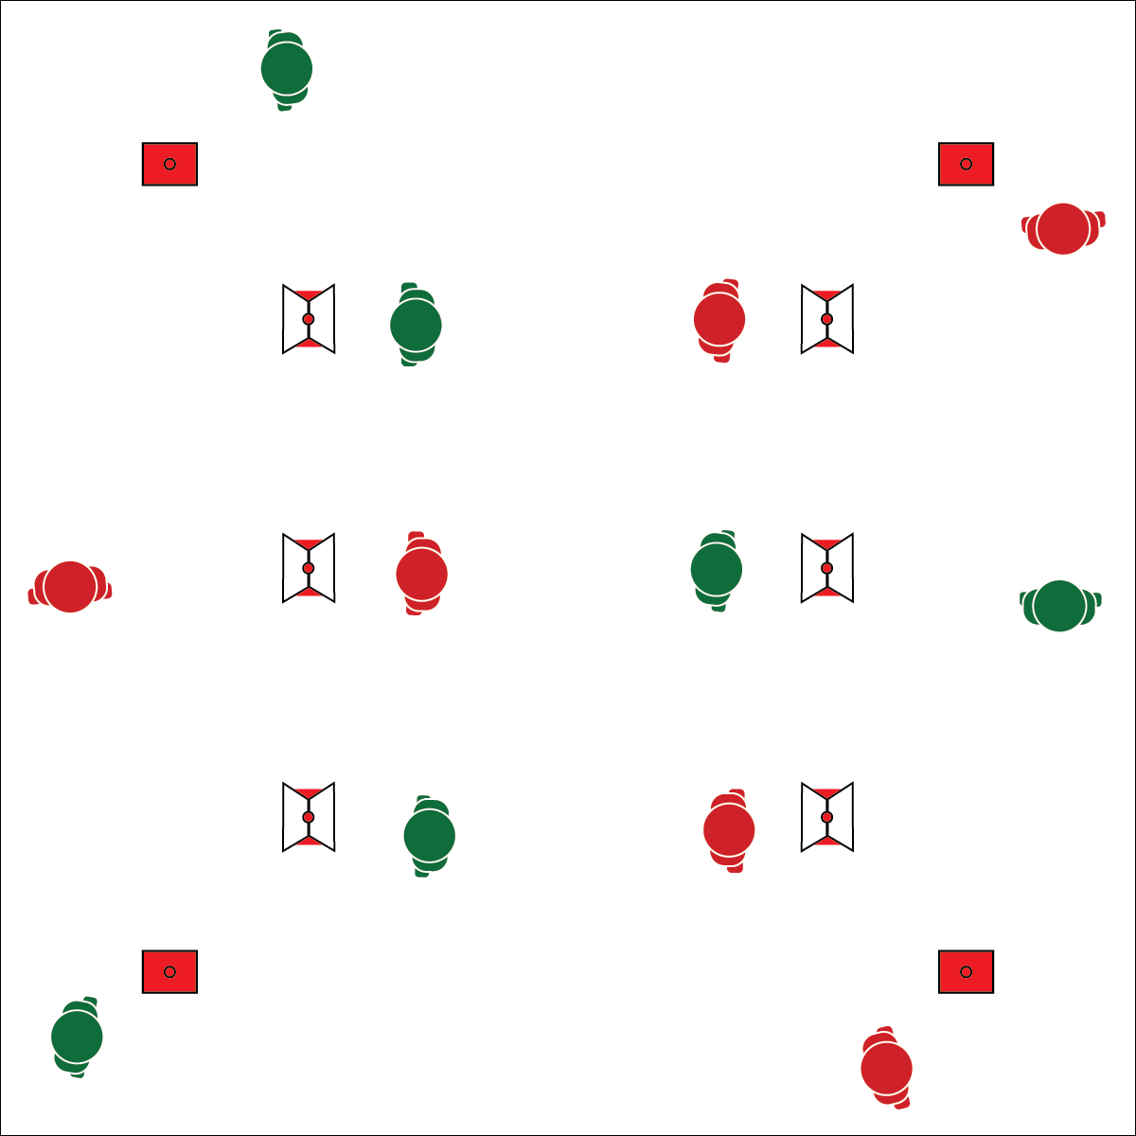

**Activity Procedures:**

1. Today’s activity is called AMRAP Teamwork. The object is to work in your target heart rate zone and complete each AMRAP station. You will also identify the components of fitness related to each station.
2. Before we begin, let’s calculate our resting heart rate. As you exercise, your heart rate will increase, and you will move up the Borg Rating of Perceived Exertion (RPE) Scale. Your goal is to work within levels 4 through 8 in order to reach the “heart health” target heart rate zone.
3. AMRAP stands for *as many reps as possible*. During each 45 second interval, you and your partner will complete as many reps of your exercise as you can.
4. On the start signal, partner 1 will jog around the outside of the coned area, completing as many laps as possible. Partner 2 will work at an AMRAP station to complete the 1st exercise on the station sign.
5. After 45 seconds, on the change signal, you’ll have 15 seconds to reverse roles with your partner.

**Grade Level Progression:**

**6th:** Review the definition of resting heart rate and have students check their heart rate after the activity has been completed. Then have them choose an RPE level and discuss.

**7th:** Discuss ways to modify exercises to increase intensity and move students higher on the RPE scale.

**8th:** Use heart rate monitors and prompt students to adjust their exercise intensity in order to stay in the heart health heart rate zone.

* Focus on Form
* Constant Pacing
* Controlled Breathing
* Think Safety
* **Skill:** I will pace my exercise intensity to work within my target heart rate zone.
* **Cognitive:** I will compare my heart rate with my rate of perceived exertion (RPE) and discuss how this relates to exercise intensity.
* **Fitness:** I will identify the component of fitness related to each station activity.
* **Personal & Social Responsibility: I** will  
  participate safely with a focus on exercise form  
  and injury prevention.

**Equipment:**

* 10+ cones
* 6+ task tents
* 6+ AMRAP Teamwork Station Signs
* 6+ AMRAP Task Cards

**Set-Up:**

1. Use 4 cones to create a large running track for student laps.
2. Use 6+ cones and task tents to create AMRAP teamwork workout stations. Choose exercises that work on different components of either health- or skill-related fitness.
3. Students in pairs or small groups around the perimeter of the running track.

**AMRAP TEAMWORK**





* Modify AMRAP Task Cards and exercises to meet the needs of all students.
* Decrease the intensity of this activity by providing a longer rest interval.



AMRAP, Borg Rating of Perceived Exertion (RPE) Scale, Health-Related Fitness, Heart Rate Monitor, Heart Rate Zones, Intensity, Resting Heart rate, Skill-Related Fitness



* **Standard 1 [M25.6-8]** Demonstrates correct technique for basic skills in one self-selected individual-performance activity (6).
* **Standard** **3 [M7.6-8]** Identifies the components of skill-related fitness (6); Distinguishes between health-related and skill-related fitness (7); Compares and contrasts health-related fitness components (8).
* **Standard 3 [M13.6-8]** Defines resting heart rate (RHR) and describes its relationship to aerobic fitness and the Borg Rating of Perceived Exertion (RPE) Scale (6); Defines how the RPE Scale can be used to determine the perception of the work effort or intensity of exercise (7); Defines how the RPE Scale can be used to adjust workout intensity during physical activity (8).
* **Standard 5 [M3.6-8]** Recognizes individual challenges and copes in a positive way, such as extending effort, asking for help/feedback, and/or modifying the tasks (6); Generates positive strategies such as offering suggestions/assistance, leading/following others, and/or providing possible solutions when faced with a group challenge (7); Develops a plan of action and makes appropriate decisions based on that plan when faced with an individual challenge (8).



* **DOK 1:** What is perceived exertion?
* **DOK 2:** What do you know about the different levels of perceived exertion? (RPE Scale 1–10)
* **DOK 3:** How is perceived exertion related to exercise intensity and heart rate?
* **DOK 4:** Using information from the Perceived Exertion Chart, analyze your effort and intensity during AMRAP Teamwork.



**Identify critical content:** Working to meet student outcomes and identifying critical content from sets of national and state outcomes are the first steps in backward-design planning. As students progress through their academic careers, the complexity of critical content increases. Perceived exertion is a complex fitness concept that students can experience and understand as their bodies respond to physical activity of different intensity levels. This is an important strategy for personalizing fitness education and helping students find relevance in complex concepts taught in the physical education classroom.

**CUPID FITNESS CAPACITY SHUFFLE**

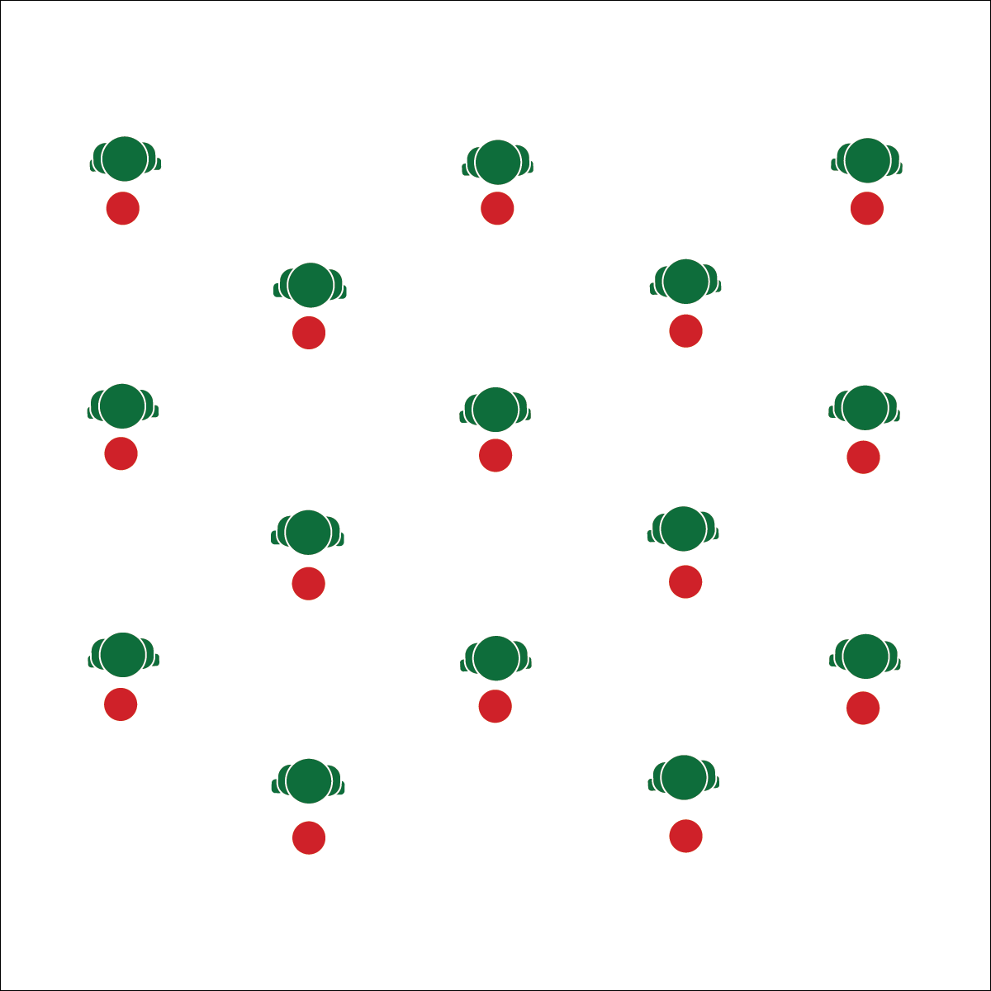

**Activity Procedures:**

1. Today’s activity is called the Cupid Fitness Capacity Shuffle. We’re going the test our aerobic and anaerobic capacity. The object of the activity is to complete the Cupid Shuffle using aerobic and anaerobic movements in order to feel our body’s physiological response.
2. First, we’ll practice the Cupid Shuffle to learn the basic dance steps. Next, we’ll use the Aerobic Capacity and Anaerobic Capacity Task Cards to increase our heart rates and test our energy systems.
3. 1 version of the dance is designed to be an aerobic activity. The other version is designed be an anaerobic activity. We’ll use heart rate monitors to track which zone we’re working in (optional).
4. Teachers: Allow students to rehydrate as needed and carefully note their perceived level of exertion.
5. At the end of the lesson, we will discuss how our bodies reacted to each performance.

**Grade Level Progression:**

**6th:** Complete both versions of the dance and discuss RPE.

**7th:** Complete the both versions of dance and then approximate the calorie burn from the activity. Next, compare calorie burn to the calories in various snacks.

**8th:** Compete both versions of the dance in 2 consecutive classes. First, students will use heart rate monitors to adjust workout intensity. Next, they will use monitors to track average heart rate, but they won’t look at them during the activity. Instead, use RPE to adjust intensity.

* Stay in Personal Space
* Safely Push Your Limits
* Rehydrate

**Equipment:**

* Cupid Shuffle Song ([iTunes](https://itunes.apple.com/us/album/cupid-shuffle/263058619?i=263059061))
* 1 spot marker per student
* 1 Cupid Anaerobic Capacity Task Card
* 1 Cupid Aerobic Capacity Task Card

**Set-Up:**

1. Scatter spot markers in a large activity area. Each student at a spot.
2. Be sure all students have enough space to complete the movements safely.

* **Skill:** I will maintain proper body alignment while performing fitness activities.
* **Cognitive:** I will discuss the difference between aerobic and anaerobic exercise.
* **Fitness:** I will monitor my heart rate while performing aerobic and anaerobic exercise.
* **Personal & Social Responsibility: I** will participate safely with attention to exercise form and injury prevention.

**CUPID FITNESS CAPACITY SHUFFLE**





* **DOK** **1:** What is aerobic capacity? What is anaerobic capacity?
* **DOK 2:** How does each type of activity affect how long you can perform a specific exercise?
* **DOK 3:** How is each type of activity related to rate of perceived exertion (RPE)?
* **DOK 4:** Using information gathered from your heart rate monitor, analyze your ability to pace your activity using only perceived exertion.



* **Standard** **3 [M10.6-8]** Differentiates between aerobic and anaerobic capacity, and muscle strength and endurance (6); Describes the role of exercise and nutrition in weight management (7).
* **Standard 3 [M13.6-8]** Defines resting heart rate (RHR) and describes its relationship to aerobic fitness and the Borg Rating of Perceived Exertion (RPE) Scale (6); Defines how the RPE Scale can be used to determine the perception of the work effort or intensity of exercise (7); Defines how the RPE Scale can be used to adjust workout intensity during physical activity (8).



Aerobic, Aerobic Capacity, Anaerobic, Energy Systems, Pace, Prevention, Lactic Acid, Rate Perceived Exertion (RPE), Weight Management



* Modify both versions of this dance to meet the needs of all students.
* Focus only on aerobic steps as students become comfortable and understand RPE.
* Extension: Prompts students to take another popular party dance and develop their own progression that shows aerobic and anaerobic capacity.



**Help students practice skills, strategies, and processes.** Each year, personal fitness devices generate billions of dollars in revenue in the home fitness market. Exploring the functionality of these devices is a critical part of modern physical education instruction. By using heart rate monitoring systems as a part of the physical education classroom, you’re helping students practice the skills and strategies commonly used for personal fitness assessment and motivation.

**TABATA TO IMPROVE**

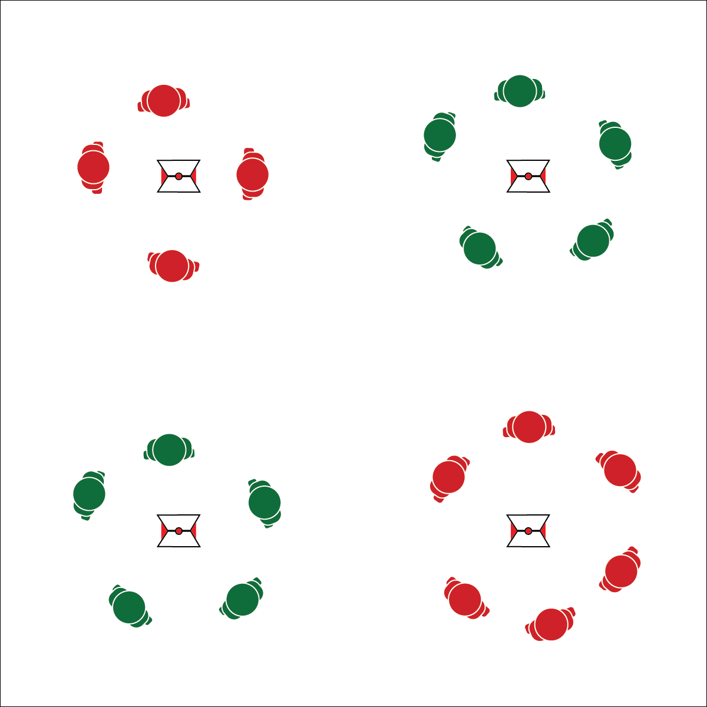

**Equipment:**

* 4 cones
* 4 task tents
* Tabata to Improve Station Cards
* Blank Tabata Station Cards (optional)
* Tabata audio cues (Tabata timer app)
* Heart rate monitors (optional)

**Set-Up:**

1. Create 4 stations using cones, task tents, and Tabata Station Cards.
2. Place station cards in task tents on cones.
3. Distribute station equipment (if any) at spots.
4. Allow students to choose which station they’d like to begin.

* Follow Exercise Cues
* Focus on Safety
* Listen for Start/Stop Signals
* Rotate Quickly
* **Skill:** I will perform fitness exercises with proper form and a focus on safety.
* **Cognitive:** I will choose fitness activities in order to maintain or improve my overall level of fitness.
* **Fitness:** I will use a heart rate monitor to track and adjust exercise intensity so that I am working in my target zone.
* **Personal & Social Responsibility:** I will work independently and with consideration for others.

**Activity Procedures:**

1. Today’s activity is Tabata to Improve – Tabata-style training with a focus on improving areas of fitness not in the Healthy Fitness Zone. For example, you’ll work on upper body muscular strength and endurance if your push-up score is not in the healthy fitness zone.
2. Tabata training was created by a Japanese scientist named Dr. Izumi Tabata. True Tabata workouts combine 20 seconds of vigorous activity with 10 seconds of rest. Dr. Tabata’s research showed that even 4-minute workouts using his timing formula can have positive results on a person’s overall fitness.
3. There are 4 stations, and each one corresponds with a fitness testing category. You can choose which station to work at for each 4-minute Tabata routine. After each routine, choose a new station for the next one. The full workout will be 16 minutes. Pace your activity to stay in your target heart rate zone.
4. Listen for the audio cues to start and stop your activity and rest intervals.

**Grade Level Progression:**

**6th:** Play the activity as described above.

**7th–8th:** Allow students to create custom Tabata to Improve Station Cards based on personal fitness test results and improvement plan.

**TABATA TO IMPROVE**





* **Standard** **3 [M8.6-8]** Sets and monitors a self-selected physical activity goal for aerobic and/or muscle- and bone-strengthening activity based on current fitness level (6); Adjusts physical activity based on quantity of exercise needed for a minimal health standard and/or optimal functioning based on current fitness level (7); Uses available technology to self-monitor quantity of exercise needed for a minimal health standard and/or optimal functioning based on current fitness level (8).
* **Standard 3 [M15.6-8]** Designs and implements a program of remediation for any areas of weakness based on the results of health-related fitness assessment (6); Designs and implements a program of remediation for two areas of weakness based on the results of health-related fitness assessment (7); Designs and implements a program of remediation for three areas of weakness based on the results of health-related fitness assessment (8).
* **Standard 5 [M1.6-8]** Describes how being physically active leads to a healthy body (6); Identifies different types of physical activities and describes how each exerts a positive impact on health (7); Identifies the five components of health-related fitness (muscle strength, muscle endurance, flexibility, cardiovascular endurance, and body composition) and explains the connections between fitness and overall physical and mental health (8).



* **DOK 1:** What is the Healthy Fitness Zone (HFZ)?
* **DOK 2:** What do you know about improving fitness scores that are not in the HFZ? What do you know about maintaining scores that are in the HFZ?
* **DOK 3:** How would you adapt an exercise that we did today so that it works to improve more than one fitness testing category?
* **DOK 4:** Analyze the consequences of past behavior with respect to lifestyle and physical activity. How have your choices and behaviors either enhanced or hindered your level of fitness? Why?



**Help students elaborate on content:** The debrief question set above requires students to make inferences about the information presented in class as it relates to prior experiences and past behavior. Allow students to explore these inferences through focused discussion, prompting them to give evidence and context to support their thinking.



Aerobic Capacity, Abdominal Strength and Endurance, Fitness, Flexibility, Healthy Fitness Zone, Heart Rate Monitor, Improve, Interval, Maintain, Tabata, Upper Body Strength and Endurance



* Adjust the duration of work and rest intervals to meet the needs of your students.
* Provide modifications at each station and allow students to work at a level of their choice.

**STRETCH ARM STRONG**

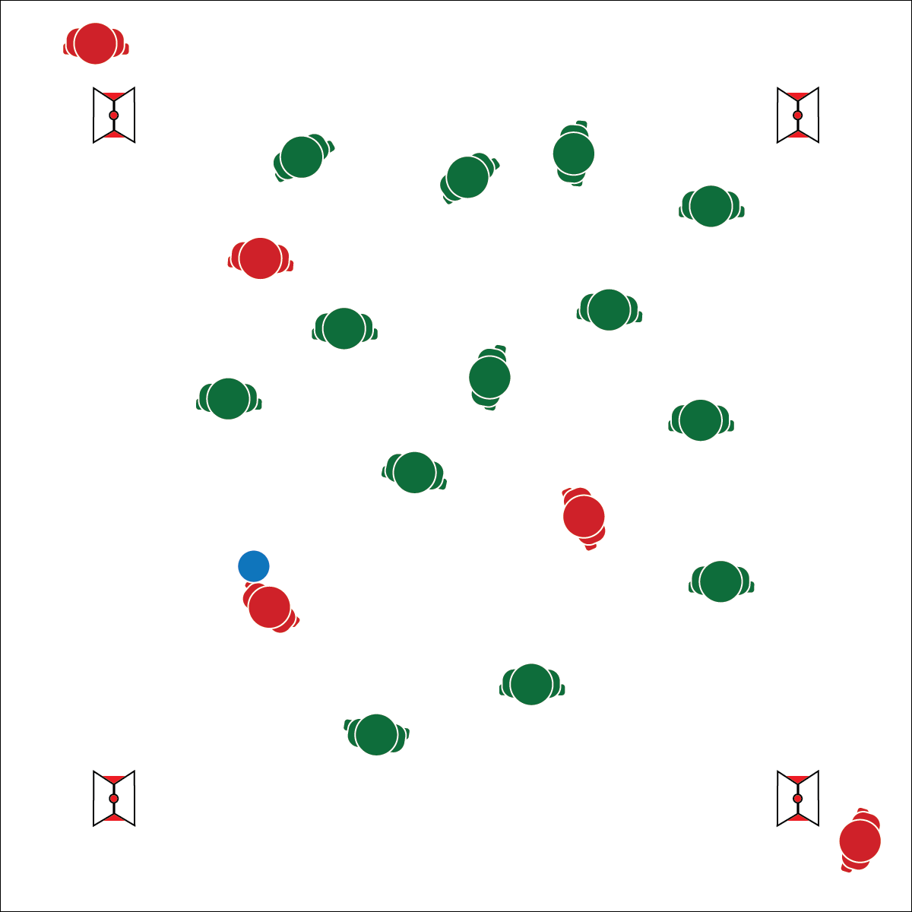

**Activity Procedures:**

1. Today we’re going to warm up with a fast-paced game of Stretch Arm Strong.
2. The object of the game is for the Super Stretch Student to build an army by tagging other players with the foam ball. Once tagged, players will find a Stretch Arm Strong Task Card, perform all dynamic stretches on the card, and then reenter the game as a member of the Stretch Arm Strong Army.
3. The Super Stretch Student can pass the ball to new teammates in order to quickly gain an advantage and tag others with super stretch powers.
4. When everyone but 1 player has been tagged, that player wins and becomes the next Super Stretch Student.

**Grade Level Progression:**

**6th:** Play the activity as described above.

**7th–8th:** The students will design their own Super Stretch Task Cards with developmentally appropriate dynamic stretches.

**Equipment:**

* 1 foam ball
* 4 cones for boundaries
* 4 task tents
* 4 Stretch Arm Strong Task Cards

**Set-Up:**

1. Create an activity area using 4 cones.
2. Place task cards in task tents and display them on the cones.
3. Students scattered in the area.
4. Designate 1 player as the Super Stretch Student (tagger). The Super Stretch Student starts with the foam ball.
5. Create multiple games for large class sizes.

* Tag Safely
* Make Passes to Close Space and Help Execute a Tag
* Tag Safely
* **Skill:** I will participate in dynamic stretching activities that involve locomotor movements and balance activities.
* **Cognitive:** I will discuss the difference between static and dynamic stretches.
* **Fitness: I** will perform all dynamic stretches with a focus on form and safety.
* **Personal & Social Responsibility:** I will work with others by following the rules and etiquette of the game.

**STRETCH ARM STRONG**





* **Standard 1 [M25.6-8]** Demonstrates correct technique for basic skills in one self-selected individual-performance activity (6).
* **Standard** **3 [M9.6-8]** Employs correct techniques and methods of stretching (6); Describes and demonstrates the difference between dynamic and static stretches (7); Employs a variety of appropriate static stretching techniques for all major muscle groups (8).
* **Standard 3 [M12.6-8]** Describes the role of warm-ups and cool-downs before and after physical activity (6); Designs a warm-up/cool-down regimen for a self-selected physical activity (7); Designs and implements a warm-up/cool-down regimen for a self-selected physical activity (8).
* **Standard 4 [M6.6-8]** Identifies the rules and etiquette for physical activities/games and dance activities (6).



**Identify Critical Content:** Warming up the body at the start of a physical activity is essential to performance and safety. Providing this critical content in a fun and interactive way will help students relate to and retain key cognitive objectives. However, it’s important to take time for discussion before and after the activity in order to teach the content. Use academic language cards to introduce the concept before the activity. Use the DOK debrief questions after the activity to help students process the information.



* **DOK 1:** What are dynamic stretches? What are static stretches?
* **DOK 2:** How does warming up your muscles impact your performance?
* **DOK 3:** How are the components of health-related fitness related to Stretch Arm Strong? Explain your answer for a specific component.



Work Independently, Safety, Benefits, Social Interaction, Open Space, Actively Engage, Static Stretch, Dynamic Stretch, Warm-Up, Cool-Down



* Limit student speed to fast walking pace.

**MAKE A MYPLATE MEAL**

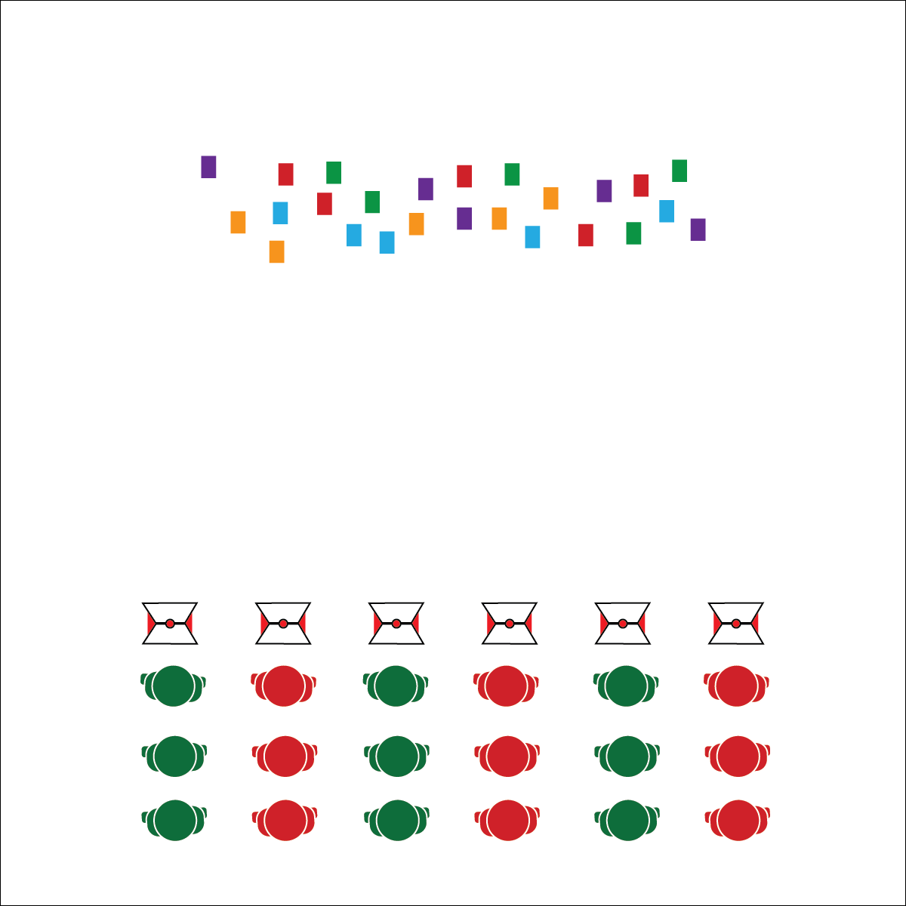

* Stay Alert While Moving
* Encourage Others
* Have Fun

**Activity Procedures:**

1. Today’s activity is called Make a MyPlate Meal. Your goal is to make a meal with balanced nutrition while dealing with life’s roadblocks. We will use MyPlate from the USDA to make our balanced meals.
2. On the start signal, the 1st player on each team will sprint and pick up a food card that is face-down on the other side of the gym. They will bring the card back to the group. In order to “buy” the food, 1 player will roll the dice and the entire team will complete the fitness activity that aligns with the number rolled.
3. If you roll 1 of life’s roadblocks, the entire group must complete 1 lap around the perimeter before rolling again.
4. Repeat this process until the group has enough food to build a balance MyPlate meal. Place the items on the plate for a quick teacher check. If you finish building a plate, keep building others until you hear the stop signal. Each healthy plate built is worth 1 point.

**Grade Level Progression:**

**6th:** Play the activity as described above.

**7th:** Students create their own MyPlate Activity Card with appropriate activities and realistic barriers related to maintaining an active lifestyle.

**8th:** Students complete the Nutrition Knowledge Exit Slip.

**Equipment:**

* Food Group Cards
* 6 cones and 6 task tents
* 6-color set of foam dice
* MyPlate Dice Chart
* MyPlate Activity Card

**Set-Up:**

1. Scatter food cards on 1 side of the gym, face-down.
2. Place 6 cones at the opposite end of the boundary area from food cards.
3. Place dice next to each cone.
4. Create groups of 3–6 students behind each cone in relay-style formation.

* **Skill:** I will perform health-related fitness activities in personal and general space.
* **Cognitive:** I will design a MyPlate meal with a focus on balanced nutrition.
* **Fitness:** I will identify foods in each of the 5 food groups.
* **Personal & Social Responsibility: I** will use positive communication and encouraging language with my teammates.

**MAKE A MYPLATE MEAL**





* **Standard** **3 [M17.6-8]** Identifies foods within each of the basic food groups and selects appropriate servings and portions for his/her age and physical activity levels (6); Develops strategies to balance healthy food, snacks, and water intake, along with daily physical activity (7); Describes the relationship between poor nutrition and health risk factors (8).
* **Standard 3 [M1.6-8]** Describes how being physically active leads to a healthy body (6); Identifies barriers related to maintaining a physically active lifestyle and seeks solutions for eliminating those barriers (7); Identifies the five components of health-related fitness (muscle strength, muscle endurance, flexibility, CV endurance, body composition) and explains the connections between fitness and overall physical and mental health (8).
* **Standard 5 [M6.6-8]** Demonstrates respect for self and others in activities and games by following the rules, encouraging others, and playing within the spirit of the game or activity (6); Demonstrates the importance of social interaction by helping and encouraging others, avoiding trash talk, and providing support to classmates (7); Demonstrates respect for self by asking for help and helping others in various physical activities (8).



* **DOK 1:** What are the 5 food groups? How many servings do you need in 1 day for each food group?
* **DOK 2:** How would you summarize the importance of creating meals that are balanced nutritionally?
* **DOK 3:** Can you describe some of the physiological responses that your body has to poor nutrition? How does that relate to stress management?
* **DOK 4:** Let’s design a stress management plan that includes healthy snacks, balanced meals, and a physical activity routine that you enjoy. Then we’ll identify potentially stressful times when this plan could help you feel better.



**Organize students to interact with content.** This activity provides students with rich opportunities to engage with nutrition content while interacting with their peers in a team environment. When implemented in its full form, this activity gives students a vigorous dose of exercise, provides an opportunity for them to learn and process critical content, and reinforces the use of academic language.



Nutrition, Protein, Grain, Fruits, Vegetables, Dairy, Appropriate Serving, Healthy Risks, Health-Related Fitness, Balance, Food, Food Groups, Calorie Intake, Calorie Expenditure



* Provide students with large pictures of food.
* Change the size of the activity area to meet the needs of all students.
* Students complete all components of this activity with a partner.

**FREEZE YOGA**

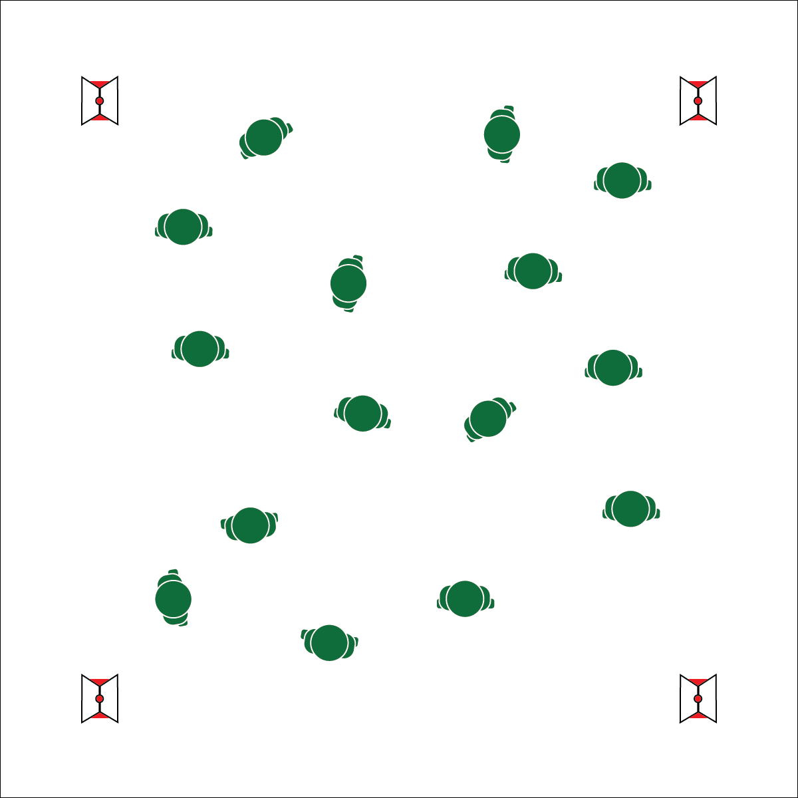

**Equipment:**

* 4 cones
* 4 task tents
* 4 Freeze Yoga Pose Posters
* Slow to medium music and music player

**Set-Up:**

1. Use 4 cones to create the perimeter of a large activity area.
2. Place pose posters in task tents and display on cones.
3. Scatter students throughout the activity area.

* Control Movement to the Tempo
* Freeze and Pose
* Focus on Form and Safety

**Activity Procedures:**

1. Today’s activity is called Freeze Yoga. The object of the activity is to perform a yoga pose within 5 seconds of the music stopping. Before we begin the game, we’ll practice a series of yoga poses using our Freeze Yoga Pose Posters.
2. When the music starts, begin moving throughout open space, taking large, slow, and controlled steps matching the tempo of the music. When the music stops, get into one of the yoga poses that we’ve learned in class with a focus on form and safety. We will hold our yoga pose for 10 seconds before beginning the music again.
3. If you do not get into a yoga pose within 5 seconds, quickly move to a Freeze Yoga Pose station and practice 2 of the yoga poses on the pose poster before re-entering the activity.
4. We’ll continue this activity through a series of 10–15 yoga poses.

**Grade Level Progression:**

**6th:** Play the activity as described above.

**7th:** Students complete the Mental and Emotional Health Exit Slip.

**8th:** Introduce Tai Chi to students and allow them to choose to complete yoga poses or Tai Chi movements when the music stops. See OPEN’s High School Tai Chi module for ideas.

* **Skill:** I will demonstrate correct technique for basic yoga poses.
* **Cognitive:** I will identify and discuss positive and negative results of stress and appropriate ways of dealing with each.
* **Fitness:** I will demonstrate basic movements used in the stress-reducing activity of yoga.
* **Personal & Social Responsibility:** I will identify positive mental and emotional aspects of participating  
  in yoga.

**FREEZE YOGA**





* Give students longer than 5 seconds to move into a pose.
* Project 1 or 2 poses onto the wall. When the music stops, students all perform the same pose together.



* **DOK** **1:** How can you recognize stress?
* **DOK 2:** What do you know about the negative effects of stress?
* **DOK 2:** What do you know about the positive effects of stress?
* **DOK 3:** How are physical activities like yoga related to stress reduction?



* **Standard 1 [M25.6-8]** Demonstrates correct technique for basic skills in one self-selected individual-performance activity (6).
* **Standard 3 [M18.6&8]** Identifies positive and negative results of stress and appropriate ways of dealing with each (6); Demonstrates basic movements used in other stress-reducing activities such as yoga and Tai Chi (8).
* **Standard 5 [M2.6-8]** Identifies components of physical activity that provide opportunities for reducing stress and for social interaction (6); Identifies positive mental and emotional aspects of participating in a variety of physical activities (7).



Emotional Health, Individual Performance Activity, Mental Health, Social Interaction, Stress, Tai Chi, Technique, Yoga



**Help students examine their reasoning.** Stress and anxiety are a part of modern students’ reality, but many students have never learned about or discussed stress in a way that helps them explain the purpose of their feelings. Stress happens for a reason. There are both positive and negative consequences. Help students explore and analyze their understanding of stress. If there are errors in their reasoning, help students process factual information in order to clarify their understanding.