­­

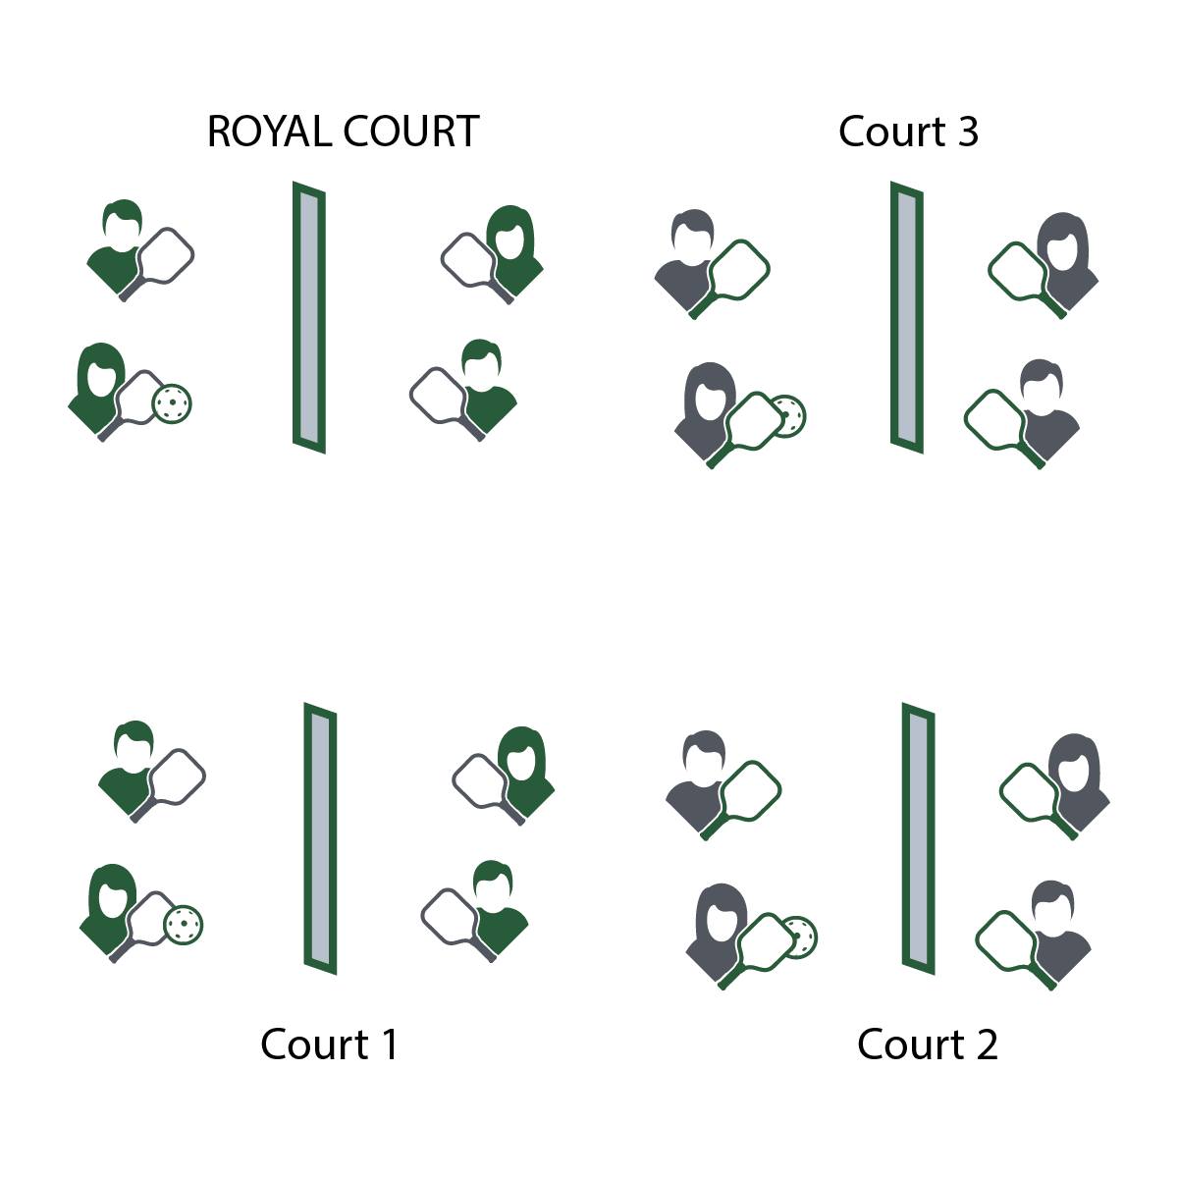

**ROYAL COURT GAME DAY**

* **Skill:** I will demonstrate striking skills with varying force and direction.
* **Cognitive:** I will discuss the importance of the spirit of the game with respect to enjoyment of pickleball match play.
* **Fitness:** I will demonstrate a variety of skill-related fitness components.
* **Personal & Social Responsibility:** I will demonstrate respect for myself and my classmates by following the rules of the game and encouraging others.
* Play with Purpose
* Follow the Spirit of the Game
* Help and Encourage Others

**Equipment:**

* 1 paddle per student
* 1 pickleball per pair of students (singles)  
  or per group of 4 students (doubles)
* 1 net per court (or jump ropes as needed)
* Spirit of the Game Award Certificates

**Set-Up:**

1. Create enough courts so the entire class can play in either a singles or doubles match.
2. Number each court, with court 1 as the starting court and the highest number court as the “Royal Court.”
3. Create teams for doubles, or pair students for singles play.
4. Send students to courts for match play.

**Activity Procedures:**

1. Today we’ll play a Royal Court Tournament as a way to test our skills and have fun with our friends. We’ll use the spirit of the game to guide our pickleball etiquette.
2. The goal of today’s tournament is to compete with a positive attitude and to work your way to the Royal Court. We’ll play 3-minute games. The winner of each game will move to a higher court. The losing team or player will move down to a lower court.
3. We’ll continue game play until class time runs out. Teams demonstrating positive attitudes and pickleball etiquette will be given Spirt of the Game Awards.

**Grade Level Progression:**

**6th:** Pair students of similar skill levels, and skip the royal court rotation. Instead, rotate students with a focus on setting them up for challenge, success, and fun.

**7–8th:** Play the activity as described above.

**ROYAL COURT GAME DAY**



Direction, Encourage, Enjoyment, Force, Skill-Related Fitness, Spirit of the Game



* **Standard 2 [M7.6-8]:** Creates open space in net/wall games with a short-handled implement by varying force and direction (6); Creates open space in net/wall games with a long-handled implement by varying force, direction, and moving opponent from side to side (7); Creates open space in net/wall games with either a long- or short-handled implement by varying force or direction, or moving opponent side to side and/or forward and back (8).
* **Standard 2 [M8.6-8]:** Reduces offensive options for opponents by returning to mid-court position (6); Selects offensive shot based on opponent’s location (hit where opponent is not) (7); Varies placement, force, and timing of return to prevent anticipation by opponent (8).
* **Standard 5 [M6.6-8]:** Demonstrates respect for self and others in activities and games by following the rules, encouraging others, and playing within the spirit of the game or activity (6); Demonstrates the importance of social interaction by helping and encouraging others, avoiding trash talk, and providing support to classmates (7); Demonstrates respect for self by asking for help and helping others in various physical activities (8).



* **DOK 1:** How would you describe the spirit of the game to a new student in our school?
* **DOK 2:** What do you know about the spirit of the game? (Think beyond the definition.)
* **DOK 3:** How would you describe a game played with the spirit of the game? How would you describe a game played without it?
* **DOK 4:** Can we create a way to evaluate the amount of the spirit of the game in any specific competition or performance?



**Help students examine their reasoning.** As students give responses to the DOK questions above, challenge their responses with prompts to elaborate or to defend their answers with evidence or logical reasoning. Model positive and constructive critiquing, and support students as they both struggle and succeed.



* Create a “recreation league” and de-emphasize tracking score. Instead, encourage students to work toward cooperative goals similar to Rally Tally. All students to choose participation in either the Royal Court format or the Rec League format.