­­

**Kinara Relay**

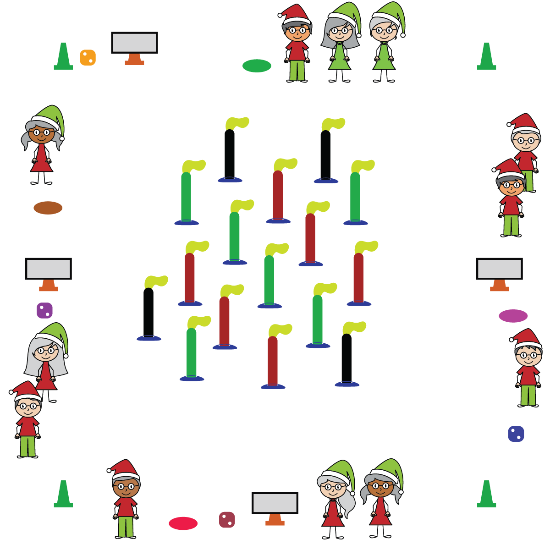

**Equipment:**

* Cones for boundaries
* 1 spot marker, task tent, activity card & die per team
* 7 half noodles (for candles) & 7 scarves (for the flames) per team; low profile cones for noodle base

**Set-Up:**

* Place a spot marker (as base of Kinara), task tent with activity card and die for each team around the perimeter of the activity space.
* Place half noodles (with scarves tucked in the top and low-profile cone on bottom) in the center of the teaching area.
* Create equal teams of 3-4. Each starts at a spot marker.

**Activity Procedures:**

1. It’s time to create a Kinara! When the music starts, it’s time to begin collecting candles for your Kinara.
2. You’ll do that by rolling the die and completing the corresponding exercise on the activity card. That earns you one candle to add to your Kinara.
3. One team member goes to the center of the activity area and brings back one candle (noodle). The first candle should be at the center of the Kinara (on the spot marker), and the remaining 6 candles should be placed with 3 on each side (for a total of 7). Once you’ve collected a candle from the center of the activity area, have the next team member roll the die. Continue this process until Kinara is complete or until music stops. Rotate who gets to roll the dice and who gets to collect the next candle.

**SEL Integration & Academic Language:** Tradition, Respect, Virtue

**Discussion Starters:**

* The lighting of the Kinara occurs from 12/26 – 1/1 as part of Kwanzaa. Each candle represents one of the 7 principles of Kwanzaa, does anyone know what those 7 principles are? (unity, self-determination, collective work and responsibility, cooperative economics, purpose, creativity, and faith)

**Priority Learning Outcomes:**

* **Demonstrates Responsible Behaviors: Working with Others** (K) Shares equipment and space with others. (1) Works independently with others in a variety of class environments. (2) Accepts responsibility for class protocols with personal and cooperative behavior as well as performance actions. (3) Works cooperatively with others. #TeachersHelpingTeachers (4) Accepts “players” of all skill levels into the physical activity. (5) Accepts, recognizes, and actively involves others with both higher and lower skill abilities into physical activities and group projects. (6) Accepts differences among classmates in physical development, maturation, and varying skill levels by providing encouragement and positive feedback. (7) Demonstrates cooperation skills by establishing rules and guidelines for resolving conflicts. (8) Responds appropriately to participants’ ethical and unethical behavior during physical activity by using rules and guidelines for resolving conflicts.
* **Skill:** I will move in general space using different pathways and speeds.
* **Physical Activity:** I will stay actively engaged in class in order to accumulate a maximum amount of activity minutes.
* Move Safely
* Work Cooperatively