­­

**POLAR BEAR CAVE**

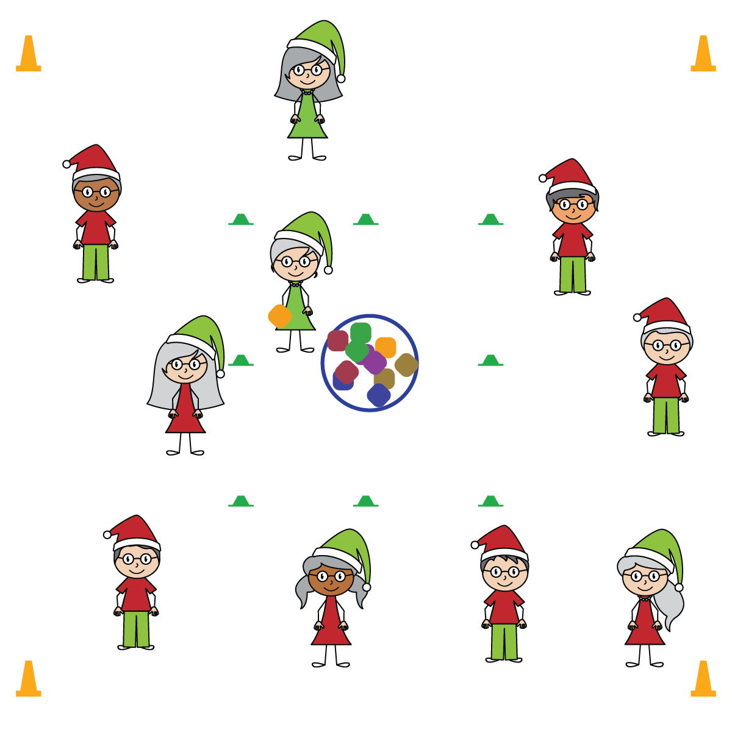

**Activity Procedures:**

1. In the cold and snowy Arctic Circle, polar bears hunt seals to keep their families alive. In this game, seals do not want to be tagged by the polar bears. This game will start at a speed-walking pace. We’ll start to move more quickly when I see personal behaviors are safe and considerate.
2. If tagged, the seal must go with the bear into the polar bear cave, where it will pick up a beanbag and become a polar bear. Then both bears re-enter the activity area and work to tag another seal.
3. Play continues until there is only 1 seal left. That seal becomes the 1st bear to start the next game.

**SEL Integration:**

* **KEYWORD:** PERSONAL BEHAVIOR. Tag games are vigorous opportunities for students to practice safe and considerate personal behaviors. In order for that opportunity to promote social and emotional learning, focused conversations must take place before and after the activity with an emphasis on the SEL skills you’re working to develop.

**Grade-Level Outcomes:**

* **Demonstrates Responsible Behaviors ­– Working with Others** (K) Shares equipment and space with others. (1) Works independently with others in a variety of class environments. (2) Accepts responsibility for class protocols with personal and cooperative behavior as well as performance actions. (3) Works cooperatively with others. (4) Accepts “players” of all skill levels into the physical activity. (5) Accepts, recognizes, and actively involves others with both higher and lower skill abilities into physical activities and group projects. (6) Accepts differences among classmates in physical development, maturation, and varying skill levels by providing encouragement and positive feedback. (7) Demonstrates cooperation skills by establishing rules and guidelines for resolving conflicts. (8) Responds appropriately to participants’ ethical and unethical behavior during physical activity by using rules and guidelines for resolving conflicts.
* Tag on Shoulders with Fingertips
* Focus on Safe Personal Behavior

**Equipment:**

* 8 low-profile cones
* 4 large cones to create boundaries
* 1 beanbag per student
* 1 hula hoop

**Set-Up:**

1. Create a play area using 4 cones to mark boundaries.
2. Use the low-profile cones to create the “polar bear cave”: a 10x10 square in the center of the activity area.
3. Place the hoop directly in the center of the 10x10 square and place all beanbags inside it.
4. Scatter students in the activity area, with 1 student in the polar bear cave holding a beanbag.

* **Skill:** I will move safely, with consideration for my classmates.
* **Personal & Social Responsibility:** I will write a sentence describing how my personal behavior contributed to a safe physical activity environment.