­­

**ICE FISHING**

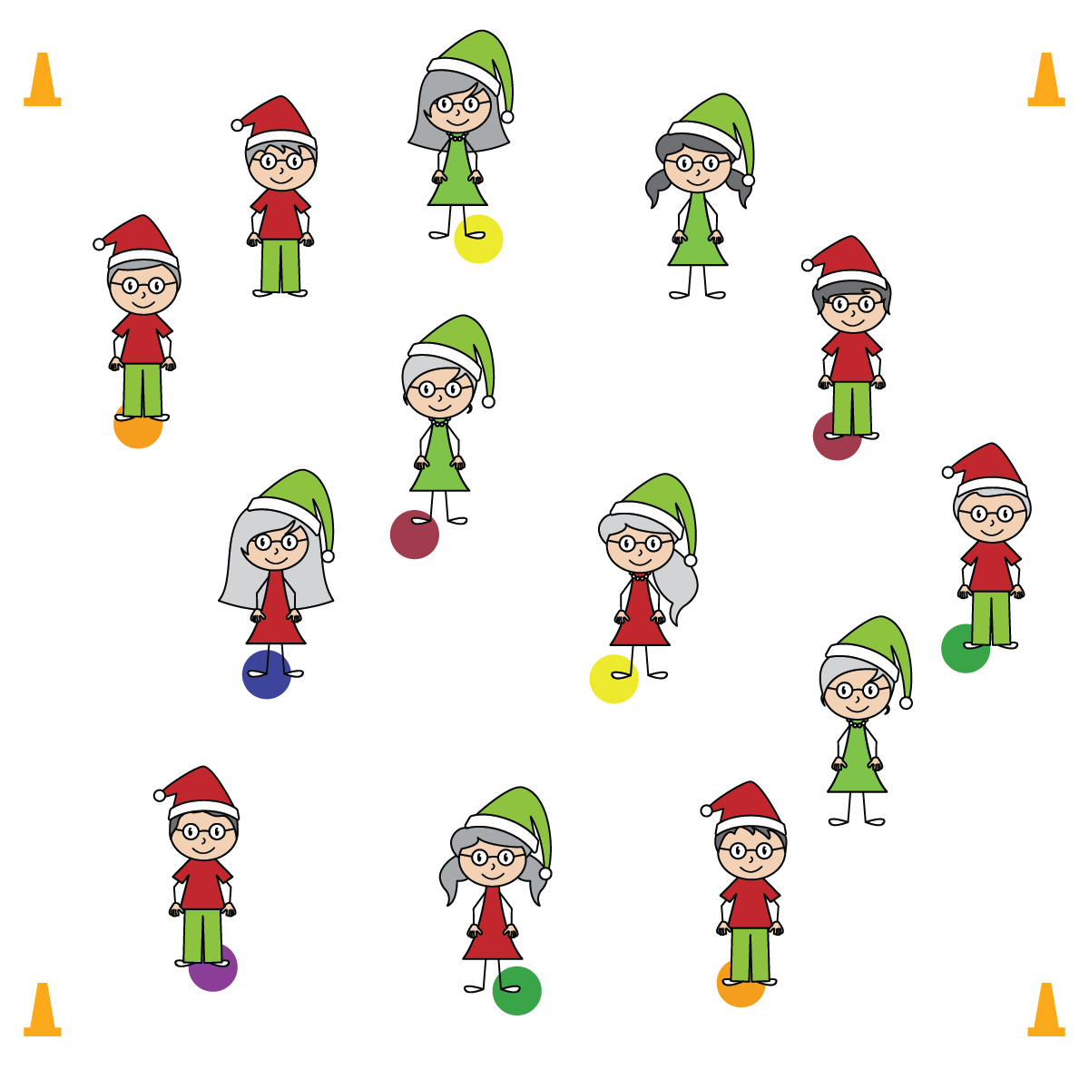

**Activity Procedures:**

1. Ice fishing requires a small hole to be cut into the ice, often inside a temporary shelter that keeps the people who are fishing out of the harsh elements of winter. Hopefully there’s fish in the hole.
2. In this game, there are 3 fisher-people who don’t have a fishing hole. They want to steal your fishing hole. When the music is playing, the fisher-people will “ice skate” around all of the fishing holes, and the people fishing will perform a stationary sitting squat as they fish.
3. When the music stops, 1 of the 3 people without a place to fish will call a color. If your spot’s color is called, quickly move to another open fishing hole before someone else does. What all spots are taken, the 3 players without spots become the new skating fisher-people looking for a fishing hole.

**SEL Integration:**

* **KEYWORD:** TEAMWORK. The combined actions of all students in a class contributes toward the common goal of a safe and positive learning environment. That is the definition of teamwork! Use this illustration to help students connect their personal behaviors to that of their teammates (i.e. classmates).

**Grade-Level Outcomes:**

* **Demonstrates Responsible Behaviors ­– Working with Others** (K) Shares equipment and space with others. (1) Works independently with others in a variety of class environments. (2) Accepts responsibility for class protocols with personal and cooperative behavior as well as performance actions. (3) Works cooperatively with others. (4) Accepts “players” of all skill levels into the physical activity. (5) Accepts, recognizes, and actively involves others with both higher and lower skill abilities into physical activities and group projects. (6) Accepts differences among classmates in physical development, maturation, and varying skill levels by providing encouragement and positive feedback. (7) Demonstrates cooperation skills by establishing rules and guidelines for resolving conflicts. (8) Responds appropriately to participants’ ethical and unethical behavior during physical activity by using rules and guidelines for resolving conflicts.
* Move Safely
* Look Where You’re Going
* Consider the Safety of your Classmates

**Equipment:**

* 6-color sets of spot markers (1 spot per student)
* Music and music player

**Set-Up:**

1. Scatter colored spot markers throughout a large activity area. There should be 3 fewer spots than there are students so that 3 students do not have spots.
2. Send all but 3 students to a spot.

* **Skill:** I will move safely, with consideration for my classmates.
* **Personal & Social Responsibility:** I will write a sentence describing how my class works together to ensure a safe and positive learning environment.