­­

**NORTH POLE VS SOUTH POLE**

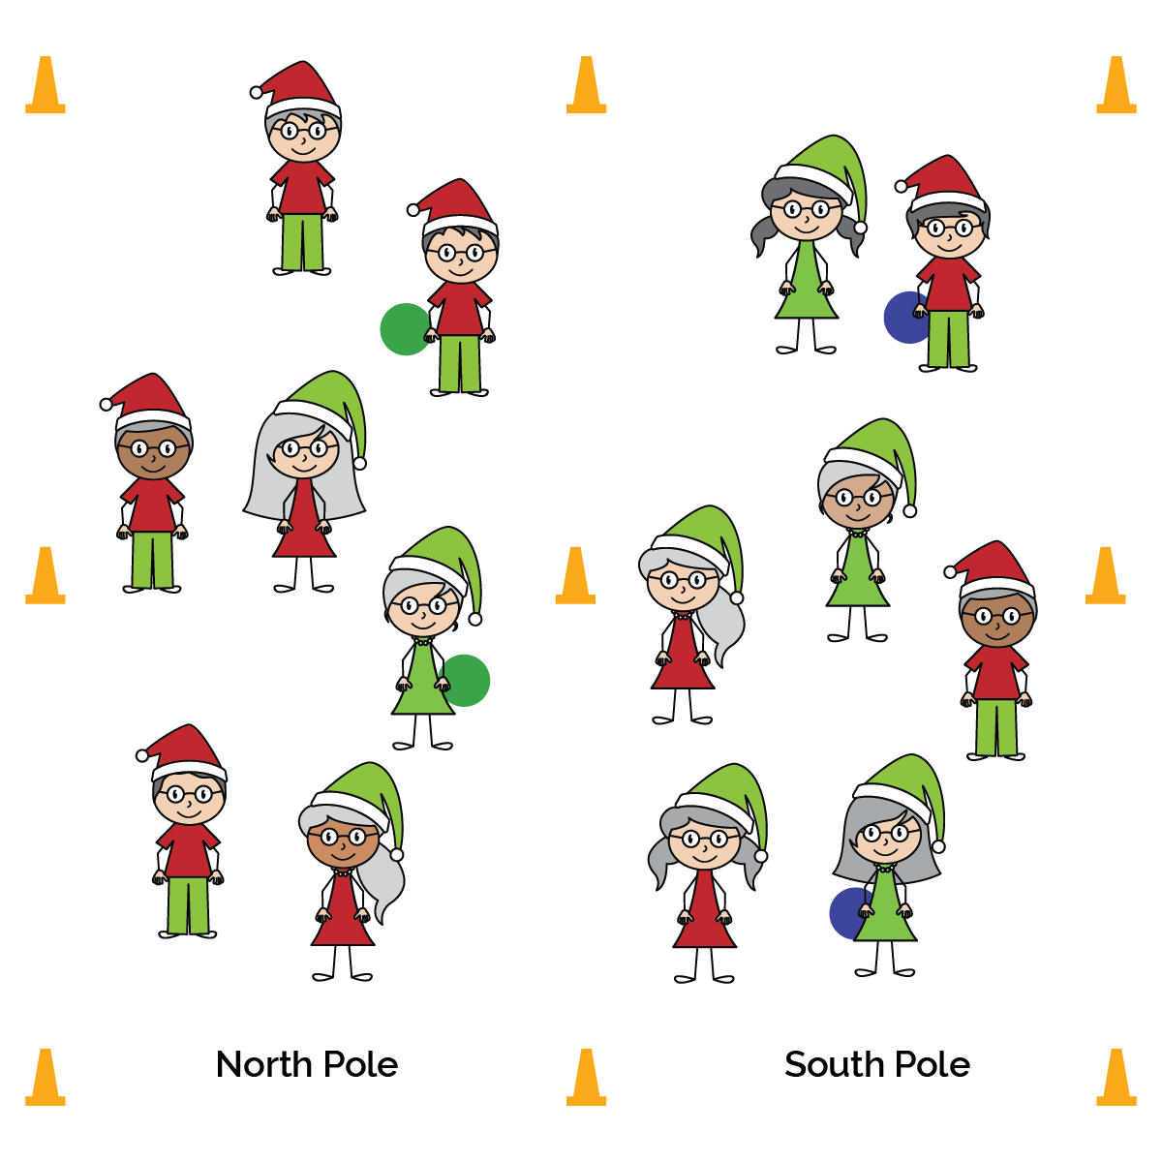

**Activity Procedures:**

1. It’s time for the annual Seal Games. This is when North and South Pole elves compete in a tag competition. All students are seals except for the elves (taggers). The North Pole elves are trying to tag seals and send them to the South Pole. The South Pole elves are trying to tag seals and send them to the North Pole. The team with the fewest number of seals when the game ends is the winner.
2. When the music starts the game begins. When seals are tagged by the elves they move to the centerline, complete 5 snowman jacks, and then re-enter the game on the other side. When the music stops, we’ll see which pole (North or South) has the fewest seals.
3. Every 3 minutes, reset the game with new elves and play again.

**SEL Integration:**

* **KEYWORD:** REGULATE. Oftentimes, young students don’t feel as if they control their own lives or their situations. However, everyone can exert some control over how they react to situations and events. This game is rich with opportunities for students to practice self-regulation. Whether they win or lose, are tagged or are tagging, students must regulate behaviors in order to maximize safe enjoyment. Enrich this learning experience with meaningful discussion and journaling.

**Grade-Level Outcomes:**

* **Demonstrates Responsible Behaviors ­– Working with Others** (K) Shares equipment and space with others. (1) Works independently with others in a variety of class environments. (2) Accepts responsibility for class protocols with personal and cooperative behavior as well as performance actions. (3) Works cooperatively with others. (4) Accepts “players” of all skill levels into the physical activity. (5) Accepts, recognizes, and actively involves others with both higher and lower skill abilities into physical activities and group projects. (6) Accepts differences among classmates in physical development, maturation, and varying skill levels by providing encouragement and positive feedback. (7) Demonstrates cooperation skills by establishing rules and guidelines for resolving conflicts. (8) Responds appropriately to participants’ ethical and unethical behavior during physical activity by using rules and guidelines for resolving conflicts.
* Regulate Your Speed
* Regulate the Force of Your Tags
* Regulate Your Emotions

**Equipment:**

* 9 large cones to create boundaries
* 4 foam balls
* Music and music player

**Set-Up:**

1. Use 9 cones to create 2 large activity areas side by side, with 3 cones forming a center line and 3 cones on each end line.
2. Scatter students evenly in each of the 2 activity areas.
3. Use foam balls to designate 2 students in each area as taggers. 1 team of taggers is the North Pole elves, and the other is the South Pole elves.

* **Skill:** I will regulate the speed and force of my movements.
* **Personal & Social Responsibility:** I will regulate my emotions.