­­

**GINGERBREAD GUMDROPS**

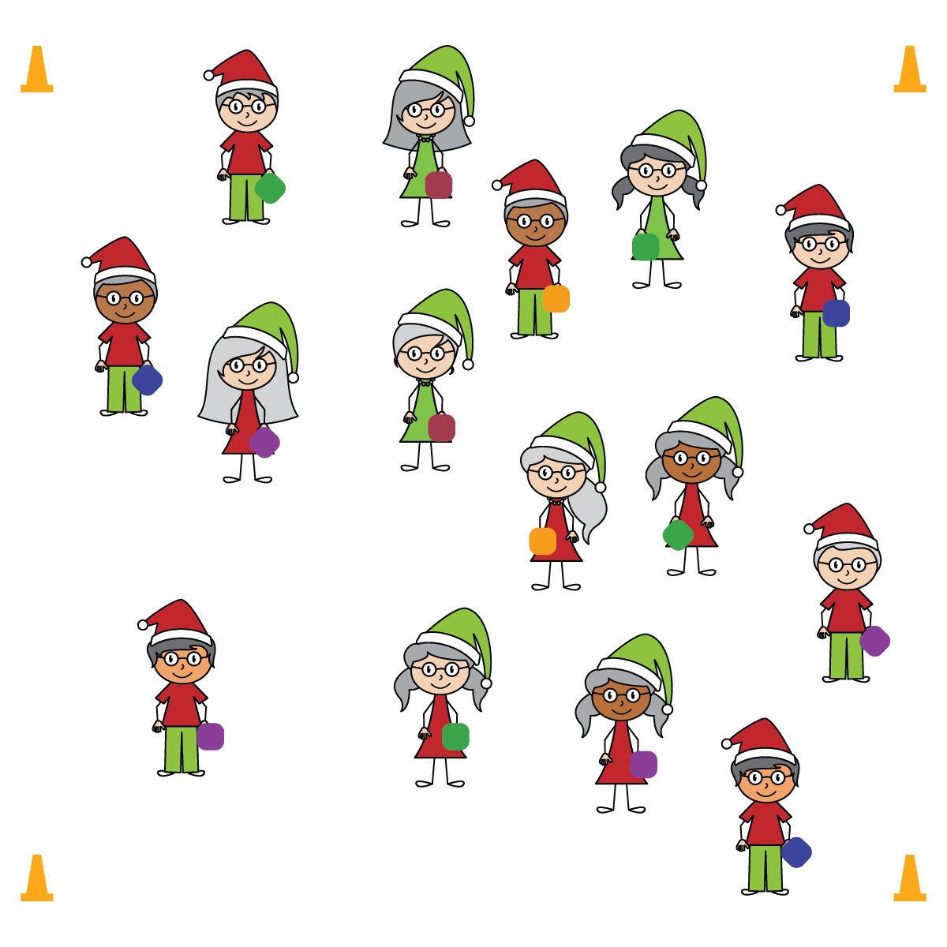

**Equipment:**

* 4 large cones to create boundaries
* 1 beanbag per student
* Music and music player

**Set-Up:**

1. Use 4 cones to create boundaries.
2. Scatter students in the activity area, each with a beanbag.

* **Skill:** I will express myself through movement.
* **Personal & Social Responsibility:** I will use positive language to encourage my classmates to express themselves through movement.
* Safe Movement
* Positive Expressions
* Positive Encouragement

**Activity Procedures:**

1. Gingerbread people love to jump to a beat. Guess what?! You’re all gingerbread people!
2. On the start signal, begin walking in general space while self-tossing and catching your beanbag.
3. When the you hear the teacher yell “GUMDROP!” the music will start, and you’ll drop your beanbag onto the floor right at your feet. Then begin jumping over as many different beanbags as you can while the music plays. Remember to jump to the beat and express yourself!
4. When the music stops, pick up the nearest beanbag and walk in space, tossing and catching.
5. We’ll move like this for several rounds of playful expression.

**SEL Integration:**

* **KEYWORD:** SELF-EXPRESSION. Throughout history, people have expressed emotions and ideas through movement. This type of expression is a muscle that must be exercised and encouraged. Students of all ages can benefit from simple instructions that can frame a freedom of expression in the structure of active play.

**Grade-Level Outcomes:**

* **Values Physical Activity –** **Personal Enjoyment** (K) Identifies physical activities that are enjoyable.   
  (1) Describes positive feelings that result from physical activity participation. (2) Discusses personal reasons for enjoying selected physical activities. (3) Reflects on the reasons for enjoying selected physical activities. (4) Ranks the enjoyment of participating in different physical activities. (5) Analyzes different activity choices for enjoyment and identifies reasons for positive or negative responses.   
  (6) Describes how moving competently creates enjoyment and self-expression. (7) Explains the relationship between self-expression and lifelong enjoyment of physical activity. (8) Discusses ways to increase enjoyment in self-selected physical activities.