Grades K – 2: Walking Trail Day 1
Use the walking trail posters in this packet to create an at-home walking trail. You can make your trail indoors or outdoors. There are 5 walking trail signs to create 5 stations that you will visit on your Wonderful Walks.

All walks end at the Handwashing Station – make sure you wash for 20 seconds or more.

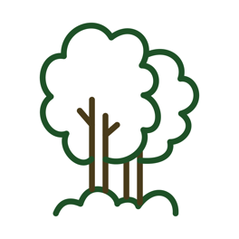 | Station 1: The Forest  Trees are amazing. They naturally filter the air that we breath and they’re home to many creatures that we share the Earth with. If you’re indoors, find a window with space for you to hang The Forrest Poster. Make sure there’s enough space for you to move safely. If you’re outdoors, find a real tree or a signpost that you can pretend is a tree, and make that your forest.
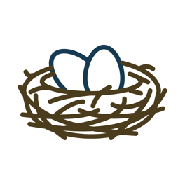 | Station 2: The Nest  Lots of creatures build and live in nests. Birds, squirrels, and bees are a few examples of creatures that we know can build nests in the world around us. If you’re indoors, hang this poster next to your bed and pretend that your bed is your nest. If you’re outdoors, find a place to hang the poster where you’d like to see a creature build a nest. Make sure you hang it in a safe place.
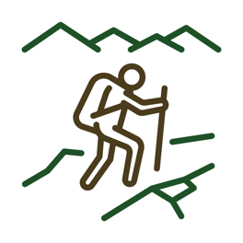 | Station 3: The Mountain Trail  Walking up a mountain trail can be really great exercise for your muscles and your heart. And mountain trails can have spectacular views of the lands around it. If you’re indoors, hang this poster next to a place in your home that has a picture that you like. It could be a picture of a friend, family member, or a special place. It can also be a painting or piece of art that you really like looking at. If you’re outdoors, find a place with a view that you enjoy. This is the start of your mountain trail.
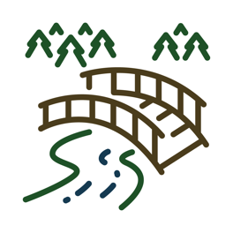 | Station 4: The Bridge  Bridges can help us travel over an obstacle. The obstacle might be water, a giant ditch or a busy road. Bridges have to be strong in order to keep us safe. If you’re indoors, hang this poster in a place with enough room for you to make a bridge with your body. If you’re outdoors, find a place that is safe for you to move and play in.
Station 5: The Handwashing Station
Every time we go out and explore our world on a wonderful walk, we need to stop and wash our hands. Washing our hands for 20 seconds or more will wash germs down the drain and keep our family and friends safe. Hang this poster next to a sink where you can wash your hands. If you can, listen to the song 20 Seconds or More while you wash the germs away.

Station 1: The Forest
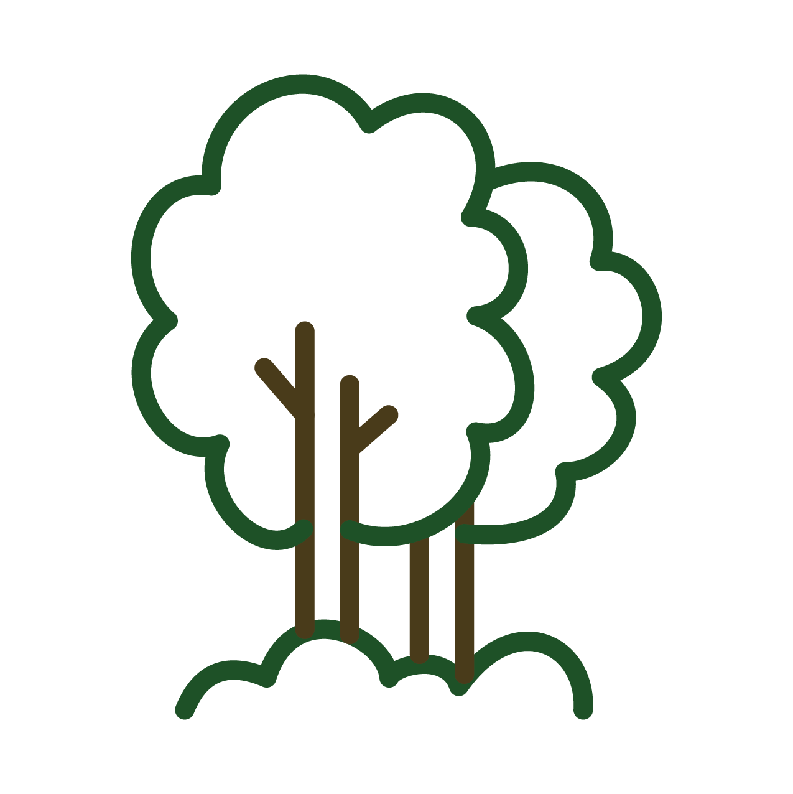
Day 1: Build the Trail – Hang your posters in safe places. Get help from a grown-up and talk about why you chose each of the spots where you’re hanging each poster.

Day 2: Hold Tree Pose for 20 seconds or more.

Day 3: Show a family member or friend Tree Pose. Then, hold the pose together for 20 seconds or more.

Day 4: If you were a tall and strong tree what would you look like? Create your own “Tree Pose” and hold it for 20 seconds or more.

Day 5: Show a family member or friend the Tree Post that you created. Then hold the pose together for 20 seconds more.

Station 2: The Nest
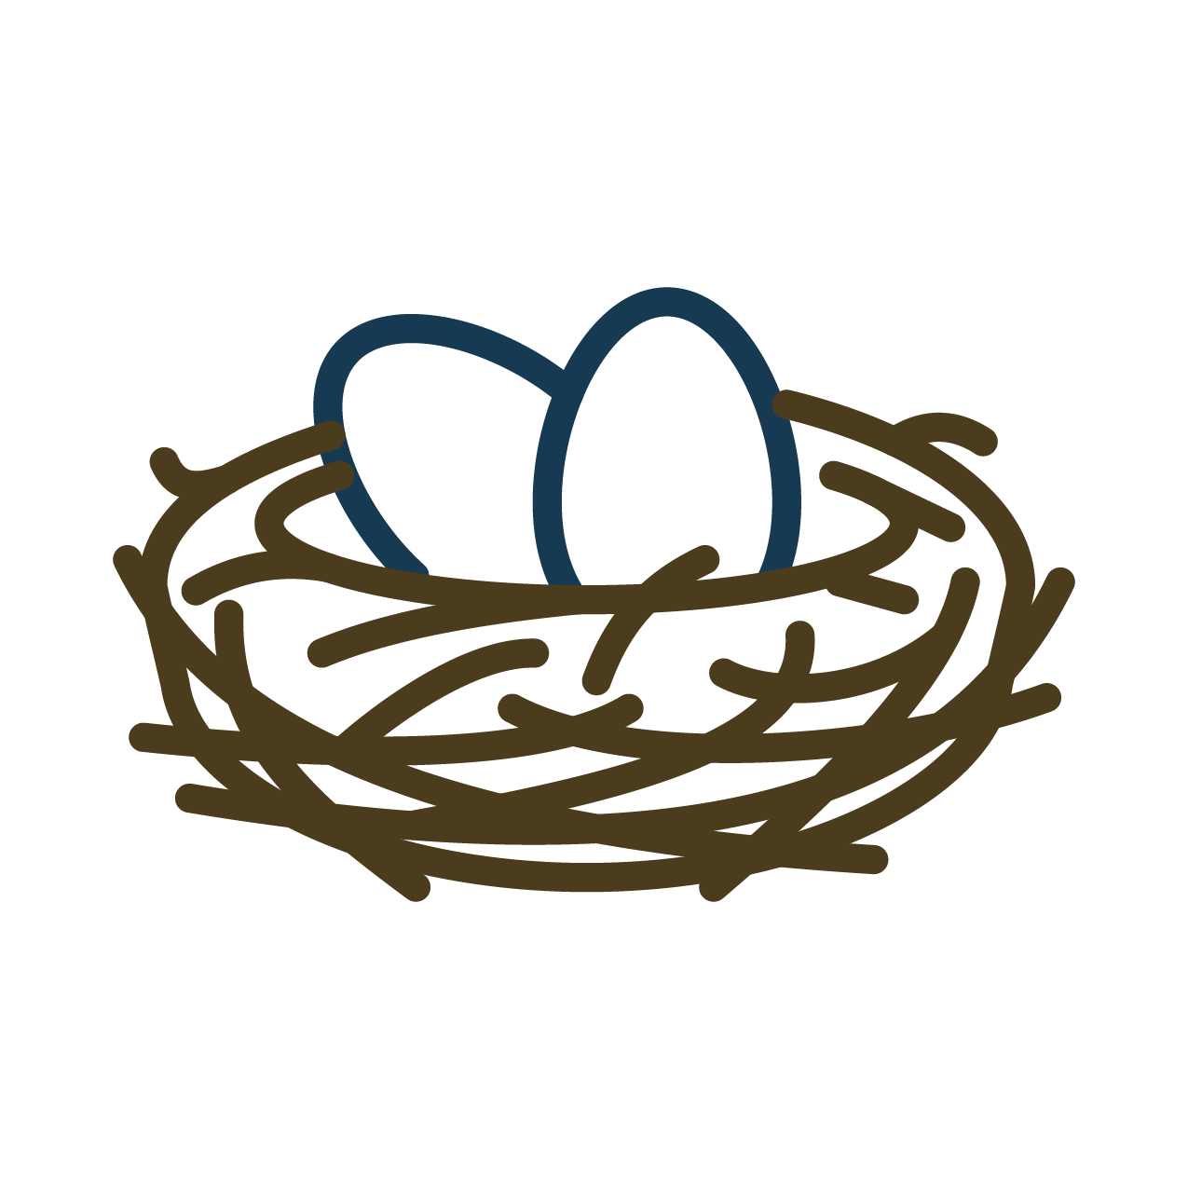
Day 1: Build the Trail – Hang your posters in safe places. Get help from a grown-up and talk about why you chose each of the spots where you’re hanging each poster.

Day 2: A nest is a place where creatures feel safe. Sit or stand at this station and breathe deeply. Inhale slowly and count to 7. Exhale slowly and count to 11. Repeat 3 times.

Day 3: Show a family member your nest and teach them the breathing exercise. When you’re done with the exercise, share 1 thing that you are both grateful for.

Day 4: Complete the breathing exercise. Today when you finish the exercise, thing of 1 thing that you are grateful for and whisper it to yourself.

Day 5: Show a family member your nest and do the breathing exercise together. When you’re done, tell your family member what you like about your nest.

Station 3: The Mountain Trail
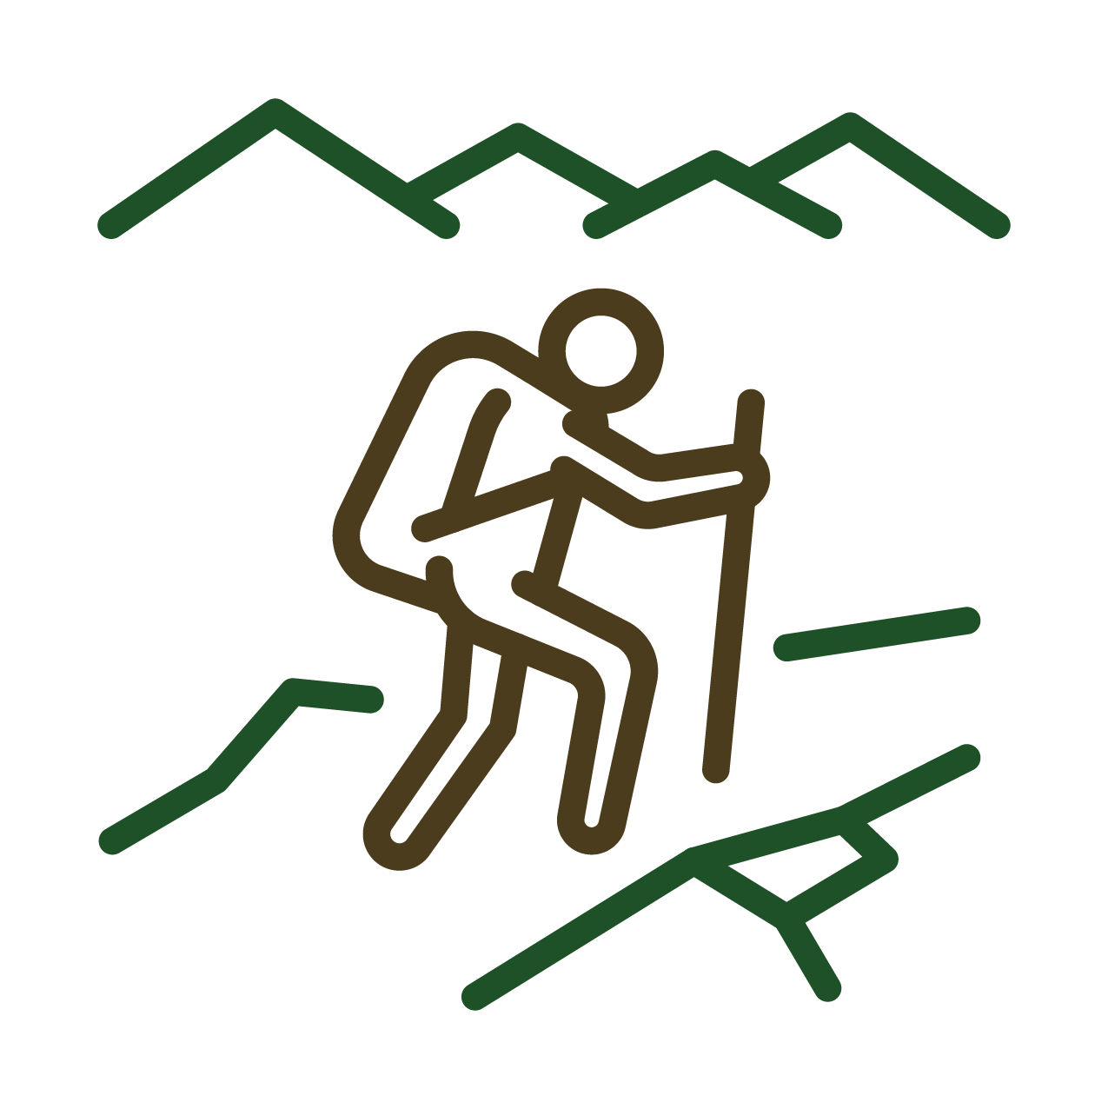
Day 1: Build the Trail – Hang your posters in safe places. Get help from a grown-up and talk about why you chose each of the spots where you’re hanging each poster.

Day 2: Hold Mountain Pose for 20 seconds or more.

Day 3: Show a family member or friend Mountain Pose. Then, hold the pose together for 20 seconds or more.

Day 4: If you were a giant mountain what would you look like? Create your own “Mountain Pose” and hold it for 20 seconds or more.

Day 5: Show a family member or friend the Mountain Post that you created. Then hold the pose together for 20 seconds more.
Station 4: The Bridge
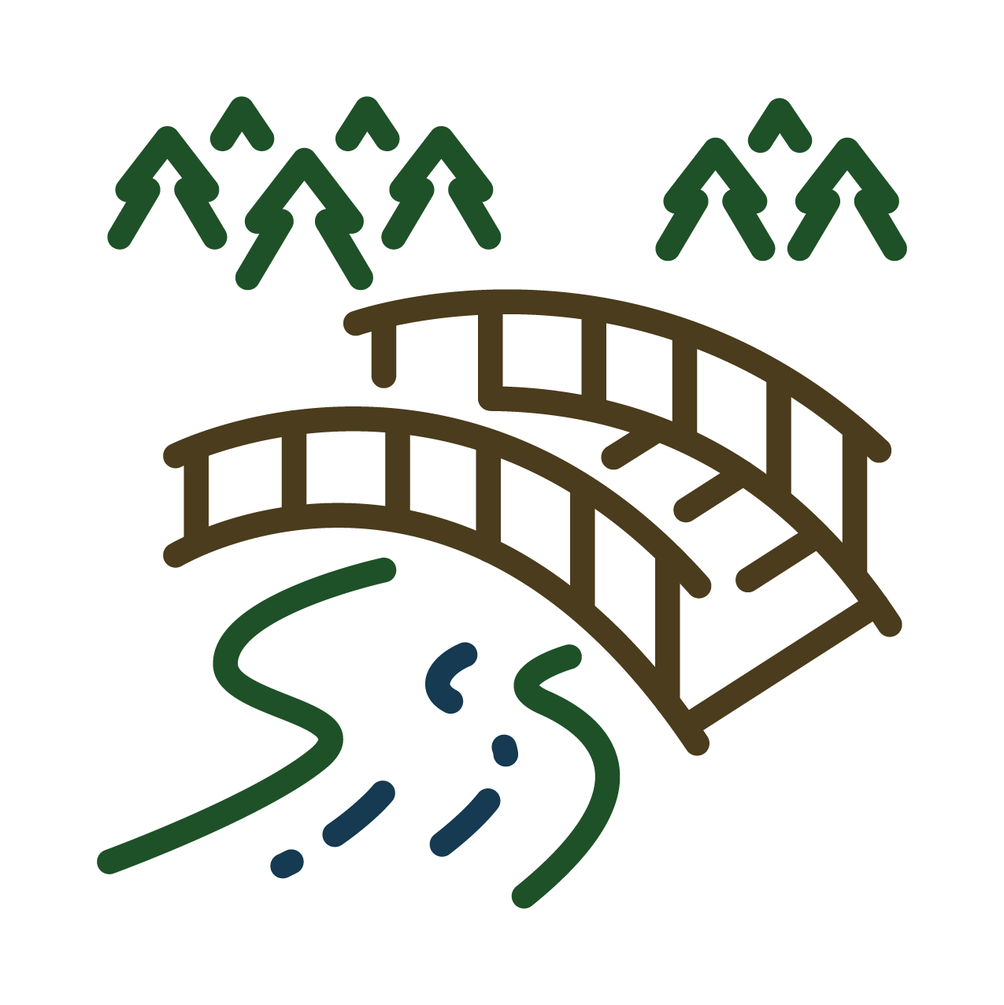
Day 1: Build the Trail – Hang your posters in safe places. Get help from a grown-up and talk about why you chose each of the spots where you’re hanging each poster.

Day 2: Hold a Bridge Pose for 20 seconds or more.

Day 3: Show a family member or friend Bridge Pose. Then, hold the pose together for 20 seconds or more.

Day 4: If you were a strong bridge what would you look like? Create your own “Bridge Pose” and hold it for 20 seconds or more.

Day 5: Show a family member or friend the Bridge Post that you created. Then hold the pose together for 20 seconds more.

Station 5: The Handwashing Station
Every Day:

- Washing our hands for 20 seconds or more will wash germs down the drain and keep our family and friends safe.

- If you can, listen to the song 20 Seconds or More while you wash the germs away. It’s okay to do a little dance while you wash!

Strike a Pose
Here are examples of poses that you can make during your Wonderful Walks.

TREE
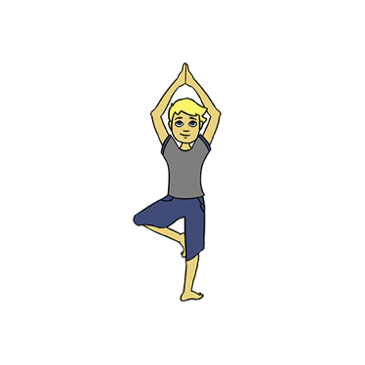
NEST
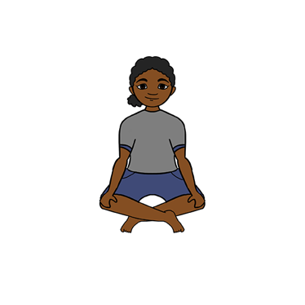
MOUNTAIN
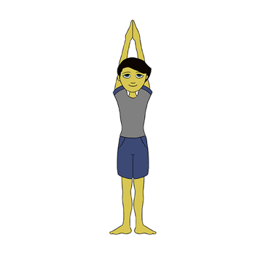
BRIDGE
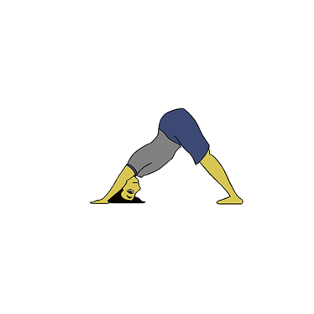 | 