­­

**WASH WITH WORDS**

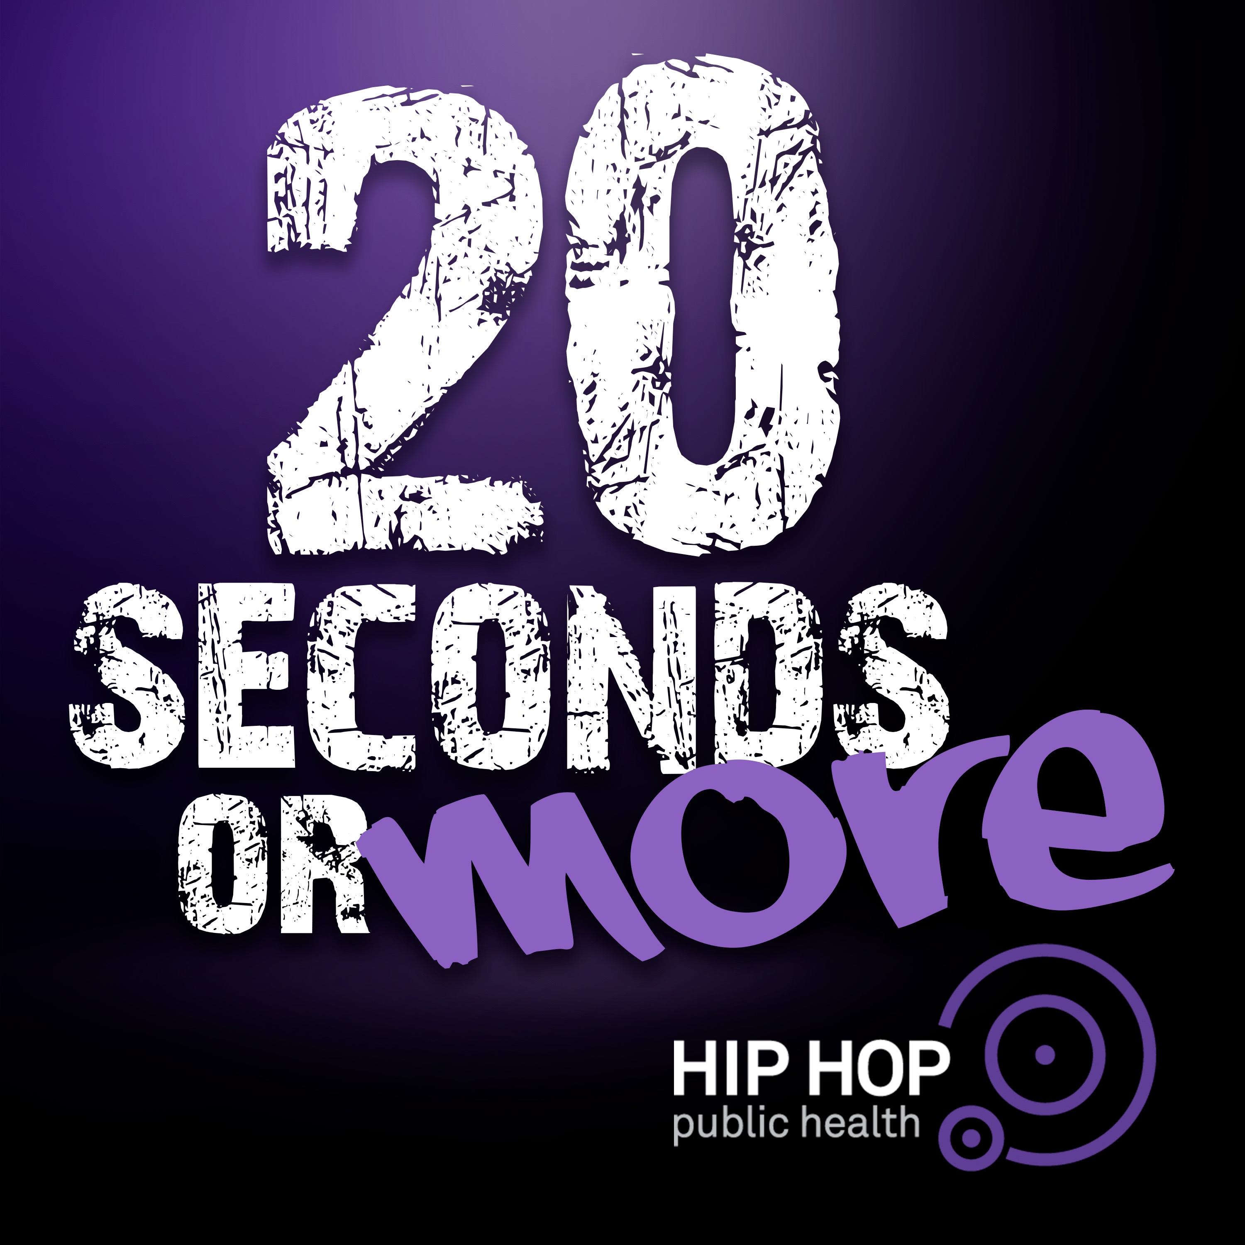

**Equipment:**

* *20 Seconds or More* music file  
  (Links available below or at [HHPH.org](https://hhph.org/repository/#filter=.rhythm-and-move))
* Wash with Words Phrases (Below)
* Wash with Words Brainstorming Page

**Get the Track… *20 Seconds Or More!***

* [YouTube](https://youtu.be/2yu4jSPNtic)
* [Spotify](https://open.spotify.com/track/2End3WpFD3mqAu6UtC09tP?si=Ks-TN2hSTd6Bex8_tVkp1Q)
* [iTunes](http://itunes.apple.com/album/id1507995304?ls=1&app=itunes)
* [Apple Music](https://music.apple.com/us/album/20-seconds-or-more-single/1507995304)

**Activity Procedures:**

* Today we’re going to Wash with Words!
* [**20 Seconds or More**](http://HHPH.org/20secondsormore)**,** is a Hip Hop song featuring legendary rapper Doug E. Fresh who co-wrote the song with multi-platinum producer, Artie Green and Gerry Gunn, along with medical oversight from our founder, Dr. Olajide Williams.
* This song was created by Hip Hop Public Health to empower YOU and your family with the right information, tools and resources to help stop the spread of COVID-19.
* Wash with Words is a fun way to interact with this amazing Hip Hop track with self-expressive dance.

**Here’s how it works:**

* You and a friend or family member will create 8-count dance movements for 4 of the Wash with Words phrases below. There are 8 phases listed, you can choose 4.
* Next, practice your dance moves and use the Brainstorming Page in this packet to create a dance sequence. Take time, practice your moves, and then (if you’re brave) perform them for an audience! Feel like you really have it down? Post your dance using #20SecondsOrMore and tag @HHPHorg and @OPENPhysEd.org

**Wash with Words Phrases**

|  |  |  |  |
| --- | --- | --- | --- |
| **Slippery Soap** | **Big Bubbles** | **Freezing Water** | **Angry Wash** |
| **Slow Motion Soap** | **Head Bob Wash Routine** | **Speed Scrubbing** | **Happy Wash** |