INVISIBLE DUMBBELL
FITNESS STATIONS

Notes to instructors:
Help students work on muscular fitness without the heavy lifting! These cards are designed to be set up in station format with small groups of students working at each station. Time each station interval for 30 seconds to 2 minutes. Students perform the exercise on the card and then rotate to the next station.

As with any game or activity resource, it’s up to you to assess the needs and abilities of the students under your supervision. Modify these activities as needed to meet the requirements of your space, group size, and age ranges.

The pages of this packet are designed to be used as station cards. The instructions can be read and explained by older and more mature students. However, we strongly recommend teaching each exercise to the group before allowing students to work independently.

Every page includes a reminder to practice safe social distancing. All of the exercises in this packet were designed to allow students to remain a minimum of 6 feet apart and DO NOT require them to use or share equipment.

INVISIBLE DUMBBELL
BICEPS CURL

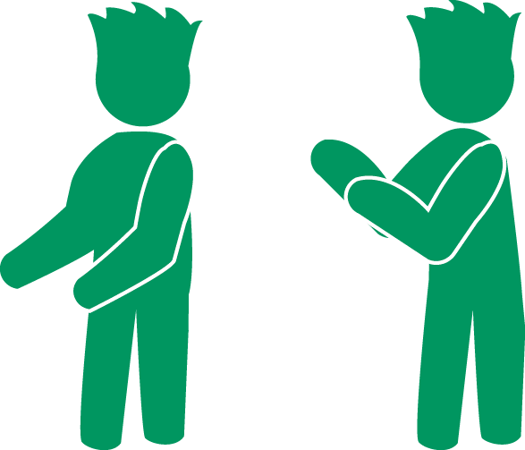
- Stand tall, feet shoulder-width apart, holding invisible dumbbells at your hips.
- Curl both invisible dumbbells up toward your shoulders.
- Lower your arms and repeat.

Muscle Focus: Biceps

INVISIBLE DUMBBELL
DUMBBELL CRUNCH

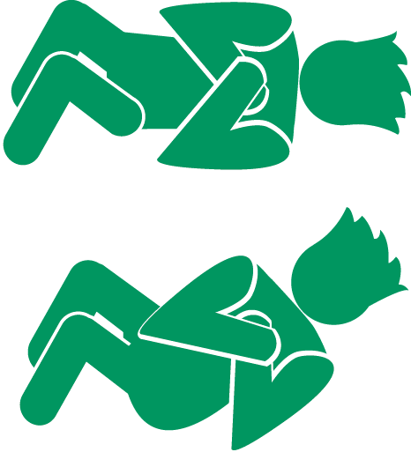
- Lay on your back with your knees bent, holding the invisible dumbbell on your chest.
- Slowly curl your head and shoulders up, and then lower back down to the starting position.

Muscle Focus: Rectus Abdominis

INVISIBLE DUMBBELL
DUMBBELL LUNGES
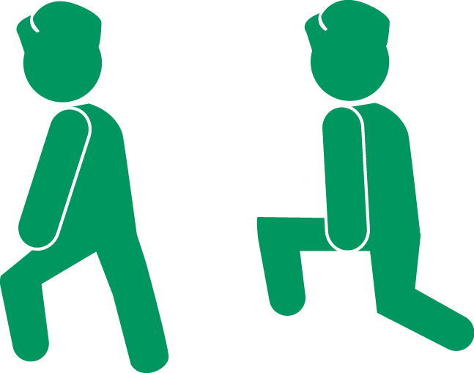
- Stand tall, holding the invisible dumbbells down at your sides.
- Step with your right foot until your right thigh is parallel to the floor (left leg stays in place).
- Push back up into the starting position.
- Repeat with your left leg.

Hamstrings, Quadriceps

INVISIBLE DUMBBELL
DUMBBELL PLANK ROWS
- Start in plank position.
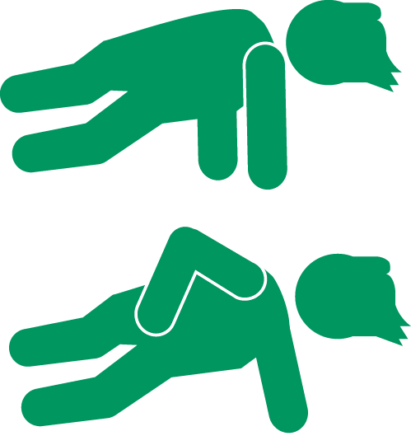
- Shift your weight to your left arm, and then pull an invisible dumbbell up to your shoulder with your right arm.
- Lower back to plank position. Repeat with the other side.
- Count 1 rep every time you complete a row with your left arm.
Muscle Focus: Pectoralis, Biceps

INVISIBLE DUMBBELL
DUMBBELL SQUATS
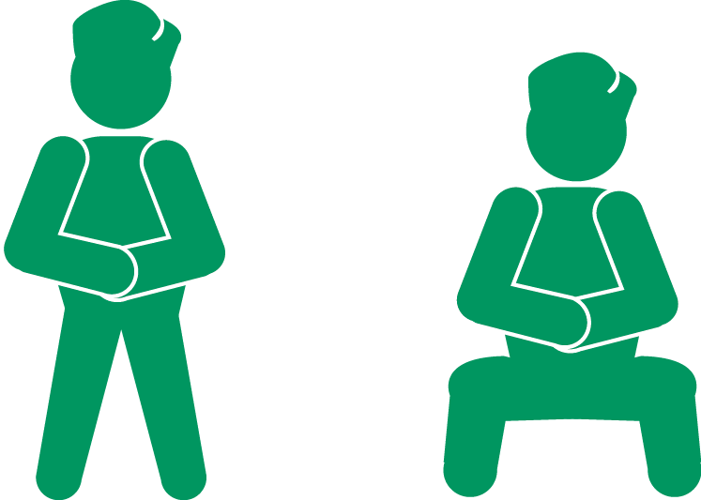
- Stand tall, feet wider than shoulder-width, holding the invisible dumbbell with both hands at the center of your chest.
- Squat down, keeping your knees above your toes, and then stand back up to the starting position.

Muscle Focus: Quadriceps, Gluteus Maximus

INVISIBLE DUMBBELL
DUMBBELL TRICEPS PUSH
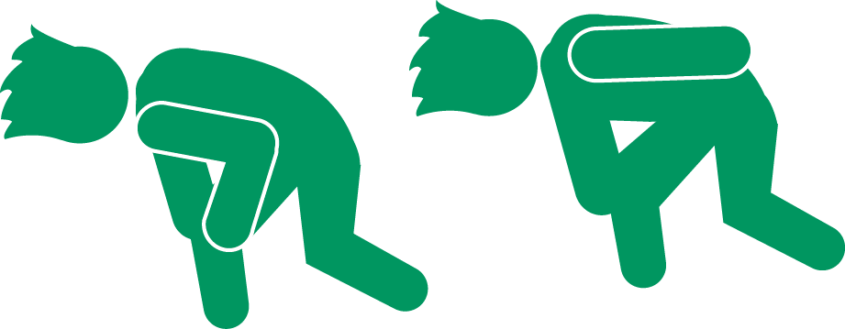
- Feet shoulder-width apart. Bend forward. Back straight, upper body parallel to floor.
- Invisible dumbbell in your right hand. Elbow close to your body and your arm bent at a right angle.
- Keeping elbow in place, push back. Extend arm until it’s straight. Slowly return to starting position.
Muscle Focus: Triceps

