FLOOR TAPE LINE GAMES

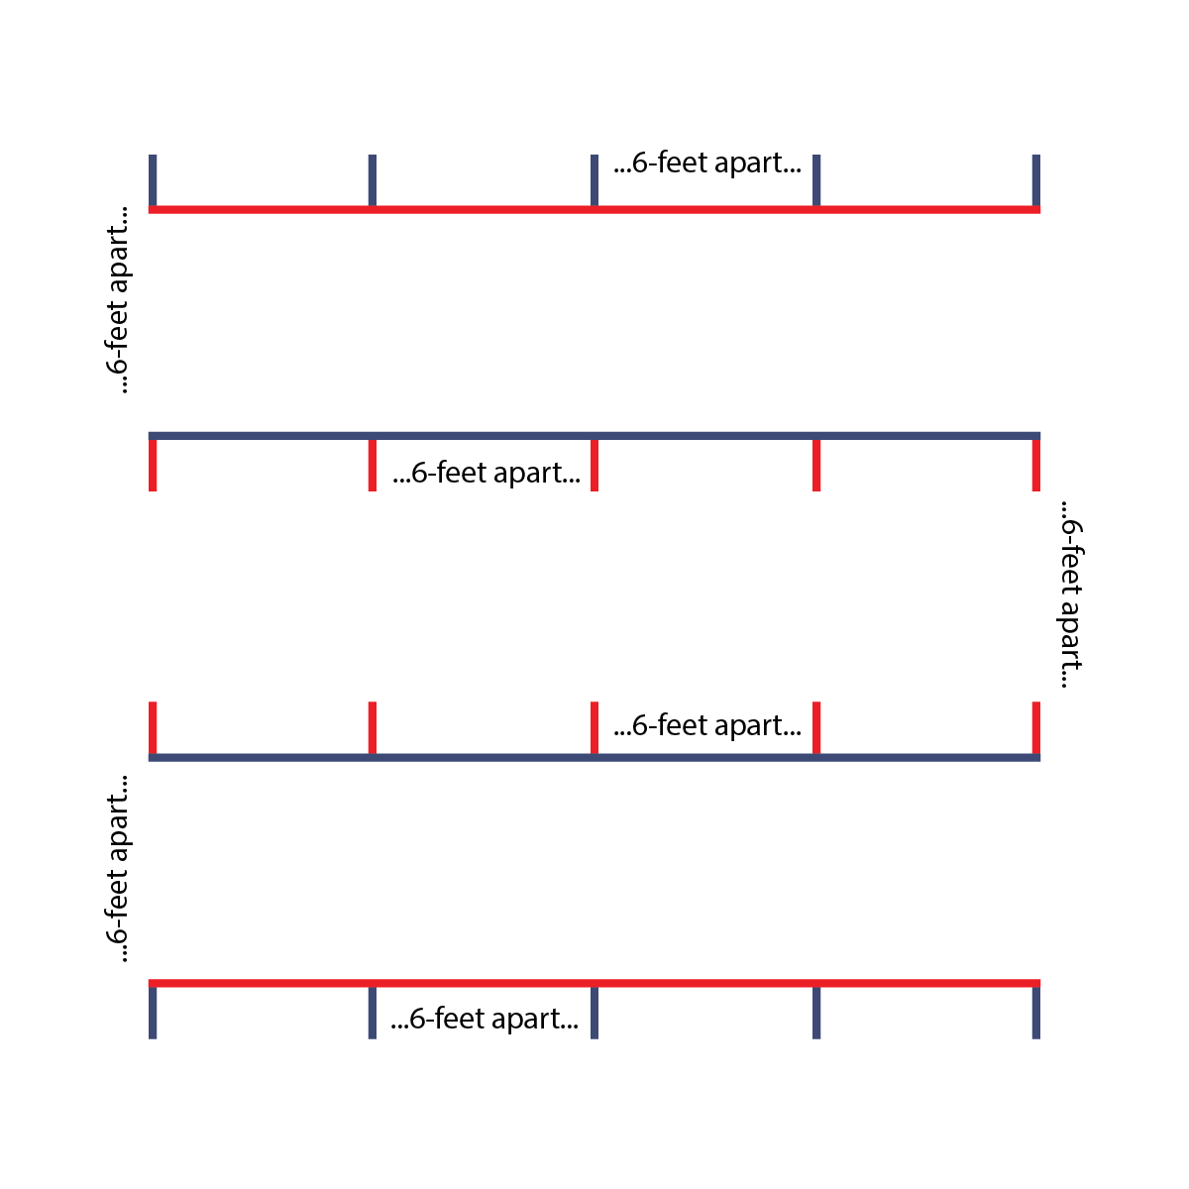
Notes to instructors:
This packet includes a series of group and partner games that can be done using four parallel lines marked with floor tape. (See diagram for set-up details.) These activities are fun, active, and interactive. The floor tape marks ensure safe physical distancing.

As with any game or activity resource, it’s up to you to assess the needs and abilities of the students under your supervision. Modify these games as needed to meet the requirements of your space, group size, and age ranges.

The pages of this packet are designed to be used as leader activity cards. We recommend that activity leaders use the cards to guide their instruction. Teach each game in large groups with all students properly spaced as you give instructions and a demonstration.

Every page includes a reminder to practice safe social distancing. All of the games in this packet were designed to allow students to remain a minimum of 6 feet apart and DO NOT require them to use or share equipment.

WHATCHA’ DOING?
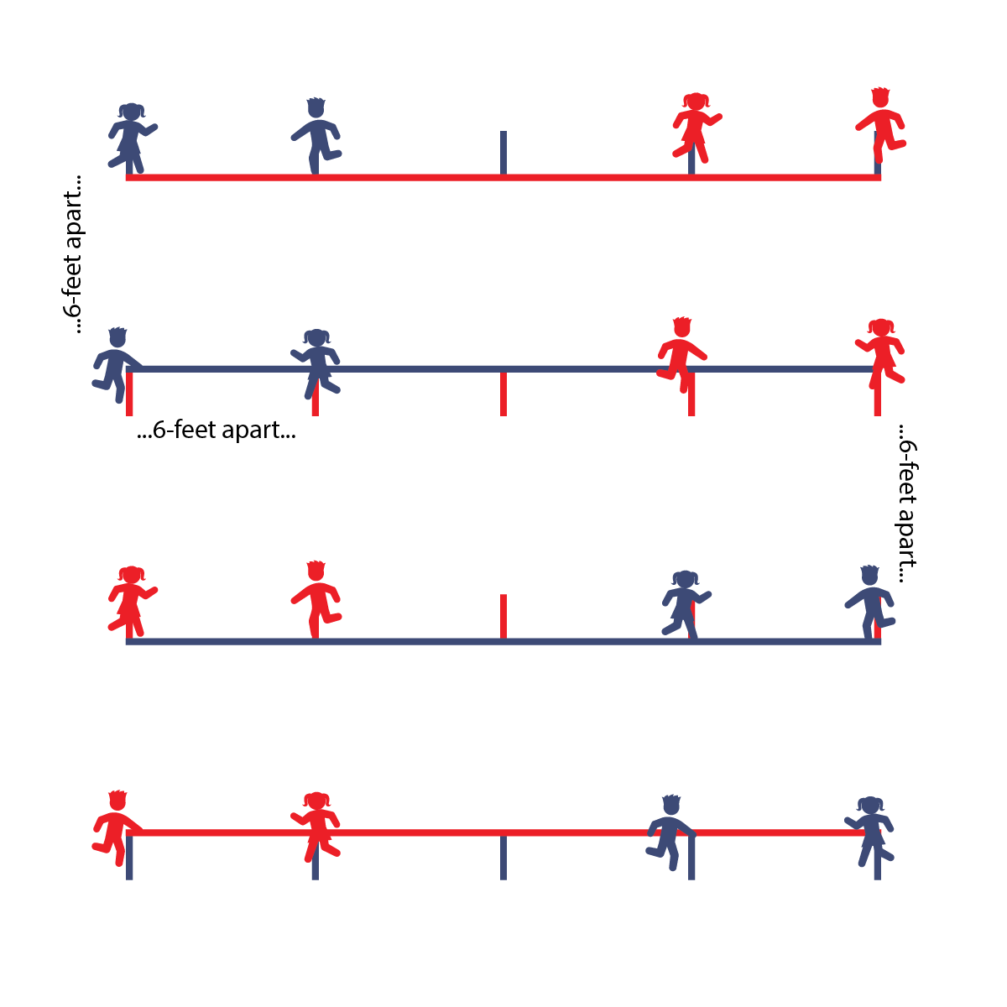
Game Set Up
- Use floor tape lines to make squares. Players in groups of 4 on the corners of the squares – 6’ apart as marked with floor tape.
Game Instructions
- 1 person starts as the actor and begins pantomiming a sport activity; for example, dribbling a basketball.
- The person to their right asks, “Watcha doing?”
- The actor responds with anything EXCEPT what they are actually doing; for example, “I’m swimming!”
- The person who asked becomes the new actor and immediately starts swimming.
- The person to their right now asks, “Whatcha doing?”
- The actor responds with something other than swimming, for example, “I’m climbing a mountain!”
- The new actor climbs a mountain, and so on, and on, and on.
Pantomime Activity Themes
- Healthy Habits: brushing teeth, sleeping, washing hands, etc.
- Chores: making a bed, sweeping the floor, washing dishes, etc.
- Occupations: flying a plane, building a bridge, teaching a class, painting a picture, etc.
- Wide Open and Silly: painting a rainbow, riding a llama, feeding my pet dragon, juggling piranhas, etc.
Extra Challenges
- Partner Showdown: In pairs. If actors don’t respond in 3 seconds, other partner gets a point actor does 10 jumping jacks.
- Fill in the Blank: Actors have to add a 2nd response by filling in the blanks of “I’m ________________ with a _____________.” (For example, “I am riding a bike with a porcupine.”)
- Two Groups: Students are in two groups, scattered 6’ apart from teammates. Instructor points to Group 1 and tells them what they are doing; for example, flying a kite. Group 1 immediately starts “flying a kite” (staying 6’ apart from others). Group 2 collectively asks, “Whatcha’ doing?” The instructor responds, “They are washing a rocket ship!” Group 2 starts washing a rocket ship. Group 1 asks, “Whatcha’ doing?” And so on, and so on, and so on.

WAVE RELAYS
Game Set Up
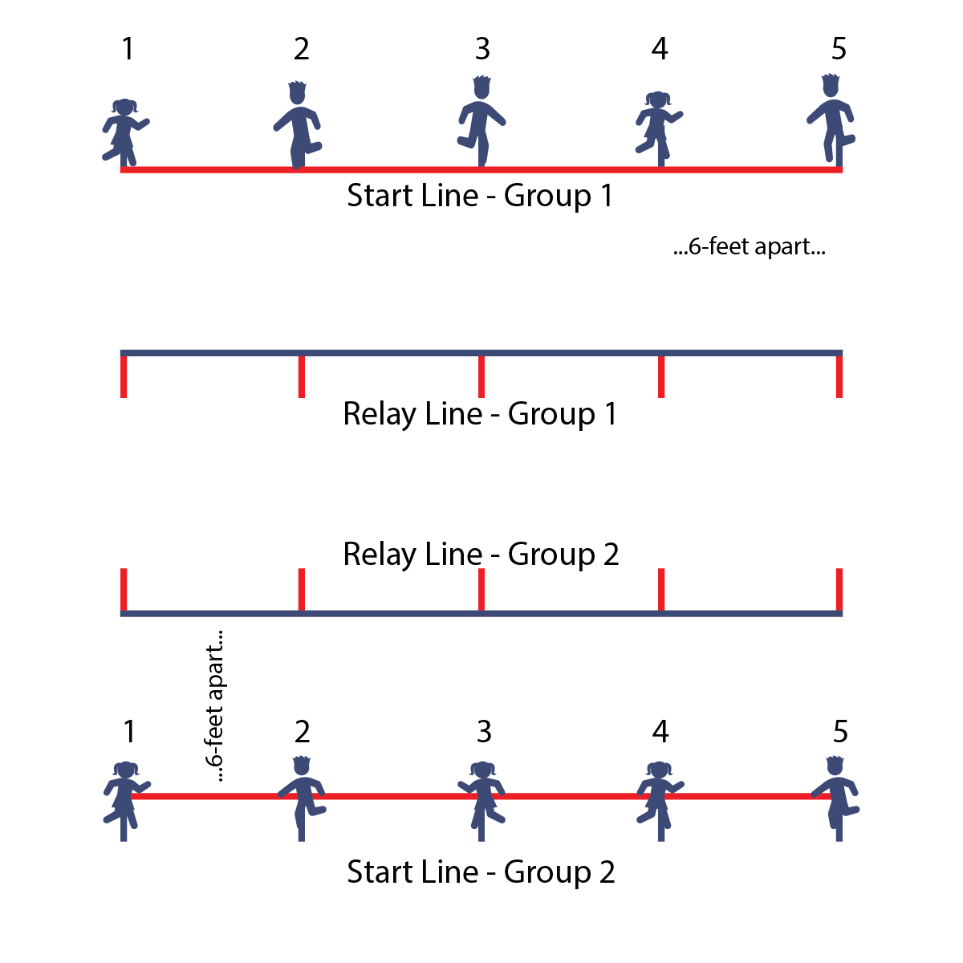
- Groups of 5–8. Stand 6’ away from your neighbor.
- Each group needs a “start line” and a “relay line” made from floor tape, set 6–8’ apart.
- Starting on one side of the each line, number the students, beginning at 1 through how many students there are in the line.

Game Instructions
- The objective of the game is to be the 1st team to complete the relay tasks. The race starts with student #1 and finishes with the last person in line.
- On the start signal, student #1 runs and touches the relay line, then returns and touches the start line.
- As soon as student #1 touches the start line, student #2 runs and touches the relay line, then returns and touches the start line.
- Continue until everyone in your group is finished. Remember, you can’t run until your neighbor has returned and touched the start line.

Extra Challenges
- Down & Back: The race starts AND finishes with student #1. The last person in line has to go twice, and then the traveling order goes in reverse until student #1 finishes the task.
- Add a Task: Add an exercise. For example, everyone has to do a burpee at the start line and 5 jumping jacks at the relay line.
- Travel Challenges: Instead of running, students must jump on 2 feet, crab walk, hop on 1 foot, bear walk, etc.

FIRST THINGS FIRST
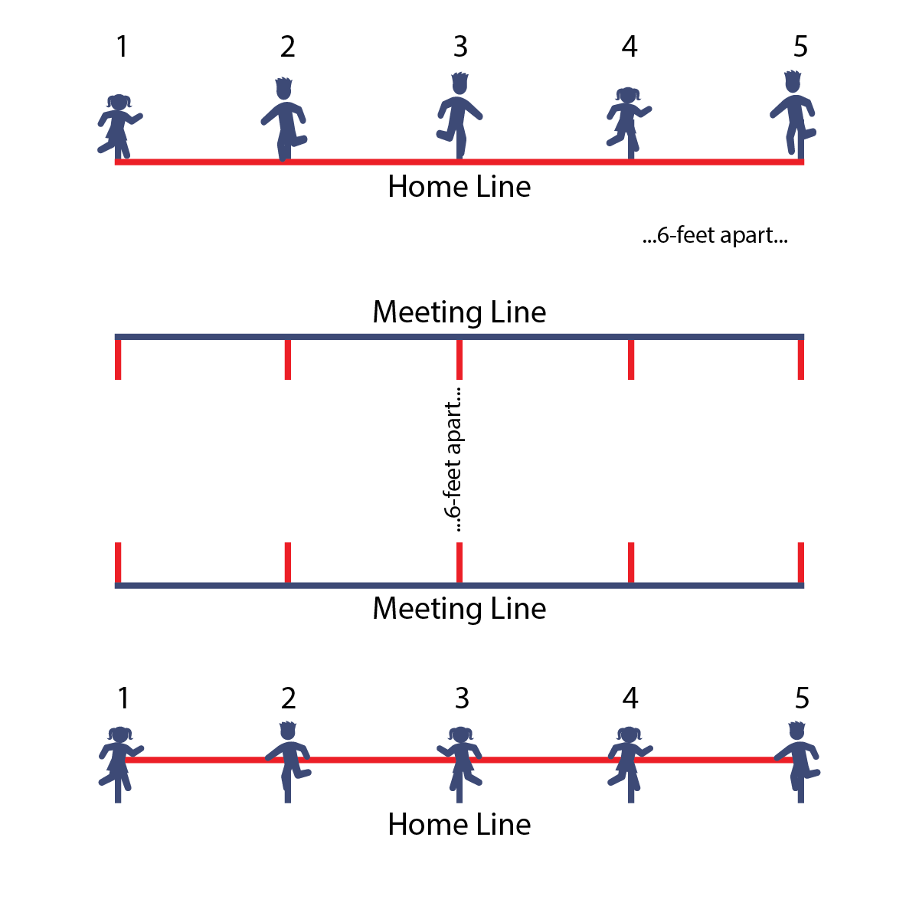
Game Set Up
- Work with a partner.
- Using floor tape, create 4 lines: a home line, a meeting line 12–15’ away, another meeting line 6–8’ away from the first meeting line one, and then another home line 12–15’ away from the second meeting line.
- Partners stand on their home lines, across from one another. (Stand 6’ away from people on either side of you).
Game Instructions
- The object is to create a sequence of 4–6 moves.
- Designate 1 side to be the “First-Things-First Partners.” This group will create the 1st move.
- On “Go!” partners travel toward one another and stop at their respective meeting Lines. The First-Things-First Partner creates a move or exercise that both partners do together. For example, burpee, virtual low-5 (no touching hands), superhero pose, etc.
- When finished, partners return to their home lines.
- Next, the students on the other side become Second-Things-Second Partners. On “Go!” partners return to their respective meeting lines, repeat the 1st move, and now add a Second-Things-Second Move. When done with both moves, partners return to their respective home lines.
- Repeat with the 1st group; now the Third-Things-Third Partners. Finish with the 2nd group and call them Last-Things-Last Partners. The result will be a sequence of 4 moves or exercises that pairs complete at the center line. (Feel free to add more moves.)
Extra Challenges
- For younger kids: Teach food groups. Whole Grains: wave hands and arms high above head. Fruit: jump up high and pick fruit from tree branches. Vegetables: push a shovel into the ground and dig up the vegetable. Lean Protein: pose in a double bicep-flex position. Dairy: pretend to milk a cow.
- For older kids: Play the song “Chariots of Fire” and have students complete the moves in slow motion.

BEST FOOT FORWARD

Game Set Up
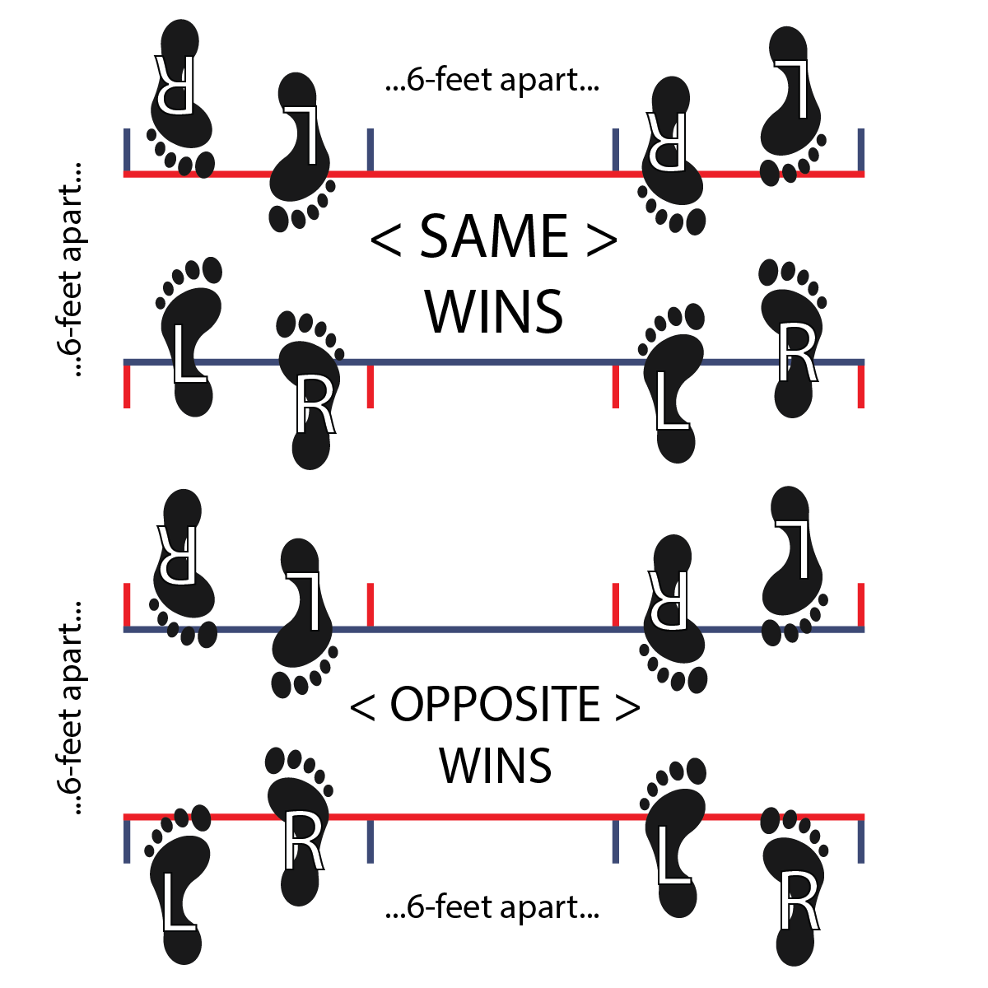
- Students work with partners. Use tape lines to ensure that students are at least 6’ apart.

Game Instructions
- The objective is to try and score 10 points.
- Decide who is SAME and who is OPPOSITE.
- Face each other — stay 6’ apart!
- Start with your feet together. Jump in place and count together: “1, 2, 3, SHOW!”
- On “SHOW,” land with 1 foot in front of the other.
- This is where it gets tricky. If both partners have the same foot in front, the SAME partner gets a point. This means either (1) you have your right foot forward and your partner has their right foot forward, or (2) you have you left foot forward and your partner has their left foot forward.
- If opposite feet are in front, the OPPOSITE partner gets a point. This means either (1) you have your left foot forward and your partner has their right foot forward, or (2) you have your right foot forward and you partner has their left foot forward.
- Play to 10 points. Give your partner a virtual first bump. Find another partner.

