BACKBOARD BANK IT

Get Ready: 5 Large Sock Balls, Laundry Basket or Bucket, A Wall

Get Set: Roll up the socks to make sock-balls. Place the basket or bucket against the wall. Mark a distance 5’ – 10’ from the basket.
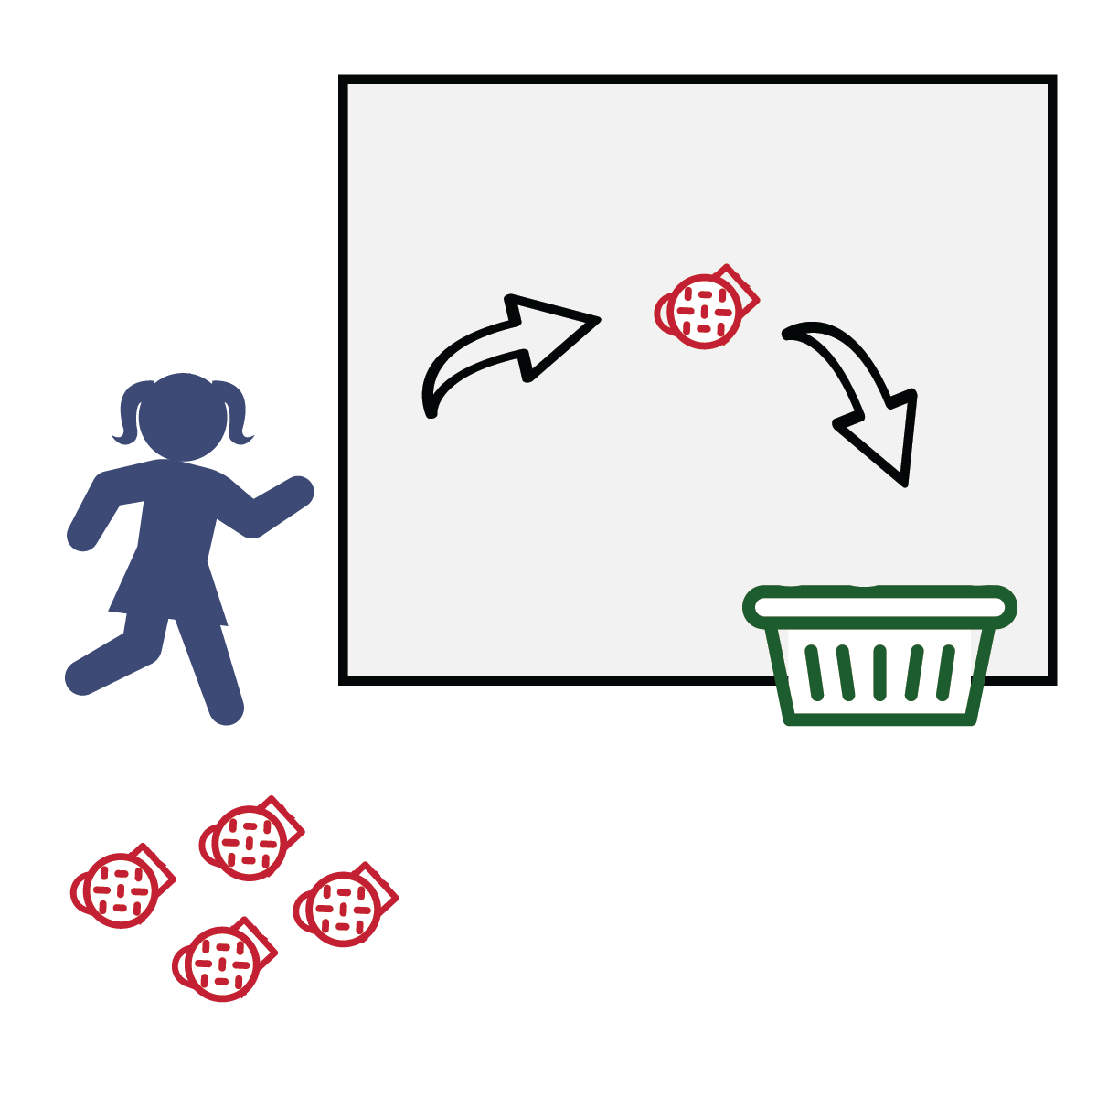
GO!
- This event is called Backboard Bank It.
- The object of this game is to score as many points as you can in 1 minute.
- Do that by tossing the sock balls off of the wall and into the basket. You MUST use the wall as your backboard and bank it into the basket.
- Score a point for every sock that is banked into the basket.
- Write your score down on the official Field Day Score Card.

COIN FLIP 400-METER DASH

Get Ready: 1 Coin

Get Set: Find an open space with enough room to run in place safely.
Hold the coin in your hand – be ready to flip it.

GO!
- This event is the Coin Flip 400-Meter Dash!
- The object is to run 400 running steps as fast as you can. Remember, you’re running in place. Your feet move, but you stay in one spot.
- On the start signal, flip the coin. Let it land flat on the floor. If it lands on “heads” run 20 running steps and then flip the coin again.
- If the coin lands on “Tails” do not run. Flip again until it lands on heads.
- Count your steps out loud. When you get to 400, time stops, and the dash is over.
- Record your time on the official Field Day Score Card.

FAN-A-WAR

Get Ready: 1 Paper Plate (Piece of Cardboard or a School Folder) per Player, Center Line (2 Shoes or Cups will work) 1 Ping Pong Ball or a Balloon

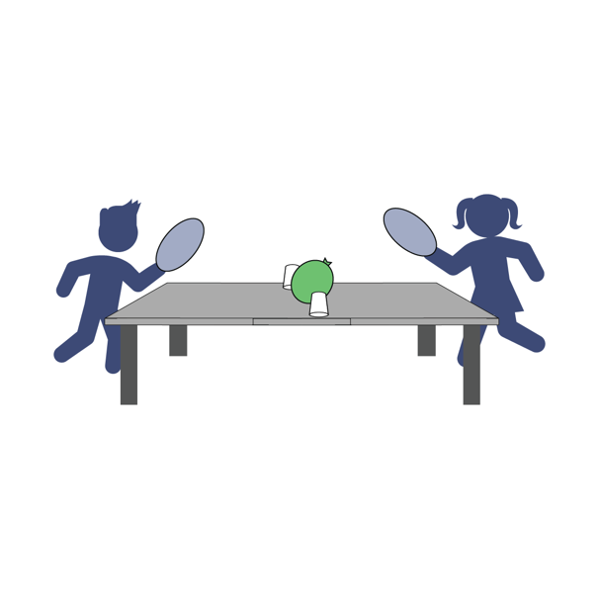
Get Set: Create a center line on a table or the floor. Place the balloon or ball on the center line. Both players across from each other with the centerline in between them.

GO!
- This event is called Fan-a-War.
- The object of this game is to keep the ball on the opponent's side of the center line. You will have 1 minute.
- On the start signal, begin fanning the ball toward your opponent’s side of the center line and away from your side.
- Continue for 1 minute. Score 5 points if the ball is on your opponent’s side.
- Play and score 2 rounds and then write your score
down on the official Field Day Score Card.

FAST FOLDER

Get Ready: 10 Clothing Items from a Laundry Basket for Each Player

Get Set: Place 10 items from your laundry basket in a pile next to you.
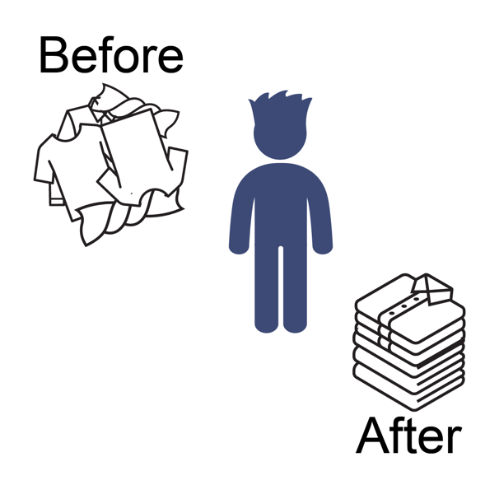
GO!
- This event is called Fast Folder.
- The object of this game is to score points by folding each item (shirt, pants, shorts, etc.). You have 1 minute to fold as many as possible.
- On the start signal, begin folding each piece of laundry.
- Score 1 point for each piece of laundry folded in one minute. Max 10 points.
- Write your score down on the official Field Day Score Card.

FLIP YOUR LID

Get Ready: Kitchen Spatula, 1 Tupperware/Plastic Lid

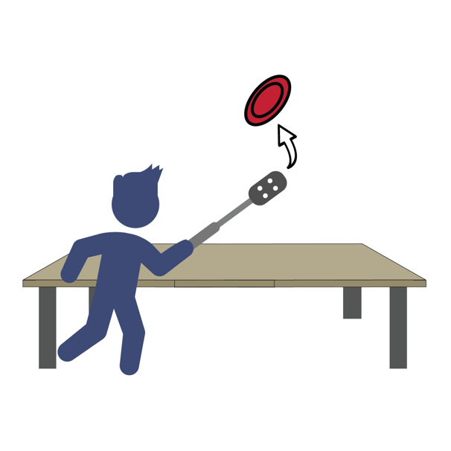
Get Set: Place the lid facing up on a table or floor. Get your spatula ready for some lid flipping!

GO!
- This event is called Flip Your Lid.
- The object of this game is to flip your Tupperware lid upside down to earn points.
- Place the lid facing up on the table or floor, then slide the spatula under and flip the lid in the air. Let it land flat on the table or floor.
- Score a point for every lid that you flip upside down (0 points if it lands right-side up).
- Quickly reset the lid each time you flip it.
- You will have 1 minute to see how many times you can flip
the lid upside down.
- Write your score down on the official Field Day Score Card.

KEEP IT UP

Get Ready: 1–3 Balloons Per Player – Blow Them Up
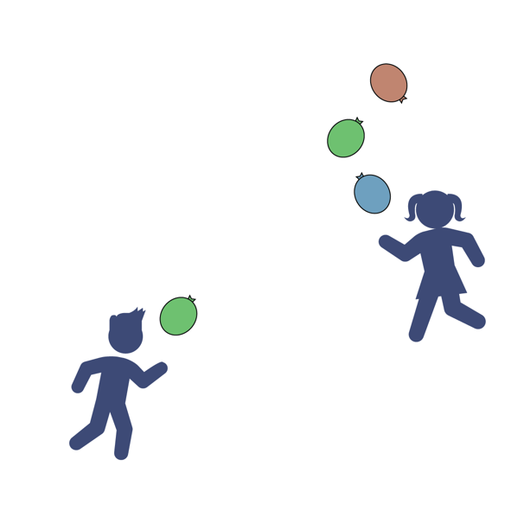
Get Set: Clear a 10’ indoor or outdoor space. Start with 1, 2 or 3 balloons.

GO!
- This is Keep It Up. The object is to strike the ball(s) up using your hands as many times as you can in 1 minute.
- Don’t let it (them) hit the floor.
- On the start signal, strike the balloon(s) upward with your hands and count how many hits you can score in 1-minute.
- If using multiple balloons, alternate striking each balloon. Don’t strike the same balloon twice.
- If the balloon hits the floor, pick it back up and continue.
- On the stop signal, record your score on the official
Field Day Score Card.

LOOK FOR THE GOOD

Get Ready: An Object to Mark Your Home Base

Get Set: Mark a Home Base anywhere in your house. You will be bringing objects back to this spot.

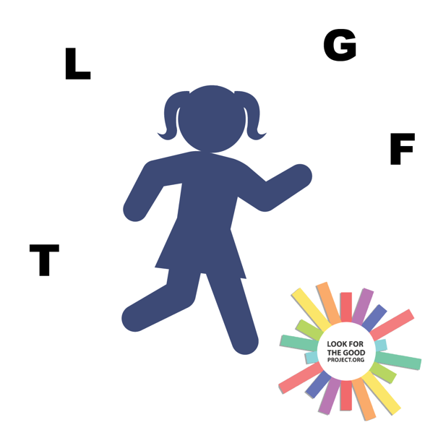
GO!
- This event is called Look for the Good!
- The object is score points by finding 4 objects in your house (1 at a time) that start with the letters L–F–T–G (Look For The Good).
- You have 1 minute to find them all.
- Score 1 point for each object and a bonus point if you find all 4 (maximum 5 possible points).
- On the start signal, leave home base and go find an object that starts with the letter L. When you find it, return the object to home base before looking for the next object. Continue until you find all 4 items,
or time runs out.
- Record your score on the official Field Day Score Card.

SCAVENGER HUNT

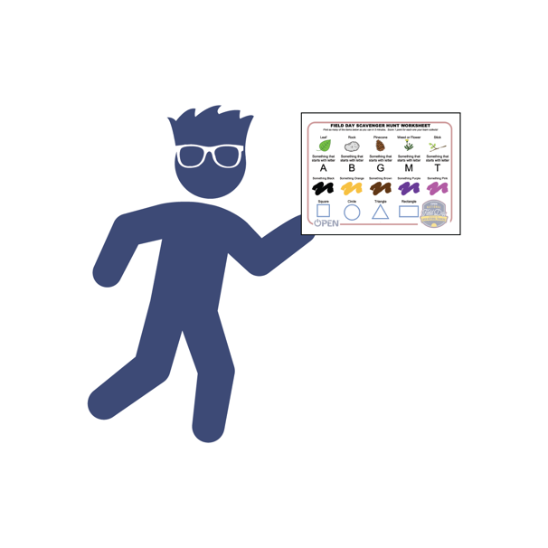
Get Ready: Scavenger Hunt Worksheet

Get Set: Have a printed copy of the Scavenger Hunt Worksheet. The items you have to find are things lying around your house and/or yard.

GO!
- This event is called Field Day Scavenger Hunt.
- The object of this game is to find as many items listed on the worksheet as possible in 5 minutes.
- On the start signal, search around your house and/or yard and collect the items that fit the description on the worksheet.
- Score a point for every item that you find. If an item can’t be collected/moved, simply check it off on your scavenger
hunt worksheet.
- Record your score on the official Field Day Score Card.

TENNIS SHOE TOWER

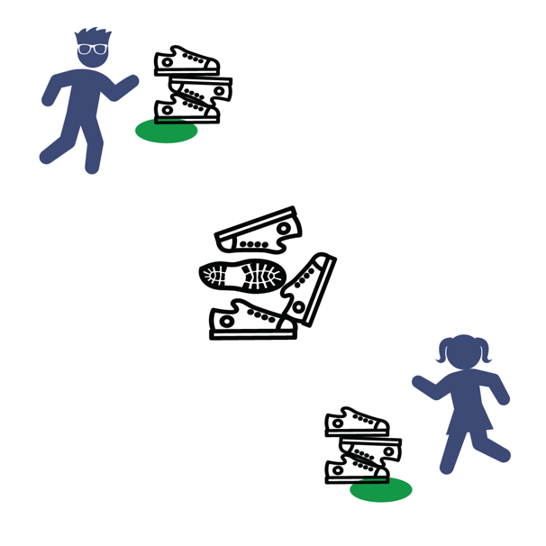
Get Ready: 5-10 Shoes per Player, 1 Spot Marker per Player to Create Home Base for Each Player (paper plate, cups, sock etc.)

Get Set: Place shoes in a pile in the center of the room. Place Home Base spots 6’-10’ from the pile and 6’ apart from other players.

GO!
- This event is called Tennis Shoe Tower.
- The object is to build a shoe tower with shoes collected from the pile.
- On the start signal, players will run and take 1 shoe from the pile, return it to their home base and place it on their shoe tower.
- Repeat till all the shoes are gone. (Run – Grab – Stack – Repeat!)
- If the tower falls, that's okay. Continue stacking to rebuild
and continue.
- On the stop signal, count and score 1 point for each shoe
in the tower.
- Write your score down on the official Field Day Score Card.

WASH YOUR HANDS RELAY

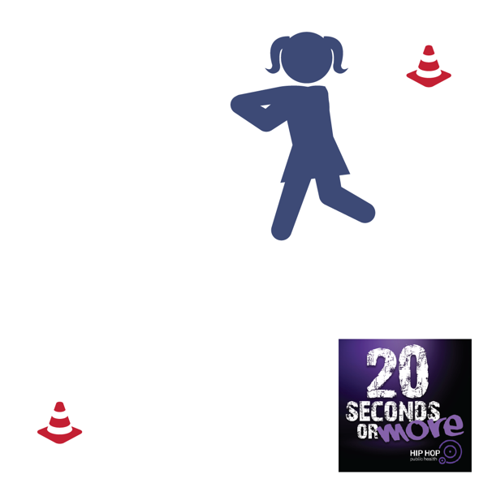
Get Ready: 20 Seconds or More Music by Doug E. Fresh, 2 Objects (shoes, cones, plastic cups)

Get Set: Create 2 end lines by setting objects 6’ to 12’ apart in an area safe for movement. Play 20 Seconds or More by Doug E. Fresh

GO!
- This event is called Wash Your Hands Relay!
- The song 20 Seconds or More helps to teach us how to wash our hands and keep our family safe from disease.
- The object of this game is to move from line-to-line as many times as you can in 1 minute while pretending to wash your hands.
- You must walk, skip, or gallop. Running or jogging is not allowed.
- On the start signal, begin moving from line-to-line.
- Count each time that you move to an end line.
- On the stop signal, record your score on the official
Field Day Score Card.

