SPOON RELAY

Get Ready: 1 spoon, 1 object to balance (small ball, marble, small toy), Items to Mark Start/Check Points (cones, socks, plastic cups, etc.), Clock or Stopwatch

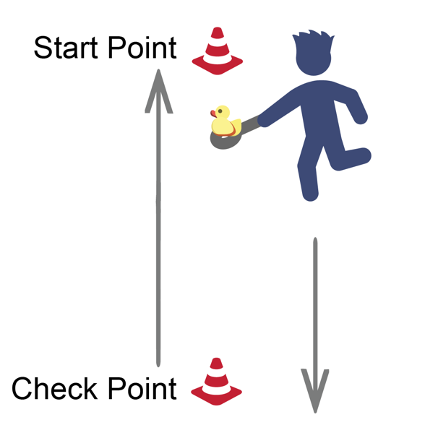
Get Set: Set a starting point and a check point. Distance can be 15 to 30 walking steps from beginning to end. At the start point, get ready by placing the object on the spoon and balance it.

GO!
- This is the Spoon Relay. You have 1 minute to Score points by completing laps with an object balanced on a spoon.
- On the start signal, move carefully from the starting point to the check point and back again
(1 lap).
- Complete as many laps as possible without a drop.
- If you drop the object, stop walking, place it on the spoon,
and begin again.
- Score 1 point for each lap completed without a drop.
- Write your score down on the official Field Day Score Card.

CLOTHES RELAY

Get Ready: Oversized Tee Shirt, Oversized Shorts, and a Hat; Items to Mark Start/Check Points (cones, socks, plastic cups, etc.); Clock or Stopwatch

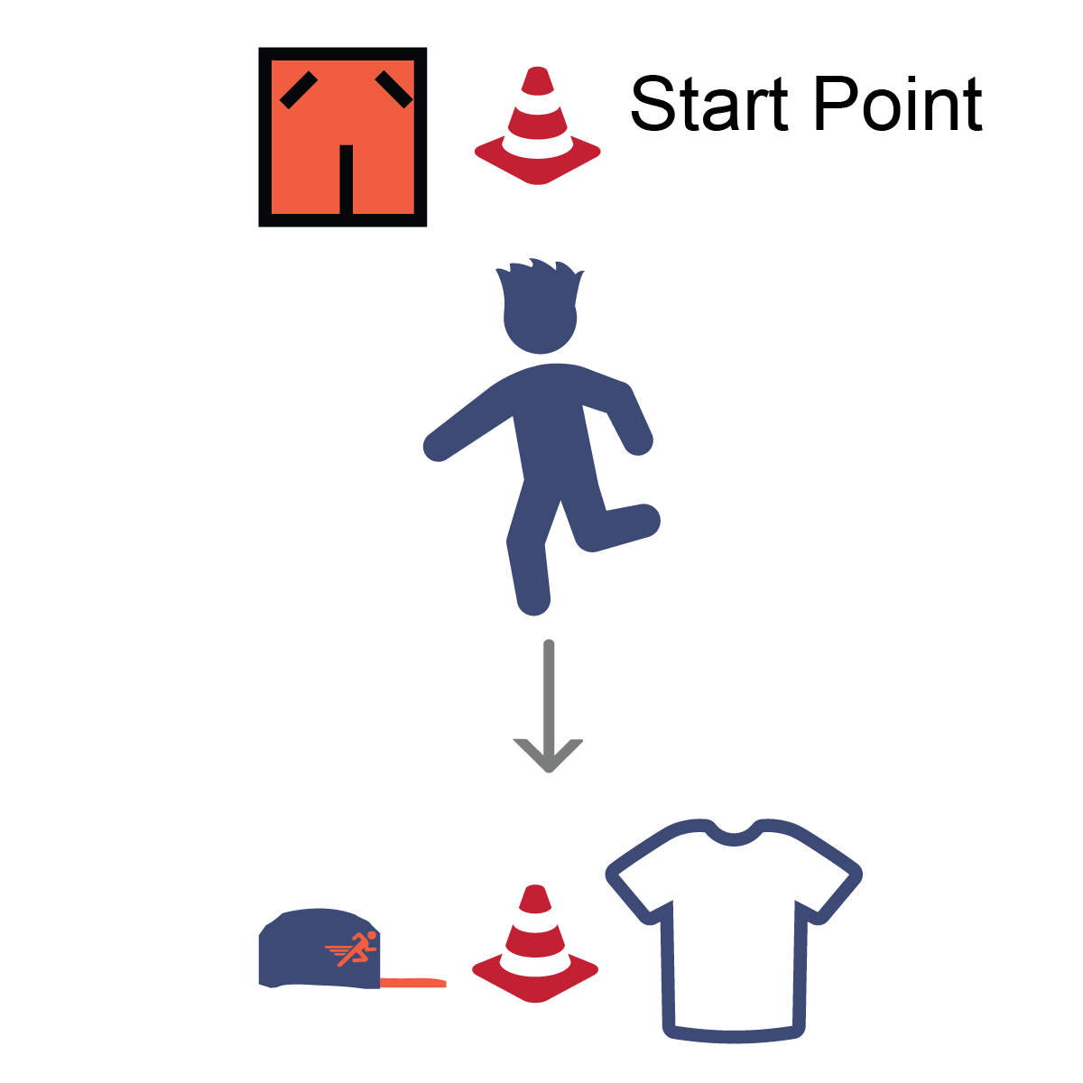
Get Set: Set up an area to move in by making a starting point and a check point. Distance can be 15 to 30 walking steps from point to point. Put the shirt and hat on the check point opposite from the start point, put the shorts on the start point.

GO!
- This event is called the Clothes Relay. The object of this game is to see how fast you can go from point to point putting on the clothes and then finishing at the starting point.
- On the start signal, jog down to the check point and put on the t-shirt, then jog back to the start point and put on the shorts, then jog back to the check point and put on the hat, then jog back to finish at the start point.
- Start the Clock on “Go” and stop when you cross the finish
with all the clothes on.

