FIELD DAY SCAVENGER HUNT WORKSHEET
Find as many of the items below as you can in 5 minutes. Score 1 point for each one your team collects!

Leaf | Rock  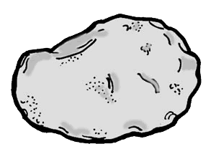 | Pinecone  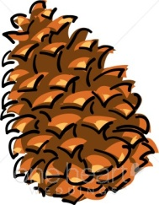 | Weed or Flower  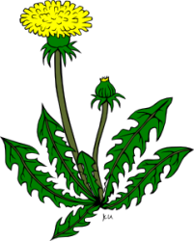 | Stick  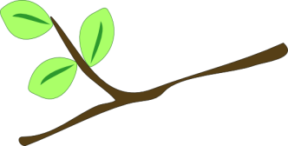
Something that starts with letter  A | Something that starts with letter  B | Something that starts with letter  G | Something that starts with letter  M | Something that starts with letter  T
Something Black | Something Orange | Something Brown | Something Purple | Something Pink
Square | Circle | Triangle | Rectangle

