BOWL BALL

Get Ready: 6 Bowls, 1 Sock Ball, Paper & Pencil to Tally Score

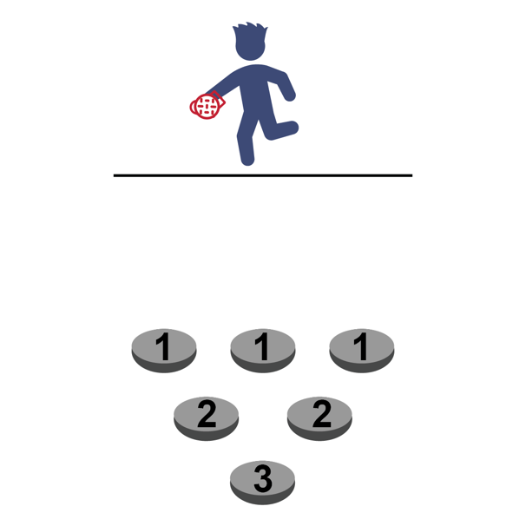
Get Set: Set the bowls on the floor in a triangle pattern 3-4 inches apart. Put a piece of paper with the point total in the bottom of each bowl. Mark a throwing line 6-8 ft. away.
Hint: Big bowls are easier than small bowls!

GO!
- The object of the game is to see how many points you can score in 1-minute.
- You do this by tossing the sock ball into the bowls and scoring points based upon where they land.
- After each throw, retrieve the sock ball and hustle back and throw again.
- If the sock lands in a bowl, use the pencil and paper to tally the points for that bowl.
- After 1-minute, calculate your tally and write your total number of points on the official Field Day Score Card.

Water Bottle Trap

Get Ready: 1 Empty Water Bottle, 1 Laundry Basket, 1 Sock/Tennis Ball

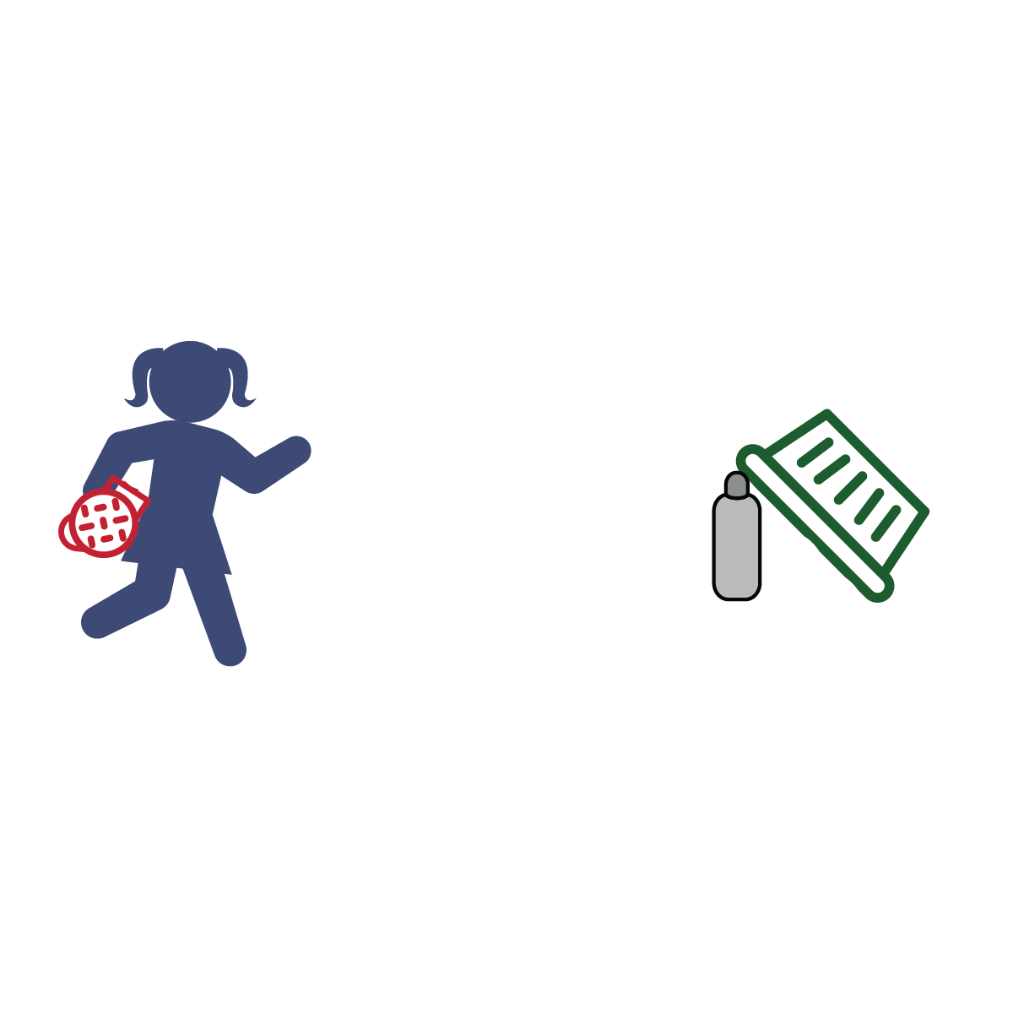
Get Set: Lean the edge of the laundry basket on top of the empty water bottle. Designate a rolling line 8-10 ft. away (the open side of the laundry basket should be facing you).

GO!
- The objective is to see how many points you can score in 1-minute.
- Do this by rolling the sock/tennis ball at the water bottle.
- To score the ball must hit the water bottle first (the roll does not count if it misses the bottle and knocks over the basket – sorry!).
- Rolls that hit the water bottle first score as follows:
1 point = basket falls and traps ball only
2 points = basket falls and traps water bottle only
3 points = basket falls and traps both ball and water bottle
- Write your total number of points on the official Field Day Score Card.

PENGUIN RACE

Get Ready: 1 Sock or Tennis Ball and 2 Plastic Cups per Person
Get Set: Set the plastic ups 15-20 ft. from each other.
GO!
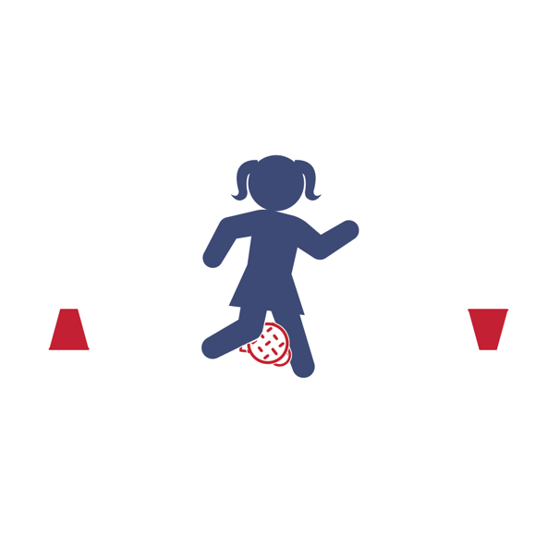
- You are a Penguin – the ball is an egg.
- There are 2 different ways to play:
(1) By Yourself or (2) Race A Partner.
- By Yourself Challenge – How many points you can score in 1-minute?
- Place the egg between your knees and waddle back and forth from one cup to the other. When you reach the cup, turn it over.
- If you drop the egg, do 5 jumping jacks before you continue.
- Score 1 point for each cup you turn over.
- Race A Partner Challenge – Be the first Penguin to turn over 6 cups!
- On the start signal, waddle to the first cup and turn it over.
- Now hustle back to the other cup (as much as one can hustle while waddling). Continue back and forth.
- If you drop the egg, do 5 jumping before you continue.
- First to turn over 6 cups wins the race (scores 6 points).
CLIMB THE LADDER

Get Ready: 6’ Ladder, 6-12 Sock Balls, Laundry Basket, Empty Water Bottle
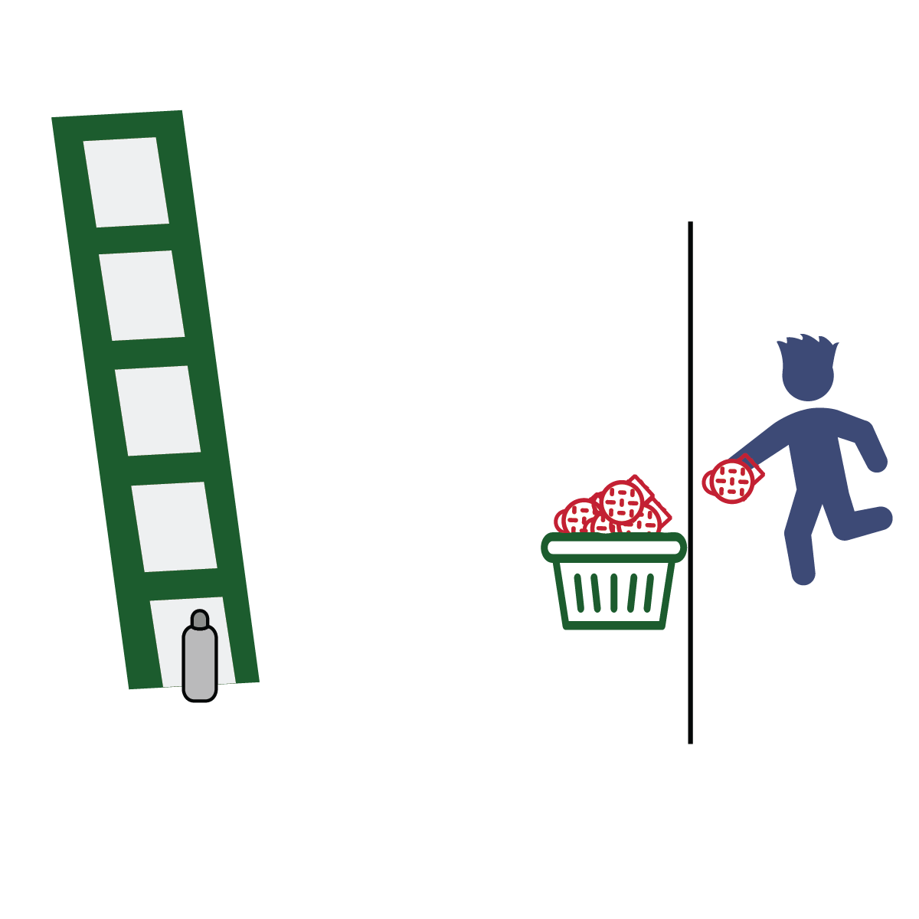
Get Set: Set up the ladder. Place the water bottle on the floor under the first rung. Mark a throwing line 10-15 ft. away. Place the laundry basket on the throwing line. Put all the sock balls inside the basket.

GO!
- “Climb the ladder” using the fewest throws.
- Start with the bottle on the floor under the first rung.
- Throw sock balls at the bottle until you knock it over. Take your time, this is not a race.
- Move the bottle up one rung each time you knock it off the ladder.
- If you run out of sock balls, collect them and continue.
- Count all of your throws on every step of the ladder. How
many throws does it take to knock the bottle off of the top
rung of the ladder?
- Write the total throws on the official Field Day Score Card.
IF THE SHOE FITS

Get Ready: 1 Tennis Shoe, Spacious Area, Clean Feet

Get Set: Make sure you have plenty of unobstructed space around you.

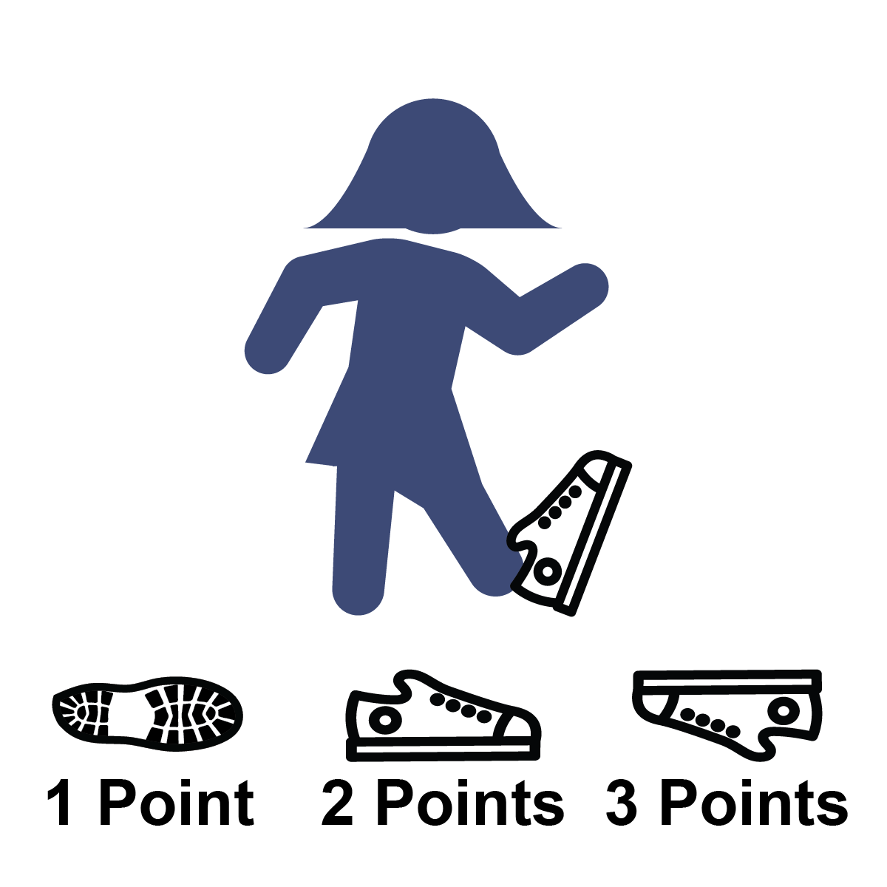
GO!
- How many points you can score in 1-minute?
- Put your foot partially into the tennis shoe.
- On the start signal, flip the shoe into the air.
- Score as follows:
1 point = shoe lands on its side
2 points = shoe lands right side up (sole of the shoe on the ground)
3 points = shoe lands perfectly upside down (no sides touching the ground)
0 points = if the shoe hits you in the head or knocks over a lamp.
- Write your total number of points on the official Field Day Score Card.
- Go wash your foot.

