CORNER NUMBER 1

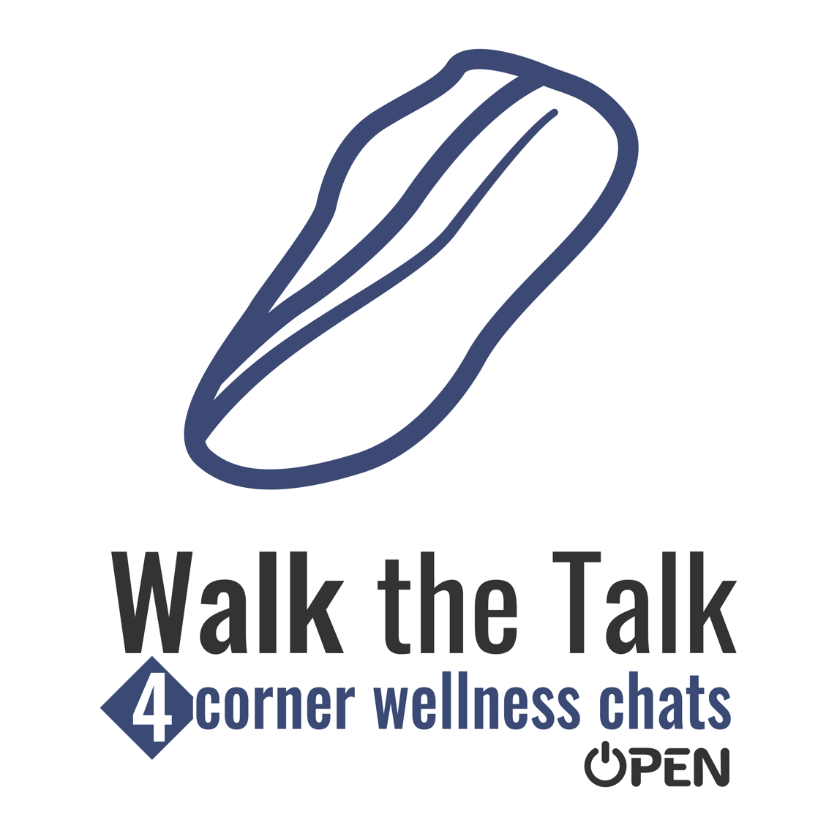 | TOPIC: ENCOURAGEMENT  QUESTION:  Can you remember the last encouraging words that you said to someone?  What did you say and  how did your words  make that person feel?

WEEK NUMBER 3

CORNER NUMBER 2

TOPIC: WELLNESS

QUESTION:

Support systems can
help us stay on track with wellness goals.

How do you support the wellness goals of the people you care about?

WEEK NUMBER 3

CORNER NUMBER 3

TOPIC: NUTRITION

QUESTION:

It’s easy to eat whatever tastes good and is in front of you.

It can take encouragement to find the foods that taste good and are really good for you too.

What nutritious foods
do you like to eat?

WEEK NUMBER 3

CORNER NUMBER 4

TOPIC: SMILES

QUESTION:

What was the last thing that
really made you smile?

What was so awesome about it that it made you happy?

WEEK NUMBER 3

