Solve the crossword puzzle. Perform the exercises after each clue for 30 seconds before moving to the next clue. There are 15 total exercise intervals for a 7-minute & 30-second interval workout.

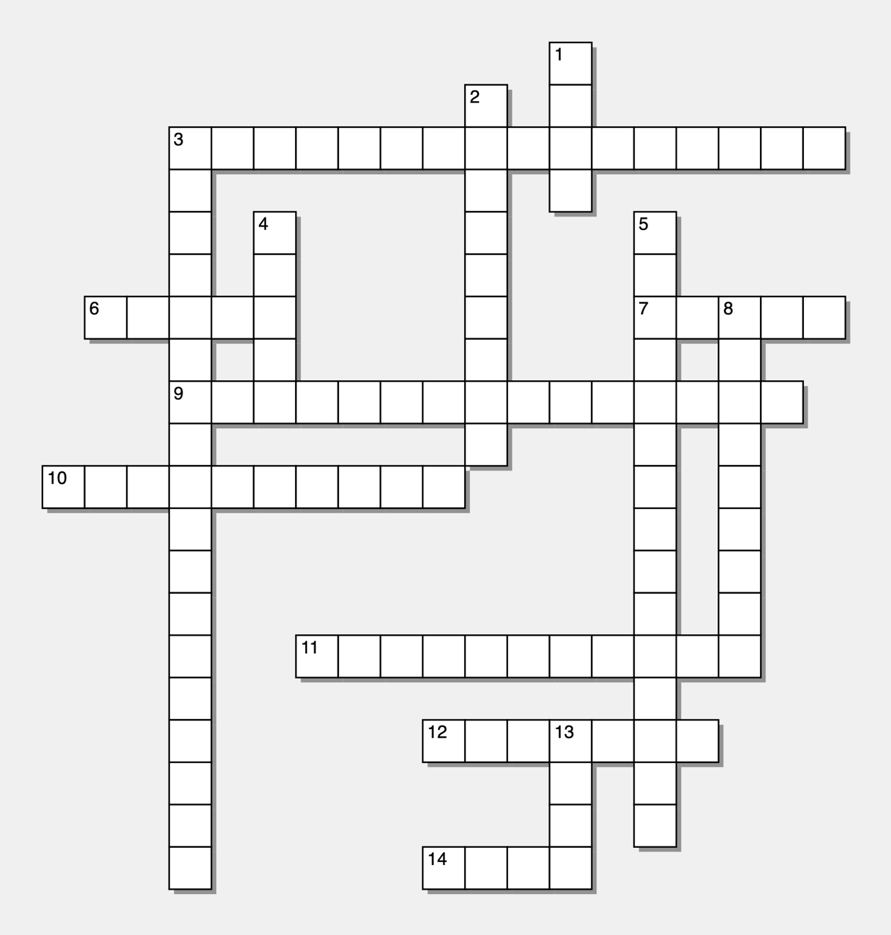

Across  3) Maximum force that a muscle can produce. (Split Jacks)  6) Sweet, edible parts of trees and plants. (Jumping Jacks)  7) Foods, primarily made from milk products, that provide a significant source of calcium. (Half Jacks)  9) The ability of the body to take in, transport, and use oxygen during physical activity. (Jumping Jacks)  10) Edible parts of plants which can include roots, leaves, and flowers. (Side Jacks)  11) The ability to move muscles and bones through the range of motion created by skeletal joints. (Seal Jacks)  12) Foods that provide a significant source of protein such as meat, beans, eggs, soy, nuts, and some seeds. (Seal Jacks)  14) The duration of a physical activity session. (Twist Jacks) | Down  1) Four elements needed for a comprehensive fitness plan. (Twist Jacks)  2) How often something happens. (Half Jacks)  3) The ability of a muscle to continue to perform without fatigue. (Plank Jacks)  4) A colorless, transparent liquid that forms the basis of the fluids that are required for life. (March Jacks)  5) The ratio of lean tissue to fat tissue. (Side Jacks)  8) The amount of sustained effort used during physical activity. (March Jacks)  13) The category associated with an activity – aerobic, strength, mindfulness, etc. (Split Jacks)

