1-Minute Balance Challenge
YouTube Video Demo

The object of this activity is to perform 5 different balance poses (1 per day) for 1 minute at a time. Try 3 different times per day with the same pose. Each day, after your balance practice, rate your balance in the chart below.

As you balance, focus on your breathing and on finding your center of gravity.

Day # | Balance Pose | Balance Rating  1 = not so good 10 = perfect
DAY 1  CHAIR | 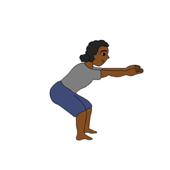 | 1 2 3 4 5 6 7 8 9 10
DAY 2  DOWN DOG | 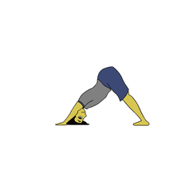 | 1 2 3 4 5 6 7 8 9 10
DAY 3  OWL | 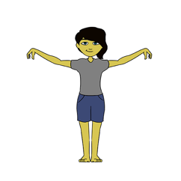 | 1 2 3 4 5 6 7 8 9 10
DAY 4  TALL MOUNTAIN | 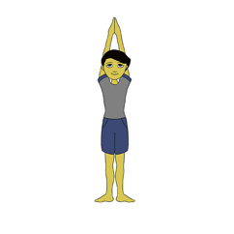 | 1 2 3 4 5 6 7 8 9 10
DAY 5  TREE | 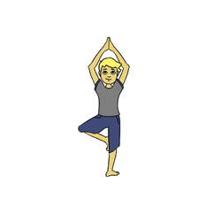 | 1 2 3 4 5 6 7 8 9 10

