Print this guide and record your progress on paper.
Or, import this document into your school e-learning system
and record progress electronically.

Student Name |  | Start Date

INTERMEDIATE GRADES 3-5

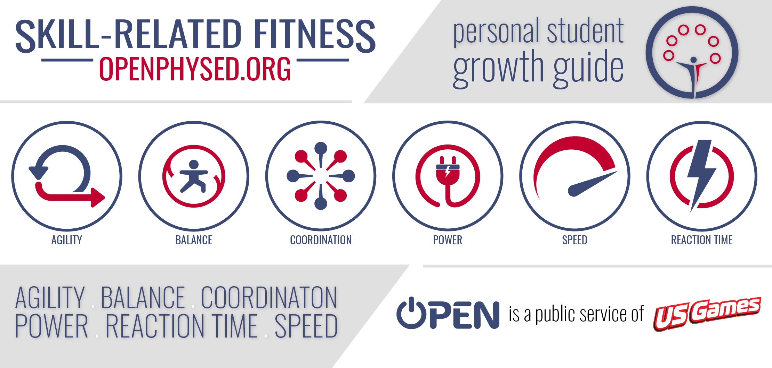

This growth guide is a week-by-week journey designed to help you develop physical and emotional skill-related fitness. Each skill is an essential component of a healthy, active, and optimistic lifestyle.

Created by Nick Kline & Aaron Hart

About this Growth Guide

Throughout this learning module, you will use skill-related physical fitness and skill-related emotional fitness to clear a path toward optimism and positivity. However, as usual, there’s more than one possible path, and not all roads lead in a positive direction. By completing each of the 6 skill-related challenge badge activities you are choosing an optimistic path.

In every person’s journey, challenges build character. How we choose to face challenges oftentimes is the greatest predictor of personal success or disappointment. Use grit, growth mindset, and emotional intelligence to navigate skill-related challenges. Work to improve physically and mentally. Success is a long-game that is built upon lessons learned through trial and error, advancements and setbacks, hard work, and determination.

You can choose a path to optimism, positivity, and success. We believe in you. Go be great.

Using this Growth Guide

Define (Read Definitions) | Read and discuss the definitions of physical and emotional skill-related fitness.
Demonstrate (Warm-Up) | Complete the health-related warm-up activity provided for each week.
Demonstrate (Physical) | Complete the skill-related physical fitness 5 days and track your improvement.
Demonstrate (Emotional) | Complete the skill-related emotional fitness activity at least 1 time during the week.
Share (Physical) | Discuss the week’s physical fitness component a friend or family member.
Share (Emotional) | Discuss the week’s emotional fitness component a friend or family member.

Table of Contents

Intro 1 About this Growth Guide

Intro 2 Badge Tracker

Week 1: Agility
(Aerobic Warm-Up, Physical Agility, Emotional Agility)

Week 2: Balance
(Muscular Fitness Warm-Up, Physical Balance, Emotional Balance)

Week 3: Coordination
(Flexibility Warm-Up, Physical Coordination, Emotional Coordination)

Week 4: Power
(Muscular Fitness Warm-Up, Physical Power, Emotional Power)

Week 5: Reaction Time
(Aerobic Warm-Up, Physical Reaction Time, Emotional Reaction Time)

Week 6: Speed
(Flexibility Warm-Up, Physical Speed, Emotional Speed)

Each week of this skill-related learning module, you have the opportunity to earn a Component Badge. To earn a badge, you must complete all 6 of the week’s Component Tasks. Record the date that each task has been fully completed in the right column below.

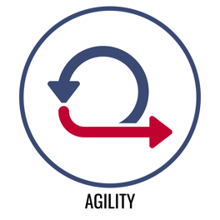 | Define (Read Definitions)
 | Demonstrate (Warm-Up)
 | Demonstrate (Physical)
 | Demonstrate (Emotional)
 | Share (Physical)
 | Share (Emotional)
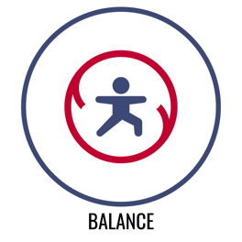 | Define (Read Definitions)
 | Demonstrate (Warm-Up)
 | Demonstrate (Physical)
 | Demonstrate (Emotional)
 | Share (Physical)
 | Share (Emotional)
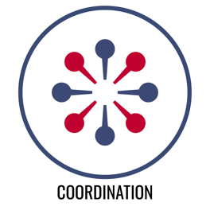 | Define (Read Definitions)
 | Demonstrate (Warm-Up)
 | Demonstrate (Physical)
 | Demonstrate (Emotional)
 | Share (Physical)
 | Share (Emotional)
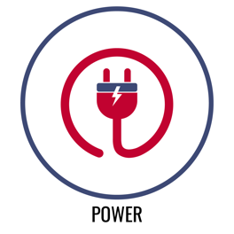 | Define (Read Definitions)
 | Demonstrate (Warm-Up)
 | Demonstrate (Physical)
 | Demonstrate (Emotional)
 | Share (Physical)
 | Share (Emotional)
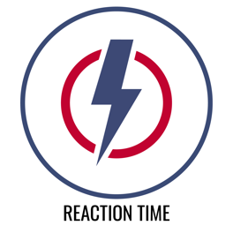 | Define (Read Definitions)
 | Demonstrate (Warm-Up)
 | Demonstrate (Physical)
 | Demonstrate (Emotional)
 | Share (Physical)
 | Share (Emotional)
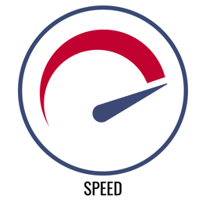 | Define (Read Definitions)
 | Demonstrate (Warm-Up)
 | Demonstrate (Physical)
 | Demonstrate (Emotional)
 | Share (Physical)
 | Share (Emotional)

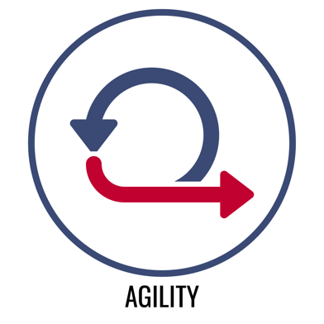 | Physical Agility  The ability to change body position and direction quickly and efficiently.
Emotional Agility
The ability to respond positively and optimistically in a variety of social and emotional situations and to regain optimism when negative events occur.

This is AGILITY week! Like every skill, you can develop and improve your agility with practice. That includes both your physical agility and your emotional agility. The way that you move through life matters.

You will have to change directions in order to overcome challenges — that’s okay. How you change direction is the key to ongoing success. Take this week to be mindful of and practice your agility. Complete every challenge and earn your Agility Badge.

Let’s get started with a Health-Related Warm-Up!

Jumping Lucky 6 (Aerobic Capacity Warm-Up) YouTube Video Demo

What you need: 1 six-sided dice, 1 jump rope (real or invisible)

Make a circle on the ground with your jump rope.

The object of this game is to roll 6 twice in order to end the game.

Each time you roll, jump into and then out of your rope circle the number of times on the die, then roll again. For example, if you roll a 5, jump in and out of the rope 5 times. Count each time your feet land inside the circle.

Continue rolling and jumping until you roll 6 twice. (It doesn’t have to be in a row.)

Quick Question
How is jumping in and out of your rope related to the skill-related fitness component of agility?

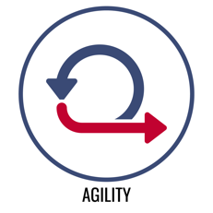 | Agility  Skill-Related Physical Fitness

Dribble Flips (Basketball or Soccer Dribble) YouTube Demo

What you need: 6 Cups; 1 basketball, soccer ball, or Spikeball;
1-minute challenge music [apple, spotify] or a stopwatch

Scatter the cups around your activity area. The object of the game is to see how many times you can flip the cups in 1 minute.

On the start signal, dribble the ball to a cup, stop your dribble, flip the cup upside down (or right-side up), and then dribble to a new cup and repeat. Continue and count the number of cups you flip during the full minute.

Try this challenge 3 times. Record your best score for the day. Repeat for 5 days and track your progress.

How many times did you flip the cups?

Day 1 Score | Day 2 Score | Day 3 Score | Day 4 Score | Day 5 Score

Reflection questions:

- Did you notice an improvement in your score over the 5 days?

- What are some possible reasons why you did (or did not) improve?

Agility
Skill-Related Emotional Fitness

Challenge Hacker YouTube Demo
Everything was going along smoothly, and you were making good progress toward your goals. And then, extreme challenges blocked your path and threatened to take away your optimism.

The object of this activity is to regain optimism by unlocking your growth mindset. Unscramble the vocabulary word based on its growth mindset definition and complete the challenge listed to find a path toward optimism.

- igrt _ _ _ _ : The combination of passion and perseverance, which allows an individual to continuously develop skill and work toward consistent achievement through a repetitive cycle of purposeful practice and peak performance.
[Do 10 Plank Jacks]

- trila dan roerr _ _ _ _ _ _ _ _ _ _ _ _ _ : The process of experimenting with various methods of doing something until one finds the most successful. [Do 5 Plank Rotations]

- eguarecmtoenn _ _ _ _ _ _ _ _ _ _ _ _ _ : Support, confidence, or hope offered by someone or some event. [Do 5 Plank Knee-Ins]

- eatnshumsi _ _ _ _ _ _ _ _ _ _ : An intense feeling of enjoyment and interest that energizes effort. [Do 10 Plank Arm Raises]

- otmspiim _ _ _ _ _ _ _ _ : A feeling of hopefulness and confidence about the future or the success of something. [Do 5 Up and Down Planks]

- upsorpt _ _ _ _ _ _ _ : To give help, assistance, and encouragement to someone or something. [Do 10 Plank Jacks]

WORD BANK

Support Enthusiasm Trial and Error Grit Encouragement Optimism

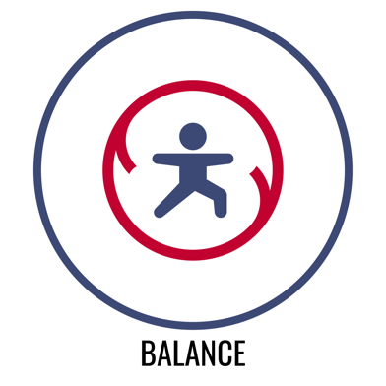 | Physical Balance  The ability to adjust the distribution of weight in order to remain upright and/or steady.
Emotional Balance
The ability to stabilize the emotional response to a potentially unstable social and emotional situation.

This is BALANCE week! Balance allows us to move through the world safely and efficiently. It allows us to go places that might otherwise be hard to go and to reach for things that may seem out of reach at first. Are we talking about Physical Balance or Emotional Balance? Actually, we’re talking about both.

You can never really know what’s around the bends of life — that’s okay. Physical and emotional balance can help you be safe and successful along life’s winding roads. Take this week to be mindful of and practice balance. Complete every challenge and earn your Balance Badge.

Let’s get started with a Health-Related Warm-Up!

Treasure Hunt (Muscular Endurance) YouTube Demo

What you need: 6 plastic cups

Scatter 6 cups in the activity space. Mark your home base with this page so you can see the locomotor movement chart below.

Use the locomotor movement chart and perform each movement while you collect the scattered cups.

The object of this activity is to quickly collect all of the cups, one-by-one.

Collect the first cup and return it to your home base. Then quickly move to collect the second cup. Continue until all cups are collected.

Collect Cup 1 Using a Jump
Collect Cup 2 Using a Gallop
Collect Cup 3 Using a Skip
Collect Cup 4 Using a Hop
Collect Cup 5 Using a March
Collect Cup 6 Using a Side Slide

Quick Question
How are locomotor skills related to the skill-related fitness component of balance?

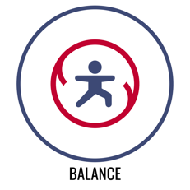 | Balance  Skill-Related Physical Fitness

The 1-Minute Balance Challenge YouTube Demo
The object of this activity is to perform 5 different balance poses (1 per day) for 1 minute at a time. Try 3 different times per day with the same pose. Each day, after your balance practice, rate your balance in the chart below.

As you balance, focus on your breathing and on finding your center of gravity.

Day # | Balance Pose | Balance Rating  1 = not so good 10 = perfect
DAY 1  CHAIR | 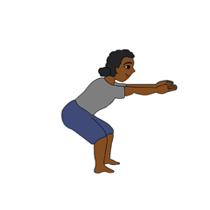 | 1 2 3 4 5 6 7 8 9 10
DAY 2  DOWN DOG | 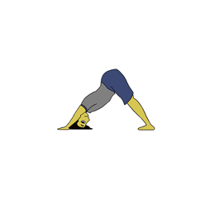 | 1 2 3 4 5 6 7 8 9 10
DAY 3  OWL | 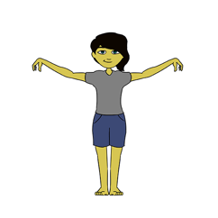 | 1 2 3 4 5 6 7 8 9 10
DAY 4  TALL MOUNTAIN | 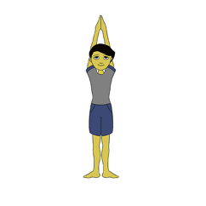 | 1 2 3 4 5 6 7 8 9 10
DAY 5  TREE | 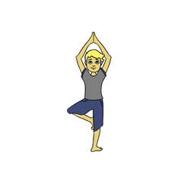 | 1 2 3 4 5 6 7 8 9 10

Balance
Skill-Related Emotional Fitness

Climbing the Cliff YouTube Demo
Overcoming obstacles can feel like climbing up a cliff. It can feel like one small mistake will throw off your balance, sending you on a painful fall. Finding balance is the key to reaching the summit of the cliff.

When challenged physically and emotionally, heart rate can tell us how balanced our effort is. The ability to recognize and control our heart rate is a skill that we can master. Pacing and mindful breathing are 2 important heart rate tools we can practice using.

The object of this activity is to complete a series of physical challenges while controlling your heart rate so that it stays in the overall active health zone (100 to 120 BPM). It’s okay if bounces into the endurance zone (120 to 140 BPM) immediately after the challenge is complete. You’ll then have 1 minute of rest in between challenges to practice high-5 mindful breathing and return your heart rate to the active health zone. Pacing and mindful breathing will be your keys to success.

Challenge 1:
1 minute of jumping jacks
- (1 minute of rest and mindful breathing)
Challenge 2:
1 minute of invisible jump rope
- (1 minute of rest and mindful breathing)
Challenge 3:
1 minute of plank shoulder taps
- (1 minute of rest and mindful breathing)
Challenge 4:
1 minute of burpees
- (1 minute of rest and mindful breathing)
Challenge 5:
1 minute of jumping jacks
- (1 minute of rest and mindful breathing)
Challenge 6:
1 minute of half jacks
- (1 minute of rest and mindful breathing)

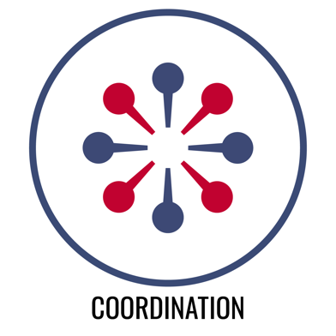 | Physical Coordination  The ability to combine movements of several parts for a focused purpose or task.
Emotional Coordination
The ability to empathize with others and respond appropriately and productively to provide social and emotional support.

This is COORDINATION week! Yes, you can develop and improve your coordination with practice. It’s important to be able to combine our movements for a focused purpose and it’s equally important to be able to coordinate our emotions with the feelings of others in order to provide support.

Just like different parts of our body work together to get tasks done. People have to be able to work together to achieve common goals. Coordination is the key.

Let’s get started with a Health-Related Warm-Up!

Full Body Warm Up with Rising NYRR (Flexibility) Vimeo Demo

What you need: The Full Body Warm Up Video from Rising New York Road Runners

The object of this activity is to perform each dynamic warm-up activity while following along with the Rising New York Road Runner video.

Ankle Circles
Leg Swings
Side Leg Swings
Trunk Twists
Hip Circles
Arm Scissors
Neck Circles
Shoulder Rolls

Quick Question
How are these dynamic stretching exercises related to the skill-related fitness component of Coordination?

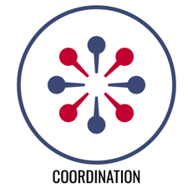 | Coordination  Skill-Related Physical Fitness

Volley Challenge YouTube Demo

What you need: 1 balloon (or small, light ball), 1-minute challenge music [apple, spotify], or a stopwatch

The object of this game is to count the number of successful balloon (or ball) volleys that you can record in 1 minute.

On the start signal, you will tap the balloon into the air. Keep the balloon in the air using underhand volleys (taps). If the balloon hits the ground, pick it up, and continue with your volleys. Count for the full minute. Try this challenge 3 times. Record your best score for the day. Repeat for 5 days and track your progress.

How many volleys (taps) did you score in 1 minute?

Day 1 Score | Day 2 Score | Day 3 Score | Day 4 Score | Day 5 Score

Reflection questions:

- Did you notice an improvement in your score over the 5 days?

- What are some possible reasons why you did (or did not) improve?

Coordination
Skill-Related Emotional Fitness

Odd and Even YouTube Demo
Everyone needs help at some point. Coordinating support for friends and family can feel like a challenge. However, providing coordinated support for people we care about is a part of building a rewarding life of service, community, and joy.

This is a dice game of odds and evens. Beat the odds and support your friends even when it’s a challenge.

The object of the game is to build your support points by finishing hop and jump routines. You get 10 rolls. Record the number that you roll as your points for that round. If you roll an odd number, complete the 1-foot hop routine. If you roll an even number, complete the 2-foot jump routine.

ODD: 1-Foot Hopping Routine | Even: 2-Foot Jump Routine
- Right, Right, Left, Left  - Right, Left, Right, Left  - Left, Left, Right, Right  - Left, Right, Left Right | - Together, Together, Apart, Apart  - Together, Apart, Together, Apart  - Apart, Apart, Together, Together  - Apart, Together, Apart, Together

Roll Number | Points Scored
1
2
3
4
5
6
7
8
9
10
TOTAL

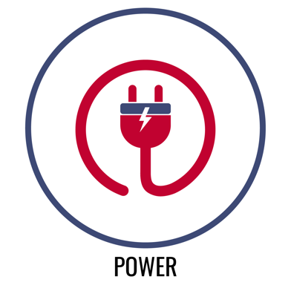 | Physical Power  The ability to quickly produce maximum force.
Emotional Power
The ability to apply the energy created from an emotional response (e.g., anger, sadness, frustration) in a positive and constructive way.

This is POWER week! Most people associate power with pure strength, but your focus on good form and efficient movement can have a big impact on the power you can generate. The same holds true with our emotional power. Self-awareness and an understanding of different emotions will help you channel your energy and increase your emotional power.

Life’s challenges will require us to do some heavy lifting. Body awareness and a focus on form will help you improve your physical power. Emotional awareness and a focus on attitude choices will help you improve your emotional power. You are powerful.

Let’s get started with a Health-Related Warm-Up!

Jumping Lucky 6 (Aerobic Capacity Warm-Up) YouTube Video Demo

What you need: 1 six-sided dice, 1 jump rope (real or invisible)

Make a circle on the ground with your jump rope.

The object of this game is to roll 6 twice in order to end the game.

Each time you roll, jump into and then out of your rope circle the number of times on the die, then roll again. For example, if you roll a 5, jump in and out of the rope 5 times. Count each time your feet land inside the circle.

Continue rolling and jumping until you roll 6 twice. (It doesn’t have to be in a row.)

Quick Question
What type of jumping is related to the skill-related fitness component of power?

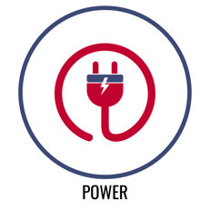 | Power  Skill-Related Physical Fitness

Star Jumper YouTube Demo

The object of this game is to star jump over as many cups as you can.

Start with 1 cup. Stand with the cup in front of you on the floor. Bend your knees to build power and then star jump over the cup to the other side.

Next, stack a cup on top of the cup you just cleared. Jump back over the 2-cup stack.

Continue stacking your cups as high as you can and clearing them with a star jump. Record the number of cups cleared each day for 5 days and track your progress.

How many cups did you jump?

Day 1 Score | Day 2 Score | Day 3 Score | Day 4 Score | Day 5 Score

Reflection questions:

- What exercises can you perform to help increase the power in your legs?

- What do you think will happen to your Star Jumper performance over time if you perform that exercise at least 3 times per week?

Power
Skill-Related Emotional Fitness

Power Dice Challenge YouTube Demo
Emotions are an important part of the human experience. When used efficiently, emotions help us build and sustain energy for positive growth and advancement. Learning how to embrace sadness to fuel our love and compassion for others can help our relationships. Learning how to harness anger to fuel our determination and grit can help us overcome obstacles and setbacks. Learning how to use joy to spark enthusiasm and optimism can help us build toward both personal and community goals and aspirations.

In the Power Dice Challenge, you will roll a die and then read the corresponding emotional power challenge. The object of the game is to complete all 6 challenges in 5 minutes or less. The clock starts when you start your first roll.

Roll Number | Emotional Power  Points Scored
1 | Sadness: Work through the sadness by jumping INVISIBLE JUMP ROPE while you count to 30.
2 | Joy: Demonstrate your joy by doing 15 STAR JUMPS.
3 | Anger: Channel your anger by doing 5 SLOW MOTION PUSH-UPS. (Modify if needed)
4 | Enthusiasm: Carry your enthusiasm by RUNNING IN PLACE while you count to 30.
5 | Fear: Face your fear by holding a 30-SECOND PLANK.
6 | Courage: Turn your courage into action by doing 30 PLANK-JACKS.

Your Challenge Time: ___________________________

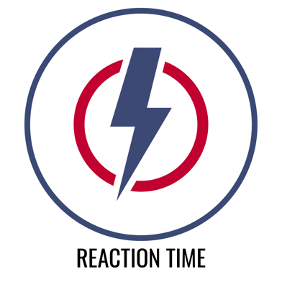 | Physical Reaction Time  The ability to quickly and effectively respond to a stimulus through purposeful movement.
Emotional Reaction Time
The ability to quickly regulate an emotional response when faced with a variety of immediate social and emotional challenges.

This is REACTION TIME week! As we move and navigate the world in front of us, challenges and obstacles will jump out at us, and reaction time helps us move safely around and over those obstacles.

Emotional reaction time works in the same way that physical reaction time does. We’re moving smoothly along, some sort of stress jumps out at us, we quickly regulate our emotions back to positive optimism in order to make the best of the situation.

Let’s get started with a Health-Related Warm-Up!

Treasure Hunt (Muscular Endurance) YouTube Demo

What you need: 6 plastic cups

Scatter 6 cups in the activity space. Mark your home base with this page so you can see the locomotor movement chart below.

Use the locomotor movement chart and perform each movement while you collect the scattered cups.

The object of this activity is to quickly collect all of the cups, one-by-one.

Collect the first cup and return it to your home base. Then quickly move to collect the second cup. Continue until all cups are collected.

Collect Cup 1 Using a Jump
Collect Cup 2 Using a Gallop
Collect Cup 3 Using a Skip
Collect Cup 4 Using a Hop
Collect Cup 5 Using a March
Collect Cup 6 Using a Side Slide

Quick Question
How can your reaction time affect the way that you move your body through space?

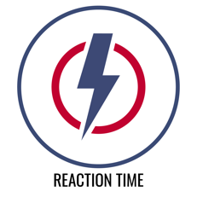 | Reaction Time  Skill-Related Physical Fitness

Walloon Challenge YouTube Demo

What you need: 1 balloon (or small, light ball), 1 wall,
1-minute challenge music [apple, spotify] or a stopwatch

The object of this game is to count the number of times that you can successfully volley your balloon (or ball) off of the wall in 1 minute.

On the start signal, you will tap the balloon toward the wall so that it bounces off the wall back to you. Keep your volley going, counting the number of successful volleys (taps).

If the balloon hits the ground, pick it up, and continue with your volleys. Count for the full minute. Try this challenge 3 times. Record your best score for the day. Repeat for 5 days and track your progress.

How many volleys (taps) did you score in 1 minute?

Day 1 Score | Day 2 Score | Day 3 Score | Day 4 Score | Day 5 Score

Reflection questions:

- Did you notice an improvement in your score over the 5 days?

- What are some possible reasons why you did (or did not) improve?

Reaction Time
Skill-Related Emotional Fitness

Flip Reaction Relay YouTube Demo
Sometimes life is unpredictable and it’s a challenge to react positively and keep emotions balanced and regulated. Mindful breathing is an important strategy for staying focused under pressure. The coin flip reaction relay will help us practice using mindful breathing to regulate our heart rate.

The object is to use 5 equal breaths (5-count inhale and 5-count exhale) to balance and slow our heart rate after intervals of jogging in place. The entire activity will last 4 minutes.

Record your heart rate in Beats Per Minute (BPM) before you begin. Use a heart rate monitor or count heartbeats for 15 seconds and multiply by 4.

Start the relay by flipping a coin. Use a timer/stopwatch to time 4 minutes.
- Heads = jog in place for a 30 count.
- Tails = take 5 equal breaths.

If you flip 2 heads in a row, you’ll jog in place for a total of 60 counts. If you flip 2 tails in a row, you’ll take 10 equal breaths.

At the end of the 4 minutes, use equal breathing for 1 full minute to lower your heart rate, and regulate your body’s response to the exercise. Then record your heart rate below.

Heart rate BEFORE the relay. | Heart rate AFTER the relay.
Trial 1:
Trial 2:

Calculate the difference between your BEFORE heart rate and your AFTER.

For example, if your HR BEFORE the relay was 85 BPM and your HR AFTER the relay was 105 BPM, then the difference is 20 BPM. The goal is to have the smallest difference possible.

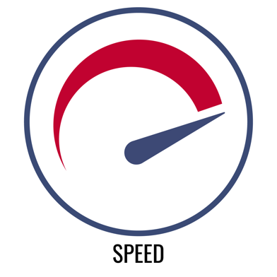 | Physical Speed  The ability to move the body quickly from one point to another.
Emotional Speed
The ability to use personal enthusiasm to improve the emotional state of others.

This is SPEED week! It’s nice to allow our speed to kick in when we need it. And yes, you guessed it, how you move can improve your speed. Your form can always be improved and so your speed can also be improved.

Emotional speed is also a matter of focus. It is a personal choice to move with enthusiasm. In fact, your choice to be enthusiastic will help others make that same positive choice. Enthusiasm is also a key ingredient to goal setting and achievement. Reaching goals isn’t always fast, but the process is almost always made faster and easier with regular boosts of enthusiasm.

Let’s get started with a Health-Related Warm-Up!

Full Body Warm Up with Rising NYRR (Flexibility) Vimeo Demo

What you need: The Full Body Warm Up Video from Rising New York Road Runners

The object of this activity is to perform each dynamic warm-up activity while following along with the Rising New York Road Runner video.

Ankle Circles
Leg Swings
Side Leg Swings
Trunk Twists
Hip Circles
Arm Scissors
Neck Circles
Shoulder Rolls

Quick Question

How does a proper dynamic warm-up affect your speed?

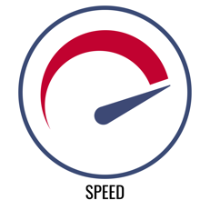 | Speed  Skill-Related Physical Fitness

Jump Rope Cup Stacker YouTube Demo

What you need: 6 Cups; 1 jump rope (visible or invisible);
1-minute challenge music [apple, spotify] or a stopwatch

Place 3 cups on each end of the activity area approximately 8 to 10 paces apart.

The object of the game is to see how many times you can build or collapse cup towers in 1 minute.

On the start signal (or music), jump rope 3 times, then carry your rope with you to the opposite cups and build a 3-cup tower. Then, jump rope 3 more time before racing to the other side to build another 3-cup tower.

Continue this pattern collapsing and then rebuilding as many times as you can for the full minute. Try this challenge 3 times. Record your best score for the day. Repeat for 5 days and track your progress.

Build and Collapses

Day 1 Score | Day 2 Score | Day 3 Score | Day 4 Score | Day 5 Score

Reflection questions:

- Did you notice an improvement in your score over the 5 days?

- What are some possible reasons why you did (or did not) improve?

Speed
Skill-Related Emotional Fitness

4-Minute Toss & Roll Race YouTube Demo
Speed creates physical momentum just like enthusiasm creates emotional momentum. Your enthusiasm can carry you and the people around you toward success, joy, and an empowering future.

In this activity, you’ll work for 4 minutes to build your heart rate into the heart health zone (120 – 180 BPM), and then you’ll take 60 seconds to breathe in the success of your work and regulate your heart rate back under 120 BPM.

Space 2 cups 6 to 10 feet apart. On top of 1 cup, there is a die. On top of the other, there is a coin. Start by rolling the die. Add a zero on the end of the number you roll (3 becomes 30) and do that many jump rope reps (real or invisible). Place the die back on the cup.

Next, quickly move to the other cup and flip the coin. If it shows heads, do 25 speed-jacks (super-fast jumping jacks). If it shows tails, do 10 burpees.

Alternate between rolling and flipping for 4 minutes. When the time is up, check your heart rate. Did you make it into the heart health zone?

Next, practice equal breathing for 60 seconds to regulate your heart rate below 120 BPM.

Heart rate at the end of the race. | Heart rate AFTER equal breathing.

Toss & Roll Exercise Guide

Dice Exercise | Coin Exercises
JUMP ROPE REPS  # on Die X 10 = Reps | HEADS = 25 Speed-Jacks  TAILS = 10 Burpees

