Print this guide and record your progress on paper.
Or, import this document into your school e-learning system
and record progress electronically.

Student Name |  | Start Date

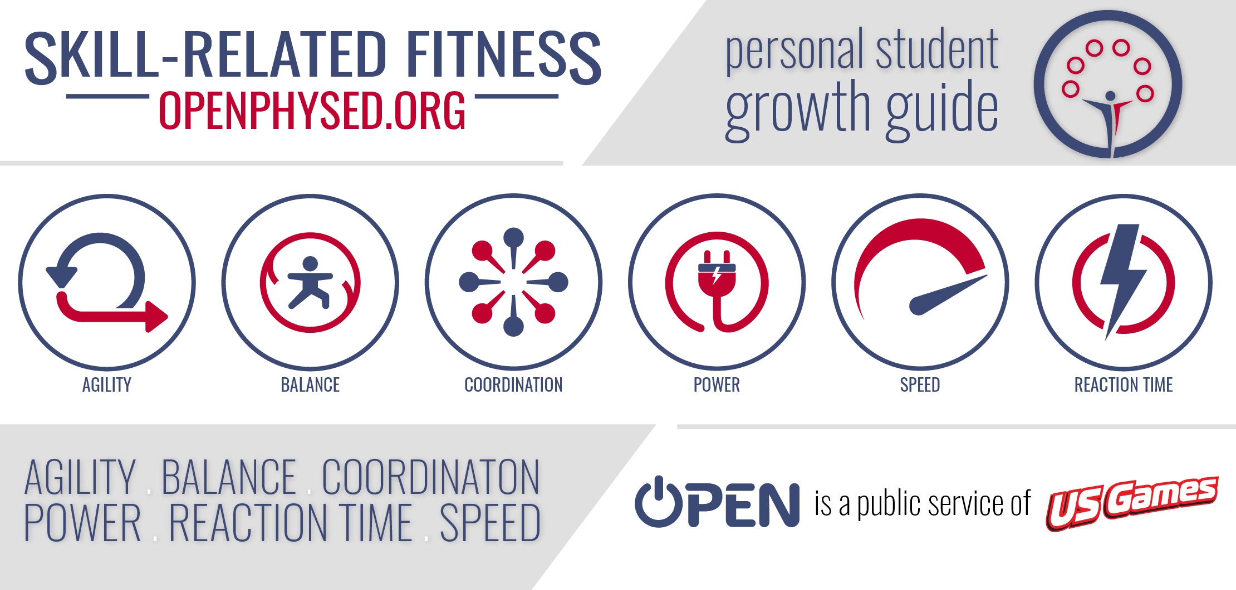

This growth guide is a week by week journey designed to help you develop physical and emotional skill-related fitness. Each skill is an essential component of a healthy, active, and optimistic lifestyle.

Created by Nick Kline & Aaron Hart

About this Growth Guide

Throughout this learning module, you will use skill-related physical fitness and skill-related emotional fitness to clear a path toward optimism and positivity. However, as usual, there’s more than one possible path, and not all roads lead in a positive direction. By completing each of the 6 skill-related challenge badge activities you are choosing an optimistic path.

In every person’s journey, challenges build character. How we choose to face challenges oftentimes is the greatest predictor of personal success or disappointment. Use grit, growth mindset, and emotional intelligence to navigate skill-related challenges. Work to improve physically and mentally. Success is a long-game that is built upon lessons learned through trial and error, advancements and setbacks, hard work, and determination.

You can choose a path to optimism, positivity, and success. We believe in you. Go be great.

Using this Growth Guide

Define (Read Definitions) | Read and discuss the definitions of physical and emotional skill-related fitness.
Demonstrate (Warm-Up) | Complete the health-related warm-up activity provided for each week.
Demonstrate (Physical) | Complete the skill-related physical fitness 5 days and track your improvement.
Demonstrate (Emotional) | Complete the skill-related emotional fitness activity at least 1 time during the week.
Share (Physical) | Discuss the week’s physical fitness component a friend or family member.
Share (Emotional) | Discuss the week’s emotional fitness component a friend or family member.

Table of Contents

Intro 1 About this Growth Guide

Intro 2 Badge Tracker

Week 1: Agility
(Aerobic Warm-Up, Physical Agility, Emotional Agility)

Week 2: Balance
(Muscular Fitness Warm-Up, Physical Balance, Emotional Balance)

Week 3: Coordination
(Flexibility Warm-Up, Physical Coordination, Emotional Coordination)

Week 4: Power
(Muscular Fitness Warm-Up, Physical Power, Emotional Power)

Week 5: Reaction Time
(Aerobic Warm-Up, Physical Reaction Time, Emotional Reaction Time)

Week 6: Speed
(Flexibility Warm-Up, Physical Speed, Emotional Speed)

Each week of this skill-related learning module, you have the opportunity to earn a Component Badge. To earn a badge, you must complete all 6 of the week’s Component Tasks. Record the date that each task has been fully completed in the right column below.

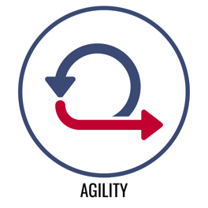 | Define (Read Definitions)
 | Demonstrate (Warm-Up)
 | Demonstrate (Physical)
 | Demonstrate (Emotional)
 | Share (Physical)
 | Share (Emotional)
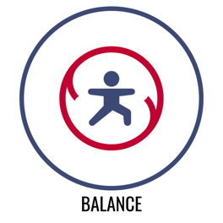 | Define (Read Definitions)
 | Demonstrate (Warm-Up)
 | Demonstrate (Physical)
 | Demonstrate (Emotional)
 | Share (Physical)
 | Share (Emotional)
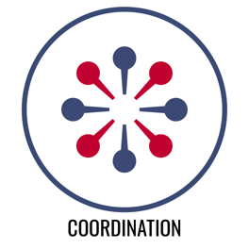 | Define (Read Definitions)
 | Demonstrate (Warm-Up)
 | Demonstrate (Physical)
 | Demonstrate (Emotional)
 | Share (Physical)
 | Share (Emotional)
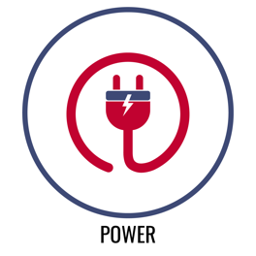 | Define (Read Definitions)
 | Demonstrate (Warm-Up)
 | Demonstrate (Physical)
 | Demonstrate (Emotional)
 | Share (Physical)
 | Share (Emotional)
 | Define (Read Definitions)
 | Demonstrate (Warm-Up)
 | Demonstrate (Physical)
 | Demonstrate (Emotional)
 | Share (Physical)
 | Share (Emotional)
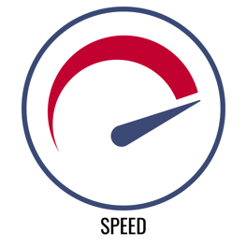 | Define (Read Definitions)
 | Demonstrate (Warm-Up)
 | Demonstrate (Physical)
 | Demonstrate (Emotional)
 | Share (Physical)
 | Share (Emotional)

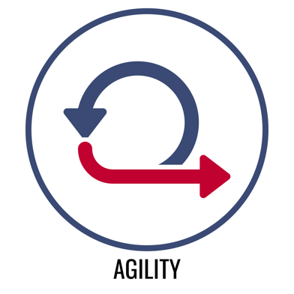 | Physical Agility  The ability to change body position and direction quickly and efficiently.
Emotional Agility
The ability to respond positively and optimistically in a variety of social and emotional situations and to regain optimism when negative events occur.

This is AGILITY week! Like every skill, you can develop and improve your agility with practice. That includes both your physical agility and your emotional agility. The way that you move through life matters.

You will have to change directions in order to overcome challenges — that’s okay. How you change direction is the key to ongoing success. Take this week to be mindful of and practice your agility. Complete every challenge and earn your Agility Badge.

Let’s get started with a Health-Related Warm-Up!

Jump Rope Dice Battle (Aerobic Capacity) YouTube Demonstration

What you need: 2 six-sided dice, 1 jump rope (real or invisible)

The object of this game is to predict which die (right or left) will have the highest point total after 8 rolls. To earn a roll, you must complete 10 jumps with a jump rope.

After each roll, record the number on each dice in a score chart. After 8 rolls, add up the score to see if your prediction was correct.

(If you have a partner, play against each other with 1 dice per player.)

Dice | Roll 1 | Roll 2 | Roll 3 | Roll 4 | Roll 5 | Roll 6 | Roll 7 | Roll 8 | Total
RIGHT
LEFT

Quick Question
How is jumping rope related to the skill-related fitness component of agility?

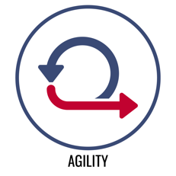 | Agility  Skill-Related Physical Fitness

Dribble Race (Basketball, Soccer, or Spikeball Self-Passes) YouTube Demo
The object of this activity is to practice the Dribble Racecourse 4 times and record your timed attempt on the 5th run. You will do this for 5 days with a focus on improving each day.

Set up 10 cups or markers 2 large paces apart. Designate 1 cup as your starting/stopping marker. A timer will give you a start signal and start a stopwatch (or you can count Mississippi’s as you move).

How long does it take you to get down and back around the cups?

Day 1 Time | Day 2 Time | Day 3 Time | Day 4 Time | Day 5 Time

In each reflection box below, answer the following 2 questions each day.
- Were you able to focus on your practice in order to work toward improving your time?
- If you were able to focus, why? If you were unable to focus, why?

On Day 5, reflect on how well you improved. What worked well and what did not.

Day 1 Reflection
Day 2 Reflection
Day 3 Reflection
Day 4 Reflection
Day 5 Reflection

Agility
Skill-Related Emotional Fitness

Challenge Hacker YouTube Demo
Everything was going along smoothly, and you were making good progress toward your goals. And then, extreme challenges blocked your path and threatened to take away your optimism.

The object of this activity is to regain optimism by unlocking your growth mindset. Unscramble the vocabulary word based on its growth mindset definition and complete the challenge listed to find a path toward optimism.

- igrt _ _ _ _ : The combination of passion and perseverance, which allows an individual to continuously develop skill and work toward consistent achievement through a repetitive cycle of purposeful practice and peak performance.
[Do 10 Plank Jacks]

- trila dan roerr _ _ _ _ _ _ _ _ _ _ _ _ _ : The process of experimenting with various methods of doing something until one finds the most successful. [Do 5 Plank Rotations]

- eguarecmtoenn _ _ _ _ _ _ _ _ _ _ _ _ _ : Support, confidence, or hope offered by someone or some event. [Do 5 Plank Knee-Ins]

- eatnshumsi _ _ _ _ _ _ _ _ _ _ : An intense feeling of enjoyment and interest that energizes effort. [Do 10 Plank Arm Raises]

- otmspiim _ _ _ _ _ _ _ _ : A feeling of hopefulness and confidence about the future or the success of something. [Do 5 Up and Down Planks]

- upsorpt _ _ _ _ _ _ _ : To give help, assistance, and encouragement to someone or something. [Do 10 Plank Jacks]

WORD BANK

Support Enthusiasm Trial and Error Grit Encouragement Optimism

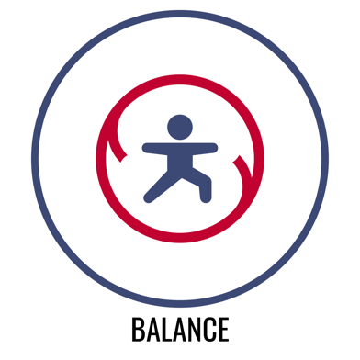 | Physical Balance  The ability to adjust the distribution of weight in order to remain upright and/or steady.
Emotional Balance
The ability to stabilize the emotional response to a potentially unstable social and emotional situation.

This is BALANCE week! Balance allows us to move through the world safely and efficiently. It allows us to go places that might otherwise be hard to go, and to reach for things that may see out of reach at first. Are we talking about Physical Balance or Emotional Balance? Actually, we’re talking about both.

You can never really know what’s around the bends of life — that’s okay. Physical and emotional balance can help you be safe and successful along life’s winding roads. Take this week to be mindful of and practice balance. Complete every challenge and earn your Balance Badge.

Let’s get started with a Health-Related Warm-Up!

Strength or Endurance (Muscular Fitness) YouTube Demo

What you need: 1 six-sided die

The object of this game is to perform each activity on the chart and then determine if it is more of a muscular strength or muscular endurance activity.

Roll the die and complete the activity that corresponds with the number rolled. Write in either strength or endurance in the fitness box on the chart. If you roll a number more than once during the activity, perform the activity again, and then quickly roll again. Continue until you have completed all activities on the chart (or you’ve played for 5 minutes total).

Dice Roll | Activity | Strength or Endurance? | Dice Roll | Activity | Strength or Endurance?
1 | 1 Push-Up with a Clap |  | 2 | 20-Second Plank Hold
3 | 3 High-Knee Tuck Jumps |  | 4 | 40-Second Squat Hold
5 | 5 Walking Lunges |  | 6 | 6 Sit-Ups

Quick Question
How is a Tuck Jump related to the skill-related fitness component of balance?

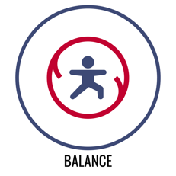 | Balance  Skill-Related Physical Fitness

The Perfect Balance Back Kick YouTube Demo
The object of this activity is to practice a perfect form Balance Back Kick over 5 days with a focus on improving your form and balance each day.

Watch the Balance Back Kick Exercise Video on Darebee.com. Then perform 10 repetitions balanced on your right leg and 10 repetitions balanced on your left leg.

After you’ve performed all repetitions for both legs, rate your form and your balance in the chart below.

How long does it take you to get down and back around the cups?

Day # | Right Leg  Circle your rating of 1–10  1 = not so good 10 = perfect | Left Leg  Rate 1-10  1 = not so good 10 = perfect
DAY 1 | 1 2 3 4 5 6 7 8 9 10 | 1 2 3 4 5 6 7 8 9 10
DAY 2 | 1 2 3 4 5 6 7 8 9 10 | 1 2 3 4 5 6 7 8 9 10
DAY 3 | 1 2 3 4 5 6 7 8 9 10 | 1 2 3 4 5 6 7 8 9 10
DAY 4 | 1 2 3 4 5 6 7 8 9 10 | 1 2 3 4 5 6 7 8 9 10
DAY 5 | 1 2 3 4 5 6 7 8 9 10 | 1 2 3 4 5 6 7 8 9 10

Reflection Question 1: Did you see an improvement from 1 day to day 5?

Reflection Question 2: What did you notice about your progress and improvement as the week went on and you continued your practice?

Balance
Skill-Related Emotional Fitness

Climbing the Cliff YouTube Demo
Overcoming obstacles can feel like climbing up a cliff. It can feel like one small mistake will throw off your balance, sending you on a painful fall. Finding balance is the key to reaching the summit of the cliff.

When challenged physically and emotionally, heart rate can tell us how balanced our effort is. The ability to recognize and control our heart rate is a skill that we can master. Pacing and mindful breathing are 2 important heart rate tools we can practice using.

The object of this activity is to complete a series of physical challenges while controlling your heart rate so that it stays in the overall active health zone (100 to 120 BPM). It’s okay if bounces into the endurance zone (120 to 140 BPM) immediately after the challenge is complete. You’ll then have 1 minute of rest in between challenges to practice high-5 mindful breathing and return your heart rate to the active health zone. Pacing and mindful breathing will be your keys to success.

Challenge 1:
1 minute of jumping jacks
- (1 minute of rest and mindful breathing)
Challenge 2:
1 minute of invisible jump rope
- (1 minute of rest and mindful breathing)
Challenge 3:
1 minute of plank shoulder taps
- (1 minute of rest and mindful breathing)
Challenge 4:
1 minute of burpees
- (1 minute of rest and mindful breathing)
Challenge 5:
1 minute of jumping jacks
- (1 minute of rest and mindful breathing)
Challenge 6:
1 minute of half jacks
- (1 minute of rest and mindful breathing)

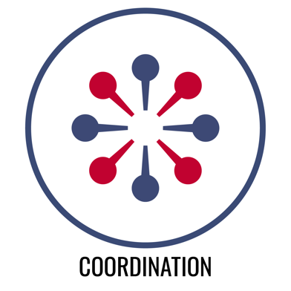 | Physical Coordination  The ability to combine movements of several parts for a focused purpose or task.
Emotional Coordination
The ability to empathize with others and respond appropriately and productively to provide social and emotional support.

This is COORDINATION week! Yes, you can develop and improve your coordination with practice. It’s important to be able to combine our movements for a focused purpose and it’s equally important to be able to coordinate our emotions with the feelings of others in order to provide support.

Just like different parts of our body work together to get tasks done. People have to be able to work together to achieve common goals. Coordination is the key.

Let’s get started with a Health-Related Warm-Up!

Dynamic Stretching Multiplier (Flexibility) YouTube Demo

What you need: 1 six-sided die

The object of this game is to total-up as many points as possible. To score points, you will first perform the correct number of repetitions for each dynamic stretching exercise and then roll the die.

Multiply the number of reps with the number rolled on the die. Write your score for that activity on your scorecard below. When all activities are complete, add the numbers for a total.

# of Reps | Activity | Your Score (reps X roll) | # of Reps | Activity | Your Score (reps X roll)
10 | March & Reach |  | 10 | Hug Chest Expansions
4 | Plank  Walk-Outs |  | 20 | Backstroke Swim Arms
6 | Walking Lunges |  | 10 | Leg Raise Toe Taps

Quick Question
How is a Leg Raise Toe Taps related to the skill-related fitness component of Coordination?

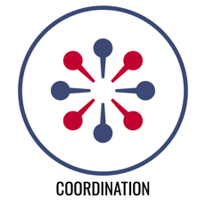 | Coordination  Skill-Related Physical Fitness

Spikeball Self-Passing Practice YouTube Demo
The object of this activity is to practice and improve your Spikeball passing skills.

Each day for 5 days you will perform the entire practice plan below, rate your progress, and then reflect on your focus and improvement.

Self-Passing Practice Plan:
For each drill, perform as many successful self-passes as you can in a row, first with your right and then your left hand. A score of 10+ earns you a Junior Varsity Rating, 20+ a Varsity Rating, 30+ All-Star Rating

- Drill 1: Below-Chest Pass Only (2 attempts each hand)
- Drill 2: Above-Chest Pass Only (2 attempts each hand)
- Drill 3: Combination of Above- and Below-Chest Passes (2 attempts each hand)

Day # | Success Rating  Circle the highest rating  earned for any drill? | Reflect  Did you improve?  Were you focused on improvement?  Provide proof in your reflection.
DAY 1 | Junior Varsity Varsity All-Star
DAY 2 | Junior Varsity Varsity All-Star
DAY 3 | Junior Varsity Varsity All-Star
DAY 4 | Junior Varsity Varsity All-Star
DAY 5 | Junior Varsity Varsity All-Star

Coordination
Skill-Related Emotional Fitness

Odd and Even YouTube Demo
Everyone needs help at some point. Coordinating support for friends and family can feel like a challenge. However, providing coordinated support for people we care about is a part of building a rewarding life of service, community, and joy.

This is a dice game of odds and evens. Beat the odds and support your friends even when it’s a challenge.

The object of the game is to build your support points by finishing hop and jump routines. You get 10 rolls. Record the number that you roll as your points for that round. If you roll an odd number, complete the 1-foot hop routine. If you roll an even number, complete the 2-foot jump routine.

ODD: 1-Foot Hopping Routine | Even: 2-Foot Jump Routine
- Right, Right, Left, Left  - Right, Left, Right, Left  - Left, Left, Right, Right  - Left, Right, Left Right | - Together, Together, Apart, Apart  - Together, Apart, Together, Apart  - Apart, Apart, Together, Together  - Apart, Together, Apart, Together

Roll Number | Points Scored
1
2
3
4
5
6
7
8
9
10
TOTAL

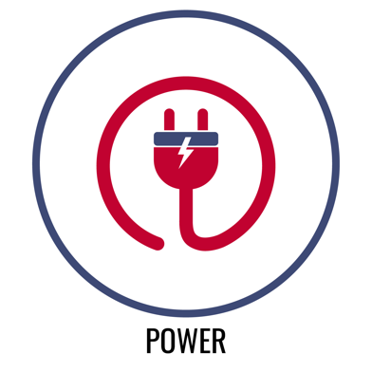 | Physical Power  The ability to quickly produce maximum force.
Emotional Power
The ability to apply the energy created from an emotional response (e.g., anger, sadness, frustration) in a positive and constructive way.

This is POWER week! Most people associate power with pure strength, but your focus on good form and efficient movement can have a big impact on the power you can generate. The same holds true with our emotional power. Self-awareness and an understanding of different emotions will help you channel your energy and increase your emotional power.

Life’s challenges will require us to do some heavy lifting. Body awareness and a focus on form will help you improve your physical power. Emotional awareness and a focus on attitude choices will help you improve your emotional power. You are powerful.

Let’s get started with a Health-Related Warm-Up!

Strength or Endurance (Muscular Fitness) YouTube Demo

What you need: 1 six-sided die

The object of this game is to perform each activity on the chart and then determine if it is more of a muscular strength or muscular endurance activity.

Roll the die and complete the activity that corresponds with the number rolled. Write in either strength or endurance in the fitness box on the chart. If you roll a number more than once during the activity, perform the activity again, and then quickly roll again. Continue until you have completed all activities on the chart (or you’ve played for 5 minutes total).

Dice Roll | Activity | Strength or Endurance? | Dice Roll | Activity | Strength or Endurance?
1 | 1 Push-Up with a Clap |  | 2 | 20-Second Plank Hold
3 | 3 High-Knee Tuck Jumps |  | 4 | 40-Second Squat Hold
5 | 5 Walking Lunges |  | 6 | 6 Sit-Ups

Quick Question
How is a push-up with a clap related to the skill-related fitness component of power?

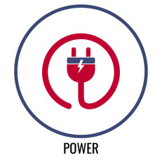 | Power  Skill-Related Physical Fitness

Standing Long Jump Power Challenge YouTube Demo
The object of this activity is to practice and improve your standing long jump distance.

Each day for 5 days you will practice your standing long jump and perform 3 sets of 10 squats to help improve your power. Record your distance and reflect on your progress.

Use tape or another type of floor marker to create a starting line. Stand behind the line with your feet comfortably shoulder-width apart. Take off and land on two feet, swinging your arms and bending your knees to generate power for the jump. Mark the floor at the spot where your heels land. Try to beat that distance and move your mark each time you jump.

The current official world record is held by NFL cornerback player Byron Jones who jumped 12 ft 2 ¾ in at the NFL Combine in 2015.

Day # | Jump Distance | Perform 10 squats  Check DONE when complete. | Reflect  Did you improve?  Were you focused on improvement?  Provide proof in your reflection.
DAY 1 |  | - Done
DAY 2 |  | - Done
DAY 3 |  | - Done
DAY 4 |  | - Done
DAY 5 |  | - Done

Power
Skill-Related Emotional Fitness

Power Dice Challenge YouTube Demo
Emotions are an important part of the human experience. When used efficiently, emotions help us build and sustain energy for positive growth and advancement. Learning how to embrace sadness to fuel our love and compassion for others can help our relationships. Learning how to harness anger to fuel our determination and grit can help us overcome obstacles and setbacks. Learning how to use joy to spark enthusiasm and optimism can help us build toward both personal and community goals and aspirations.

In the Power Dice Challenge, you will roll a die and then read the corresponding emotional power challenge. The object of the game is to complete all 6 challenges in 5 minutes or less. The clock starts when you start your first roll.

Roll Number | Emotional Power  Points Scored
1 | Sadness: Work through the sadness by jumping INVISIBLE JUMP ROPE while you count to 30.
2 | Joy: Demonstrate your joy by doing 15 STAR JUMPS.
3 | Anger: Channel your anger by doing 5 SLOW MOTION PUSH-UPS. (Modify if needed)
4 | Enthusiasm: Carry your enthusiasm by RUNNING IN PLACE while you count to 30.
5 | Fear: Face your fear by holding a 30-SECOND PLANK.
6 | Courage: Turn your courage into action by doing 30 PLANK-JACKS.

Your Challenge Time: ___________________________

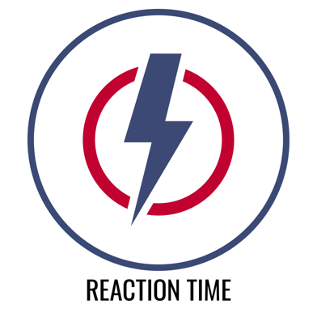 | Physical Reaction Time  The ability to quickly and effectively respond to a stimulus through purposeful movement.
Emotional Reaction Time
The ability to quickly regulate an emotional response when faced with a variety of immediate social and emotional challenges.

This is REACTION TIME week! As we move and navigate the world in front of us, challenges and obstacles will jump out at us, and reaction time helps us move safely around and over those obstacles.

Emotional reaction time works in the same way that physical reaction time does. We’re moving smoothly along, some sort of stress jumps out at us, we quickly regulate our emotions back to positive optimism in order to make the best of the situation.

Let’s get started with a Health-Related Warm-Up!

Jump Rope Dice Battle (Aerobic Capacity)

What you need: 2 six-sided dice, 1 jump rope (real or invisible)

The object of this game is to predict which die (right or left) will have the highest point total after 8 rolls. To earn a roll, you must complete 10 jumps with a jump rope.

After each roll, record the number on each dice in a score chart. After 8 rolls, add up the score to see if your prediction was correct.

(If you have a partner, play against each other with 1 dice per player.)

Dice | Roll 1 | Roll 2 | Roll 3 | Roll 4 | Roll 5 | Roll 6 | Roll 7 | Roll 8 | Total
RIGHT
LEFT

Quick Question
How is jumping rope related to the skill-related fitness component of reaction time?

Reaction Time
Skill-Related Physical Fitness

Wall Ball Challenge YouTube Demo
The object of this activity is to practice and improve your reaction time with some Spikeball Wallball Drills.

Each day for 5 days you will perform the entire practice plan below, rate your progress, and then reflect on your focus and improvement.

Wall Ball Practice Plan:
For each drill, perform as many successful consecutive wall-ball passes as you can. A score of 10+ earns you a Junior Varsity Rating, 20+ a Varsity Rating, 30+ All-Star Rating.

- Drill 1: 3 self-passes then 1 pass off the wall (repeat pattern without stopping)
- Drill 2: 2 self-passes then 1 pass off the wall (repeat pattern without stopping)
- Drill 3: Consecutive wall passes

Day # | Success Rating  Circle the highest rating  earned for any drill? | Reflect  Did you improve?  Were you focused on improvement?  Provide proof in your reflection.
DAY 1 | Junior Varsity Varsity All-Star
DAY 2 | Junior Varsity Varsity All-Star
DAY 3 | Junior Varsity Varsity All-Star
DAY 4 | Junior Varsity Varsity All-Star
DAY 5 | Junior Varsity Varsity All-Star

Reaction Time
Skill-Related Emotional Fitness

Flip Reaction Relay YouTube Demo
Sometimes life is unpredictable and it’s a challenge to react positively and keep emotions balanced and regulated. Mindful breathing is an important strategy for staying focused under pressure. The coin flip reaction relay will help us practice using mindful breathing to regulate our heart rate.

The object is to use 5 equal breaths (5-count inhale and 5-count exhale) to balance and slow our heart rate after intervals of jogging in place. The entire activity will last 4 minutes.

Record your heart rate in Beats Per Minute (BPM) before you begin. Use a heart rate monitor or count heartbeats for 15 seconds and multiply by 4.

Start the relay by flipping a coin. Use a timer/stopwatch to time 4 minutes.
- Heads = jog in place for a 30 count.
- Tails = take 5 equal breaths.

If you flip 2 heads in a row, you’ll jog in place for a total of 60 counts. If you flip 2 tails in a row, you’ll take 10 equal breaths.

At the end of the 4 minutes, use equal breathing for 1 full minute to lower your heart rate, and regulate your body’s response to the exercise. Then record your heart rate below.

Heart rate BEFORE the relay. | Heart rate AFTER the relay.
Trial 1:
Trial 2:

Calculate the difference between your BEFORE heart rate and your AFTER.

For example, if your HR BEFORE the relay was 85 BPM and your HR AFTER the relay was 105 BPM, then the difference is 20 BPM. The goal is to have the smallest difference possible.

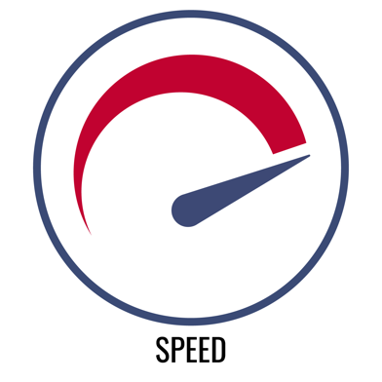 | Physical Speed  The ability to move the body quickly from one point to another.
Emotional Speed
The ability to use personal enthusiasm to improve the emotional state of others.

This is SPEED week! It’s nice to allow our speed to kick in when we need it. And yes, you guessed it, how you move can improve your speed. Form can always be improved and so your speed can also be improved.

Emotional speed is also a matter of focus. It is a personal choice to move with enthusiasm. In fact, your choice to be enthusiastic will help others make that same positive choice. Enthusiasm is also a key ingredient to goal setting and achievement. Reaching goals isn’t always fast, but the process is almost always made faster and easier with regular boosts of enthusiasm.

Let’s get started with a Health-Related Warm-Up!

Dynamic Stretching Multiplier (Flexibility)

What you need: 1 six-sided die

The object of this game is to total-up as many points as possible. To score points, you will first perform the correct number of repetitions for each dynamic stretching exercise and then roll the die.

Multiply the number of reps with the number rolled on the die. Write your score for that activity on your scorecard below. When all activities are complete, add the numbers for a total.

# of Reps | Activity | Your Score (reps X roll) | Dice Roll | Activity | Your Score (reps X roll)
10 | March & Reach |  | 10 | Hug Chest Expansions
4 | Plank  Walk-Outs |  | 20 | Backstroke Swim Arms
6 | Walking Lunges |  | 10 | Leg Raise Toe Taps

Quick Question
How is overall Flexibility related to the skill-related fitness component of Speed?

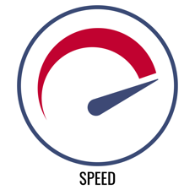 | Speed  Skill-Related Physical Fitness

Speed Rope Challenge YouTube Demo
The object of this activity is to practice a single rope jumping pattern with a focus on increasing your speed over 5 days.

Choose 1 of 2 patterns:
- Traditional 2-foot speed rope jumping
- Side to side rope swings

Use 1-Minute Challenge Music to time your jumps. As you jump, count the number of successful repetitions in 1-minute. If you make an error, quickly resume jumping and continue your count.

Perform 3 trials per day. Record your best daily score.

Number of Jumps in 1 Minute

Day 1 Score | Day 2 Score | Day 3 Score | Day 4 Score | Day 5 Score

In each reflection box below, reflect on how well you improved. What worked well and what did not, and what you’ll focus on in the next day’s practice.

Day 1 Reflection
Day 2 Reflection
Day 3 Reflection
Day 4 Reflection
Day 5 Reflection

Speed
Skill-Related Emotional Fitness

4-Minute Toss & Roll Race YouTube Demo
Speed creates physical momentum just like enthusiasm creates emotional momentum. Your enthusiasm can carry you and the people around you toward success, joy, and an empowering future.

In this activity, you’ll work for 4 minutes to build your heart rate into the heart health zone (120 – 180 BPM), and then you’ll take 60 seconds to breathe in the success of your work and regulate your heart rate back under 120 BPM.

Space 2 cups 6 to 10 feet apart. On top of 1 cup, there is a die. On top of the other, there is a coin. Start by rolling the die. Add a zero on the end of the number you roll (3 becomes 30) and do that many jump rope reps (real or invisible). Place the die back on the cup.

Next, quickly move to the other cup and flip the coin. If it shows heads, do 25 speed-jacks (super-fast jumping jacks). If it shows tails, do 10 burpees.

Alternate between rolling and flipping for 4 minutes. When the time is up, check your heart rate. Did you make it into the heart health zone?

Next, practice equal breathing for 60 seconds to regulate your heart rate below 120 BPM.

Heart rate at the end of the race. | Heart rate AFTER equal breathing.

Toss & Roll Exercise Guide

Dice Exercise | Coin Exercises
JUMP ROPE REPS  # on Die X 10 = Reps | HEADS = 25 Speed-Jacks  TAILS = 10 Burpees

