Write something nice about the person named
on this page in one of the snowflake bubbles.

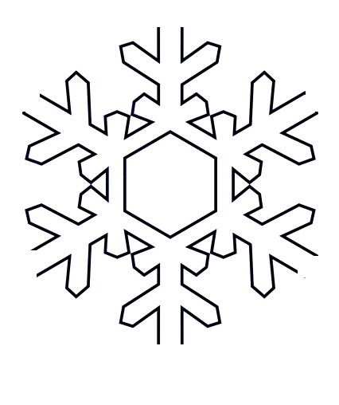
Name

