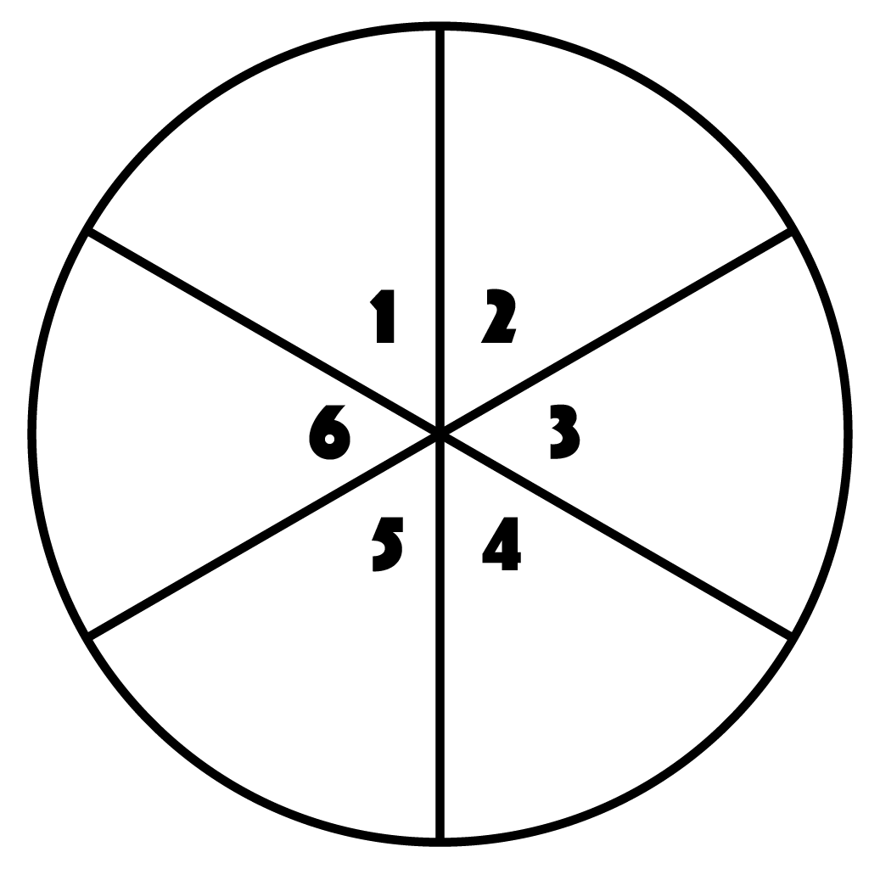

Reindeer Race
Snowman
Jacks

Elf Jumps
Wreathe Raise

Penguin
Pops
Dreidel
Spins

# | Name of Exercise | Reps | Description
1 | Snowman Jacks | 3 | Jump in air and tap feet together.
2 | Reindeer Race | 15 | Run in place.
3 | Wreathe Raise | 8 | Bend down from waist, make a circle with arms and stand.
4 | Penguin Pops | 20 | Hop back and forth from foot to foot.
5 | Dreidel Spins | 5 | Sit on bottom and spin in a circle.
6 | Elf Jumps | 4 | Jump and make a star with body.

