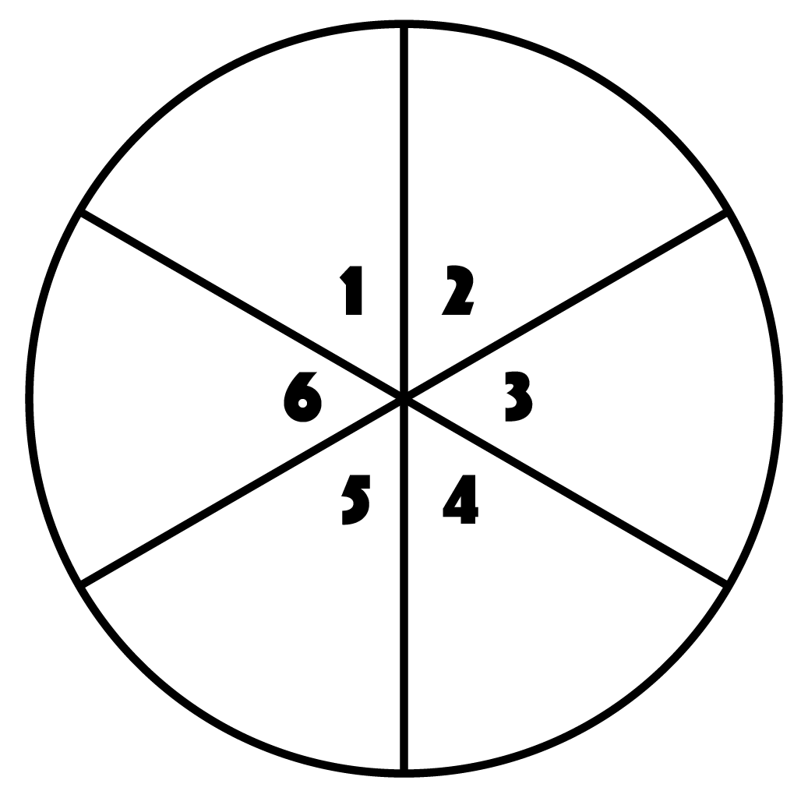

# | Name of Exercise | Reps | Description
1
2
3
4
5
6

