OFFICIAL RULES: TRADITIONAL HOPSCOTCH

What you need: Chalk to draw a Hopscotch course; 1 marker per player (beanbag, stone, pinecone, etc.); 1 or more players.

The object of Hopscotch is to toss and then retrieve your marker (beanbag, stone, etc.) from each hopscotch square, in order from 1 to 10. The first player to toss and retrieve from Square 10 wins the game.

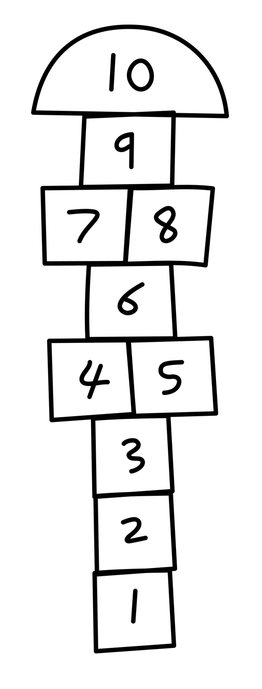
The youngest player tosses and retrieves first.

Throw your marker into Square 1. If it lands on a line or outside the square the turn is lost, and the next player tosses their mark.

To retrieve the maker, hop or jump into every empty square, skipping the square where your marker has landed. In this case, hop on 1 foot into Square 2 (the first empty square), and then hop and jump through the course. At Squares 4-5 and 7-8, jump and land with both feet straddled in the 2 squares (i.e., one foot in 4 and the other in 5).

At Square 10, jump and land in the square with both feet, then jump and make a 180-degree turn so you’re facing back down the course.

Hop and jump back through the course stopping and balancing in the square just before your maker. Then, bend over to pick up your marker while balancing in the square. In our example, hop into Square 2 and stay balanced on 1 foot while you bend over and pick up your marker in Square 1. Next, hop through the rest of the course to the end.

A jumping foul is made if you fall, jump outside/on the lines, miss a square, or drop your marker at any time. If a foul is made the turn is lost and the same number must be repeated on the next turn.

The player to successfully complete Square 10 first wins.

