OFFICIAL RULES: SLAM BALL

What you need: 1 playground ball per court, 1 square or circular target marked with paint, chalk, cones, floor tape, or a hula hoop

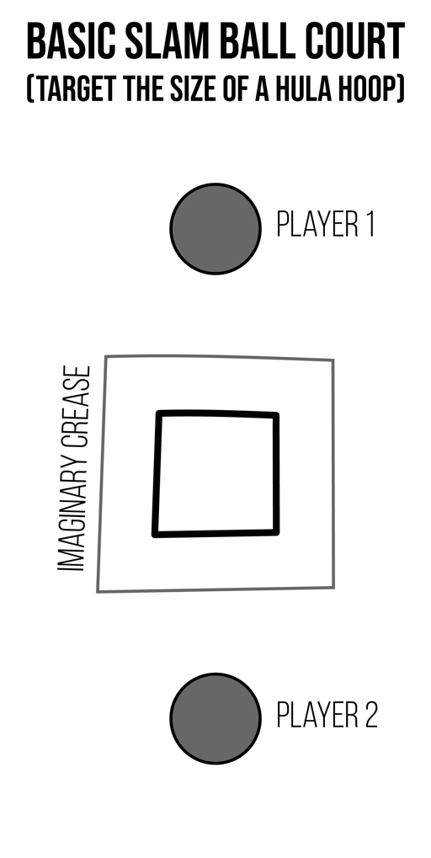
The object of Slam Ball is to avoid throwing a fault by throwing the ball into the target without hitting a line or hitting outside of the target. A point is scored by your opponent when you throw a fault or drop a ball.

Play Rock, Paper, Scissor to see who throws first.

Start with a throw into the target.

The receiver must catch the throw or a fault is committed and a point is scored by the thrower.

Each throw must travel outside of an imaginary crease 1-giant step outside of the target. Throws cannot bounce over the receiver’s head. The focus on the game is accurate throwing and alert catching.

Games can be played to a set point (e.g., 11 points), or for a set amount of time (e.g., 5 minutes).

Modify this game for beginners by:
- Allowing students to catch after 2 bounces
- Creating a larger target

