OFFICIAL RULES: 2-SQUARE

What you need: 1 playground ball per court, 2-Square courts marked with paint, chalk, cones, or floor tape

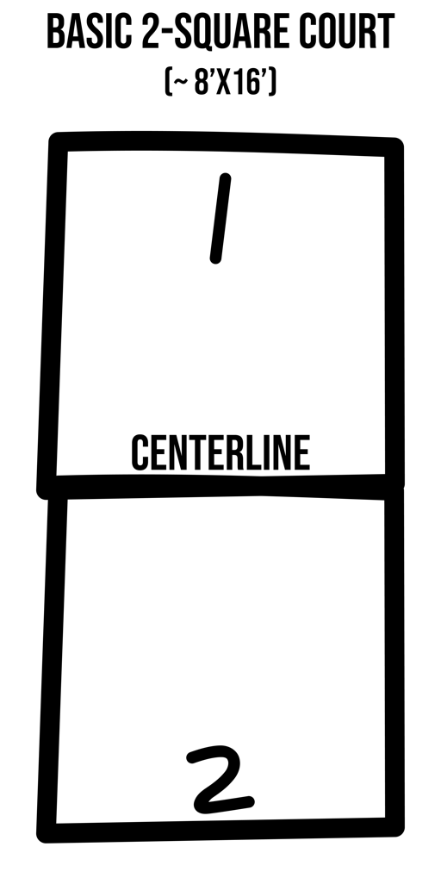
The object of 2-Square is to score points by hitting the ball fairly in play, forcing your opponent to fault (i.e., miss the return or hit the ball out of bounds).

Play Rock, Paper, Scissor to see who serves first.

Points are scored on each volley. The player who forces the fault and wins the point also wins the right to serve.

The server drops the ball and serves off a single bounce. Serves must bounce 1 time in the receiving square before being returned over the centerline.

The server gets 1 fault to put the ball fairly into play. On the second fault, the receiver gets a point and the right to serve.

Outside (perimeter) lines are in-bounds; the centerline is out of bounds. If a player hits the centerline, the point is lost.

Games can be played to a set point (e.g., 11 points), or for a set amount of time (e.g., 5 minutes).

Modify this game for beginners by:
- Allowing students to catch and toss the ball into play.
- Allowing the ball to bounce twice before being returned over the centerline.

