NAME TAG (Grades K-8)

STUDENT TARGETS
- Skill: I will safely move in general space during the tag game.
- Cognitive: I will identify my classmates’ names while participating in the activity.
- Fitness: I will stay active during the activity to ensure an increase in my heart rate.
- Social/Emotional: I will demonstrate respect for my classmates by following the rules of the game.
EQUIPMENT & SET-UP | 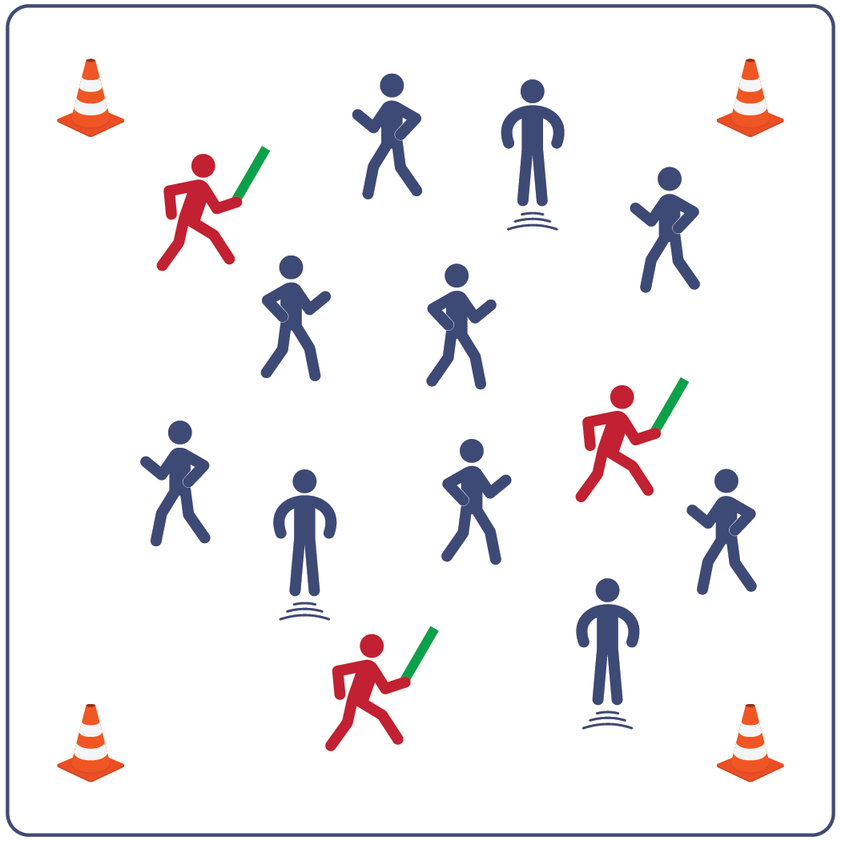
Equipment:
- 4 cones to create boundaries
- 3-4 foam noodles for taggers
- name tags for each student (optional)
- music as a start/stop signal (optional)
Set-Up:
- Create a large activity area using cones.
- If available, provide a name tag for each student. After playing for a few rounds, have students remove name tags.
- Scatter students in the activity area.
- Identify 3-4 taggers (depending on class size).
- Give each tagger a foam noodle and have them stand outside of the boundary area until they hear the start signal.
ACTIVITY PROCEDURES
- It’s time to learn the names of our classmates and practice moving safely in general space.
- This activity is called Name Tag. The object of the game is for the taggers to use the noodle to tag other players while also remembering their names! We’ll begin at a speed walking pace.
- On the start signal, begin moving by speed walking inside the boundary cones. Taggers complete 5 jumping jacks outside the cones before joining the game. Taggers must tag with noodles AND call the name of the person they are tagging.
- If you are tagged and correctly called by name, jump up and down on the spot where you were tagged. This shows other students how excited you are to meet new friends! Return to the game after you receive a high-five from a non-tagger who correctly calls you by name.
- We will switch out the taggers every few minutes. After the entire class can demonstrate safe movement while speed walking, we’ll use new locomotor skills when we change taggers.
PRIORITY OUTCOMES
- (K) Recognizes the established protocol for class activities.
- (1) Follows directions for safe participation and proper use of equipment without reminders.
- (2) Performs locomotor skills using a mature pattern and in rhythm.
- (3) Works independently and safely in physical activity settings.
- (4) Accepts “players” of all skill levels into the physical activity.
- (5) Engages in physical activity with responsible interpersonal behavior.
DEBRIEF QUESTIONS
- DOK 1: What is a rule?
- DOK 2: How does following rules affect class games and activities?
- DOK 3: How is following rules related to safely learning in class? How did it relate to your ability to learn and practice your classmates’ names?

