Hoop Tower Relay (Grades K-12)

STUDENT TARGETS
- Skill: I will cooperate with my teammates to complete the relay and build the hoop tower.
- Cognitive: I will discuss the importance of cooperation.
- Fitness: I will stay actively engaged during all activities.
- Social/Emotional: I will share equipment and space while working cooperatively.

EQUIPMENT & SET-UP | 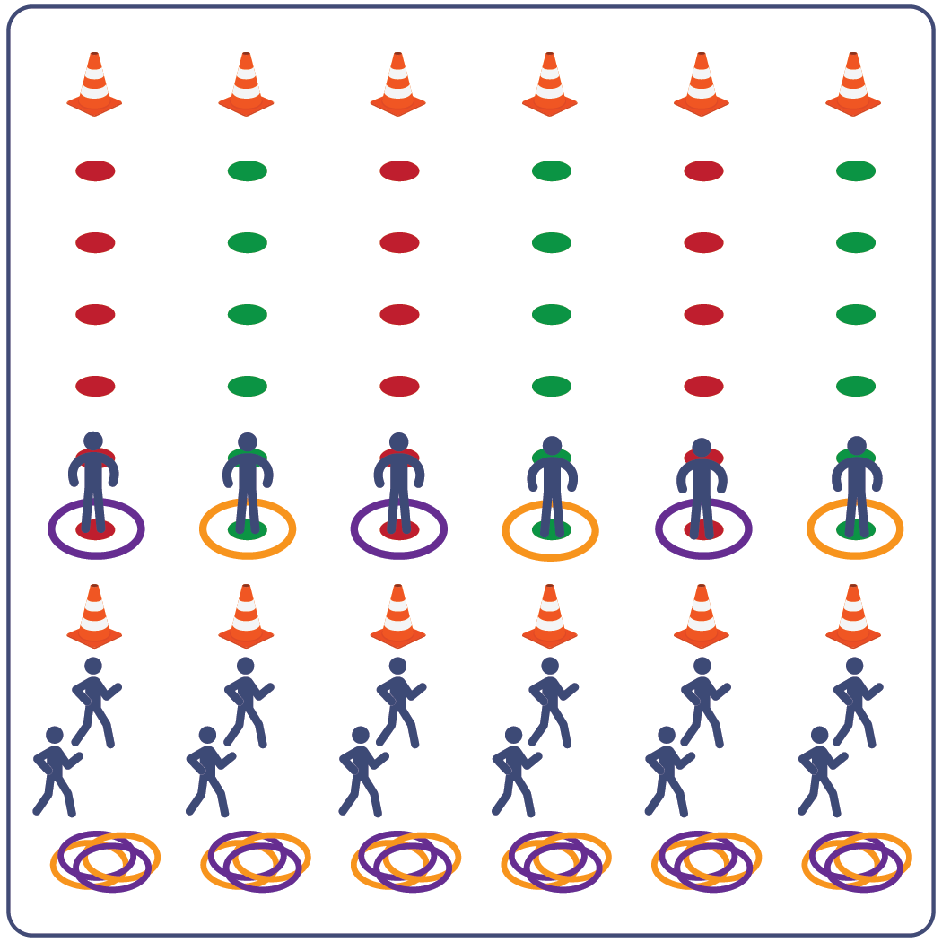
Equipment:
- 12 cones to create start/finish for relay lines
- 36 spot markers (6 for each relay line)
- 36 hula hoops (6 for each relay line)
- music as a start/stop signal (optional)
Set-Up:
- Space 6 cones in a line on each side of the activity area (across from each other). The cones on one side should also have 6 hoops.
- Evenly space out 6 spot markers between each set of cones.
- Create 6 groups of students, 1 group at each cone with hula hoops.
ACTIVITY PROCEDURES
- It’s time to work cooperatively as a team to build a Hoop Tower (Hula Hut).
- This activity is called Hoop Tower Relay. The object of the game is for each team to get all 6 hoops across the activity area and then create a Hoop Tower.
- On the start signal, one teammate moves to the first spot marker inside a hoop. Remaining teammates work together to lift the hoop up and over their teammate’s head without it touching them. All teammates must be touching the hoop at all times (except for the teammate on the spot).
- After the hoop is safely lifted, place it on top of the next spot marker. The teammate who started on the spot moves to the next spot as soon as the hoop is placed on the ground.
- This pattern continues until the team makes it across all 6 spots and leaves the hoop at the cone.
- Then, the team returns to the start and continues the process with a new teammate on the first spot. Repeat until all 6 hoops have been transported across the activity area.
- Finally, teams work cooperatively to build a hoop tower using the 6 hoops.
PRIORITY OUTCOMES
- (K-2) Discusses the enjoyment of playing with family and friends.
- (3-5) Describes the positive social interactions that come when engaged with others in physical activity.
- (6-8) Demonstrates respect for self and others in activities and games by following the rules, encouraging others, and playing within the spirit of the game or activity.
- (9-12) Uses communication skills and strategies that promote positive team/group dynamics.
DEBRIEF QUESTIONS
- DOK 1: What does cooperation mean?
- DOK 2: What are some benefits of cooperation?
- DOK 3: How is cooperation related to the success of a team?

