CATCH ME IF YOU CAN (Grades 3-12)

STUDENT TARGETS
- Skill: I will perform dynamic exercises focusing on form and safety when tagged.
- Cognitive: I will identify strategies to avoid being tagged.
- Fitness: I will stay actively engaged and work to increase my heart rate.
- Social/Emotional: I will demonstrate respect and cooperation by following the rules of the game.

EQUIPMENT & SET-UP | 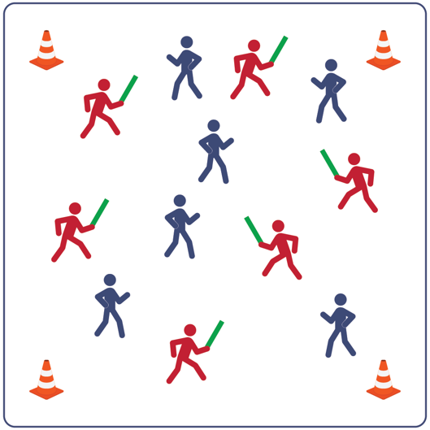
Equipment:
- 4 cones to create boundaries
- 5-7 foam noodles for taggers
- music as a start/stop signal (optional)
Set-Up:
- Create a large activity area using cones.
- Scatter students in the activity area.
- Identify 5-7 taggers (depending on class size).
- Give each tagger a foam noodle and have them stand outside of the boundary area until they hear the start signal.

ACTIVITY PROCEDURES
- It’s time to work on our health-related fitness and practice moving safely in general space.
- This activity is called Catch Me If You Can. The object of the game is for the taggers to use the noodles to tag other players. We’ll begin at a speed walking pace.
- On the start signal, begin moving by walking inside the boundary cones. Taggers complete 5 jumping jacks outside the cones before joining the game. Taggers must tag with noodles and then play a game of Rock, Paper, Scissors with the person they tagged.
- If the tagger is successful at Rock, Paper, Scissors the person tagged will go outside of the cones and complete 10 jumping jacks. Once the jumping jacks are completed, they can re-enter the game. If the person tagged is successful at Rock, Paper, Scissors the tagger will go outside the cones and complete 10 squats. After the 10 squats are completed, they can re-enter the game.
- We will switch out the taggers and the health-related fitness exercises completed every few minutes. After the entire class can demonstrate safe movement while speed walking, we’ll use new locomotor skills when we change taggers.
PRIORITY OUTCOMES
- (3) Identifies physical activity as a way to improve health and personal fitness.
- (4) Identifies the components of health-related or skill-related fitness.
- (5) Identifies activities that require and/or improve the components of fitness.
- (6-8) Analyzes movement and activity situations and adjusts with a specific purpose or to create a strategic advantage.
- (9-12) Uses movement concepts and principles to analyze and improve performance of self and others in a selected skill.
DEBRIEF QUESTIONS
- DOK 1: How can you recognize an activity that helps to improve your fitness?
- DOK 2: How does your favorite physical activity affect your personal fitness?
- DOK 3: In what ways could you modify this activity to improve the health-related components of fitness? Provide details.

