SUPER CHICKEN (Grades 3-12)

STUDENT TARGETS
- Skill: I will demonstrate the ability to work with a variety of different partners during game play.
- Cognitive: I will participate in a class discussion about personal growth and development.
- Fitness: I will stay actively engaged throughout this activity.
- Social/Emotional: I will show respect for each of my opponents regardless of whether I win or lose.

EQUIPMENT & SET-UP | 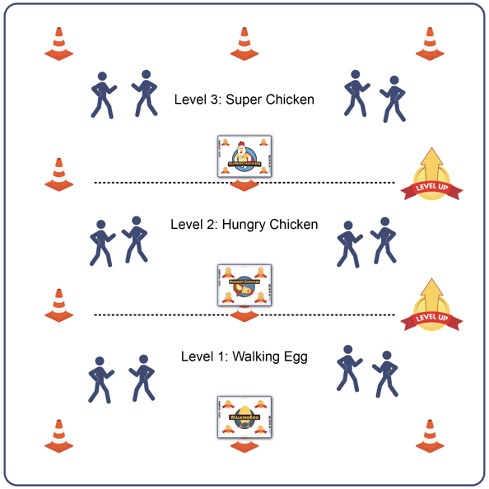
Equipment:
- 12 cones
- 3 Task Tents
- Super Chicken Believe In You Leadership Cards
- Music as a start/stop signal (optional)

Set-Up:
- Use cones to create 3 even zones.
- Place a Walking Egg card, a Hungry Chicken card, and a Super Chicken card into task tents.
- Hang the task tents on a cone in each zone to identify the 3 game zones.
- All students begin in the first Walking Egg zone.
ACTIVITY PROCEDURES
- This activity is called Super Chicken. The object of the activity is for you to evolve from a Walking Egg, into a Hungry Chicken, and then finally into a Super Chicken. You’re going to do that by winning Rock, Paper, Scissor (RPS) matches.
- Everyone begins this game as a Walking Egg. On the start signal, find any partner and play RPS. If you win, you evolve and move into the next zone – the Hungry Chicken Zone. If you don’t win, find another partner and try again.
- In each zone, find a partner and play RPS in an attempt to evolve.
- When you’ve won a match in the 3rd zone, you’ve become a Super Chicken. Do a 3 second Super Chicken Dance to celebrate and then safely and quickly move back to the Walking Egg zone to try again. How many times can you evolve into a Super Chicken before time runs out?
PRIORITY OUTCOMES
Values Physical Activity: Social Interaction
- (3) Describes the positive social interactions that come when engaged with others in physical activity.
- (6) Demonstrates respect for self and others in activities and games by following the rules, encouraging others, and playing within the spirit of the game or activity.
- (7) Demonstrates the importance of social interaction by helping and encouraging others, avoiding trash talk, and providing support to classmates.
- (HS) Identifies and evaluates the opportunity for social interaction and social support in self-selected physical activities.
DEBRIEF QUESTIONS
- DOK 1: The 3 Super Chicken words related to personal development are Awaken, Become, and Transform. In your own words, what do each of those words mean?
- DOK 2: How does your attitude about learning affect your ability to awaken, become, and transform?
- DOK 3: How does this game illustrate a person’s journey through life’s experiences?

