BUBBLE JUMPERS

STUDENT TARGETS
- Skill: I will jump and land safely on the bubbles.
- Cognitive: I will talk about good health with my classmates.
- Physical Activity: I will stay physically active for the entire activity.
- Personal & Social Responsibility: I will think about how good health is related to self-respect.

EQUIPMENT & SET-UP | 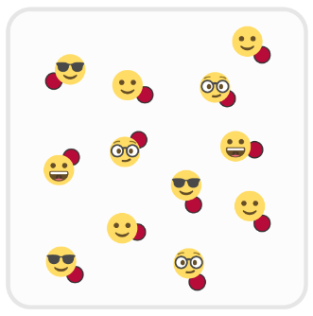
Equipment:
- 1 spot marker per student
- Music and music player

Set-Up:
- Create a large activity space using 4 cones to mark boundaries.
- Scatter spot markers throughout space.
- Students begin scattered in the activity space.

ACTIVITY PROCEDURES
- Today we are going to work on jumping and landing on as many bubbles as you can.
- All of the spot markers you see are bubbles!
- When the music begins, move to a bubble and jump and land on the bubble with 2 feet. When you land, say “POP”! Then, quickly and safely move to the next bubble and repeat. You want to pop as many bubbles as you can while the music plays.
- When the music stops, you will use your fingers to hold up the total number of bubbles that you were able to pop.
- On the stop signal freeze and be ready for the next set of instructions.

GRADE LEVEL PROGRESSION
Level 1: Allow students to “pop” the bubbles using a variety of movements they can do safely.
Level 2: Have students work on dribbling with feet or hands to “pop” the bubbles. Students “pop” the bubbles by dribbling over a spot marker.

ACADEMIC LANGUAGE
Good Health, Jump, Physical Activity, Self-respect

PRIORITY OUTCOMES
Personal Health:
Recognizes physical activity is important for good health.

DISCUSSION QUESTIONS
- What is good health? What does it look like to have good health? What does it feel like?
- What do you know about helping your body stay healthy?
- How is regular physical activity related to good health? How is that related to self-respect?

