TABATA TEAM SCRAMBLE

STUDENT TARGETS
- Skill: I will perform each exercise with control and correct technique.
- Cognitive: I will discuss the importance of correct technique.
- Physical Activity: I will move at a moderate to vigorous intensity level.
- Personal & Social Responsibility: I will cooperate with my team to score Team Scramble points.

EQUIPMENT & SET-UP | 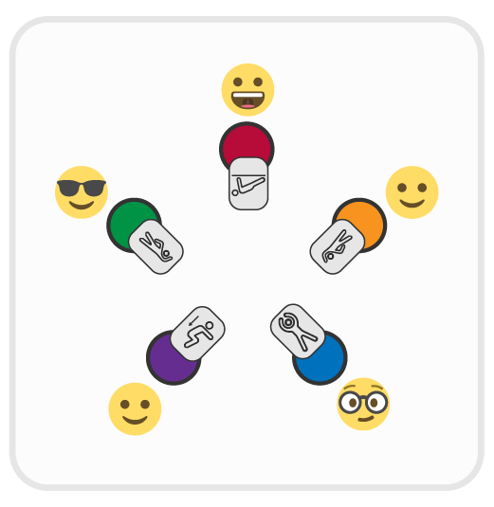
Equipment:
- 1 low-profile cone per student
- 1 fitness card per student
- Tabata Music
- Components of Fitness Posters

Set-Up:
- Place 3-5 cones in a circle for each team of students. Place an exercise card at each cone.
- Create teams of 3-5 students. Each student stands behind a low-profile cone.

ACTIVITY PROCEDURES
- Today we are going to work on proper exercise form and technique.
- When the music begins, all students will perform the exercise that is displayed on the fitness card at their cone. Focus on using proper form and technique.
- When the music stops, all students quickly scramble to a new cone before the music begins again. The object is to scramble and change cone positions when the music is off, with all team members ready at a new cone before the music begins again. Your team will score 1 point if all team members are ready to exercise when the music begins.
- When the music starts again, begin to perform the exercise that is displayed on the fitness card at your new cone.
- On the stop signal freeze and be ready for the next set of directions.

GRADE LEVEL PROGRESSION
Level 1: Simplify the activity by prompting students to rotate 1 cone clockwise or counterclockwise.
Level 2: Add a challenge with teams swapping cones with other teams.

ACADEMIC LANGUAGE
Control, Cooperate, Intensity, Moderate, Technique, Vigorous

PRIORITY OUTCOMES
Personal Responsibility & Safety:
Applies best practices for participating safely in physical activity, exercise, and dance (e.g., injury prevention, proper alignment, hydration, use of equipment, implementation of rules).

DISCUSSION QUESTIONS
- What is technique, and how is it related to exercise safety?
- What does it mean to cooperate, and how is cooperation related to positive learning environments?

