TABATA TEAM INCHWORM RELAY

STUDENT TARGETS
- Skill: I will move with a focus on safety and control.
- Cognitive: I will discuss teamwork with my classmates.
- Physical Activity: I will demonstrate good effort during the challenge.
- Personal & Social Responsibility: I will contribute to my team’s overall success as we try to improve.

EQUIPMENT & SET-UP | 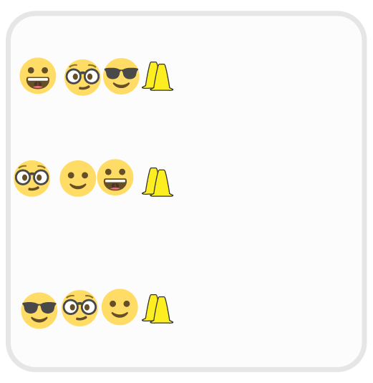
Equipment:
- 2 cones per team
- Tabata Music

Set-Up:
- Create a line of cones as the starting line of a relay race.
- Create teams of 3-5 students behind each cone, with one extra cone.
- The first student in line begins in a pike position.

ACTIVITY PROCEDURES
- Today we are going to see how far each team can move using an inchworm race format.
- When the music begins, student 1 goes from a pike to a plank position and yells “GO!” Student 2 runs to the front of the link and moves from a pike to a plank position and yells “GO!” Student 3 repeats. When all students have gone, student 1 continues by getting up and running to the front of the line and continues to move from a pike to a plank position.
- When the music stops, the student in the back of the line quickly places the extra cone to mark the spot they reached. This is the distance to try and beat during the next round.
- When the music starts again, continue the same inchworm process, and try to get further than you did the previous round.
- Teams will continue until the end of the 4-minute Tabata cycle.

GRADE LEVEL PROGRESSION
Level 1: Play as described above.
Level 2: Rather than pike-to-plank, students move to the front and lay down head-to-toe. Modify the movements and exercises however needed to match the ability level and needs of your students.

ACADEMIC LANGUAGE
Contribute, Effort, Improve, Teamwork

PRIORITY OUTCOMES
Working with Others:
Uses communication skills and strategies that promote positive team/group dynamics.

DISCUSSION QUESTIONS
- What is teamwork? What does teamwork look like? What does it sound like?
- Did your team improve each round? How did you contribute to your team’s success in this challenge?

