TABATA TEAM CHARADES

STUDENT TARGETS
- Skill: I will perform exercises using safe and controlled form.
- Cognitive: I will choose exercises that match specific fitness components.
- Physical Activity: I will increase my heart rate during this challenge.
- Personal & Social Responsibility: I will demonstrate cooperative behaviors during this challenge.

EQUIPMENT & SET-UP | 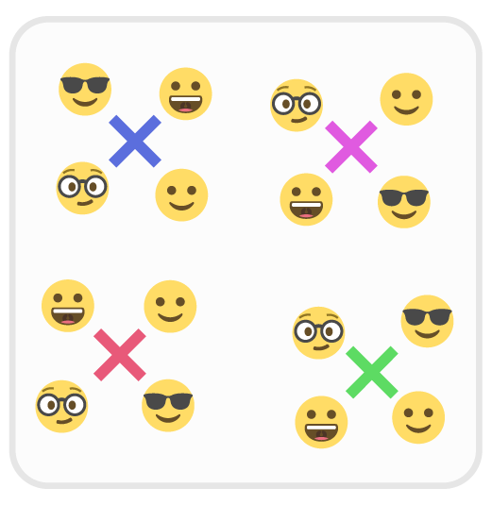
Equipment:
- 1 cone per team
- Fitness Charades Cards
- Tabata Music

Set-Up:
- Scatter cones as home base markers. Cones should be on their side with charades cards mixed up inside the bottom of the cone.
- Create teams of 3-5 students with one team in a circle around each cone.

ACTIVITY PROCEDURES
- Today we are going to see if you can guess the fitness exercise that your teammate is acting out during a game of charades.
- When the music begins, the first student pulls a card and acts out an exercise that matches the component of fitness shown on the card. Teammates all perform the exercise while they guess its name as well as the component of fitness it addresses.
- When the music stops, the next student (clockwise rotation) pulls a card from the cone and gets ready to perform a new activity or exercise that matches the fitness component on the card.
- When the music starts again, continue the game of Charades.
- Teams will continue until the end of the 4-minute Tabata cycle.

GRADE LEVEL PROGRESSION
Level 1: Provide cards with components of fitness as well as activities that match.
Level 2: Create and display a list of activities that can done for each fitness component.

ACADEMIC LANGUAGE
Control, Cooperation, Health-Related Fitness, Safe

PRIORITY OUTCOMES
Working with Others:
Uses communication skills and strategies that promote positive team/group dynamics.

DISCUSSION QUESTIONS
- What are the 5 components of fitness? What exercises/activities can we do to improve each of th 5 components?
- How did you demonstrate cooperation during this team challenge? How does cooperation affect enjoyment?

