­­

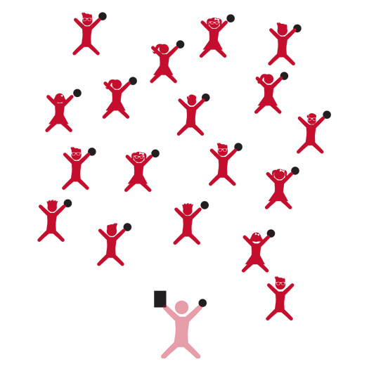

**Ball Skills 2**



* **Skill:** I will use the cues for underhand and overhand throwing during partner activities.
* **Cognitive:** I will be able to repeat the cues for throwing.
* **Fitness:** I will work to stay actively engaged during all activities.
* **Personal & Social Responsibility:** I will identify benefits of participating in physical activities with friends.



* Work Safely
* Respect Self-Space
* Actively Engage
* *See Skill Cue Teach Sheets for Skill-Specific Cues*



**Equipment:**

* 1 foam ball per student
* 1 large cone or batting tee per 2 students
* 1 bat per 2 students
* Ball Skills 2 Activity Card
* Up-tempo music

**Set-Up:**

1. Students scattered in activity area, each with a foam ball.
2. Ball Skills Activity Card ready on clipboard or tablet.

**Activity Procedures:**

1. Today we’re going to have more fun exploring movement with foam balls as well as batting off a tee.
2. I will show you a movement activity, and then you’ll repeat after me. As we move through space, we’ll work to complete the challenges to the rhythm of the music.
3. Teachers, use the following activity sequence: 1) Partner Passes; 2) Batter Up; and 3) Double Trouble.

**Grade Level Progression:**

**K:** Focus on underhand tossing with opposition as well as safe and controlled travel in general space.

**1st:** Introduce strong and light force during rolling and underhand tossing activities. Emphasize critical elements of underhand throw.

**2nd:** Prompt students to focus on a mature overhand throwing pattern along with batting a ball off a tee or cone.

**Ball Skills 2**



* Progressively increase the distance between students as they toss and catch the ball.



Control, Demonstrate, Direction, Effort, Manipulative Skill, Mature, Relationship

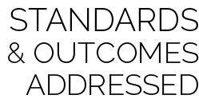

**Physical Education Priority Outcomes:**

* (K) Discusses the enjoyment of playing with family and friends.
* (1) Discusses the reasons for participating in physical activity with friends.
* (2) Discusses ways to encourage others to be physically active with friends.



* **DOK 1:** What are the cues for underhand tossing? Overhand throwing?
* **DOK 2:** How does using the cues affect how well you throw a ball?
* **DOK 2:** How is underhand tossing similar to/different from other manipulative skills?
* **DOK 3:** How is effort related to skill cues when tossing a ball?

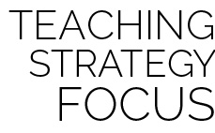

**Help students revise knowledge:** Most students have had some sort of interaction/play experience with a ball. Oftentimes this interaction is generally positive. However, most students will come to physical education with bad habits with respect to tossing, throwing, and catching. Helping them identify and correct errors and bad habits is critical to developing mature skills. While you’re correcting these errors try to infuse new content into your interaction. Work to help students view each skill from an alternative perspective in order to overcome resistance to change.



* Allow all students to choose whether to work with a ball or a scarf during toss and catch activities.