­­

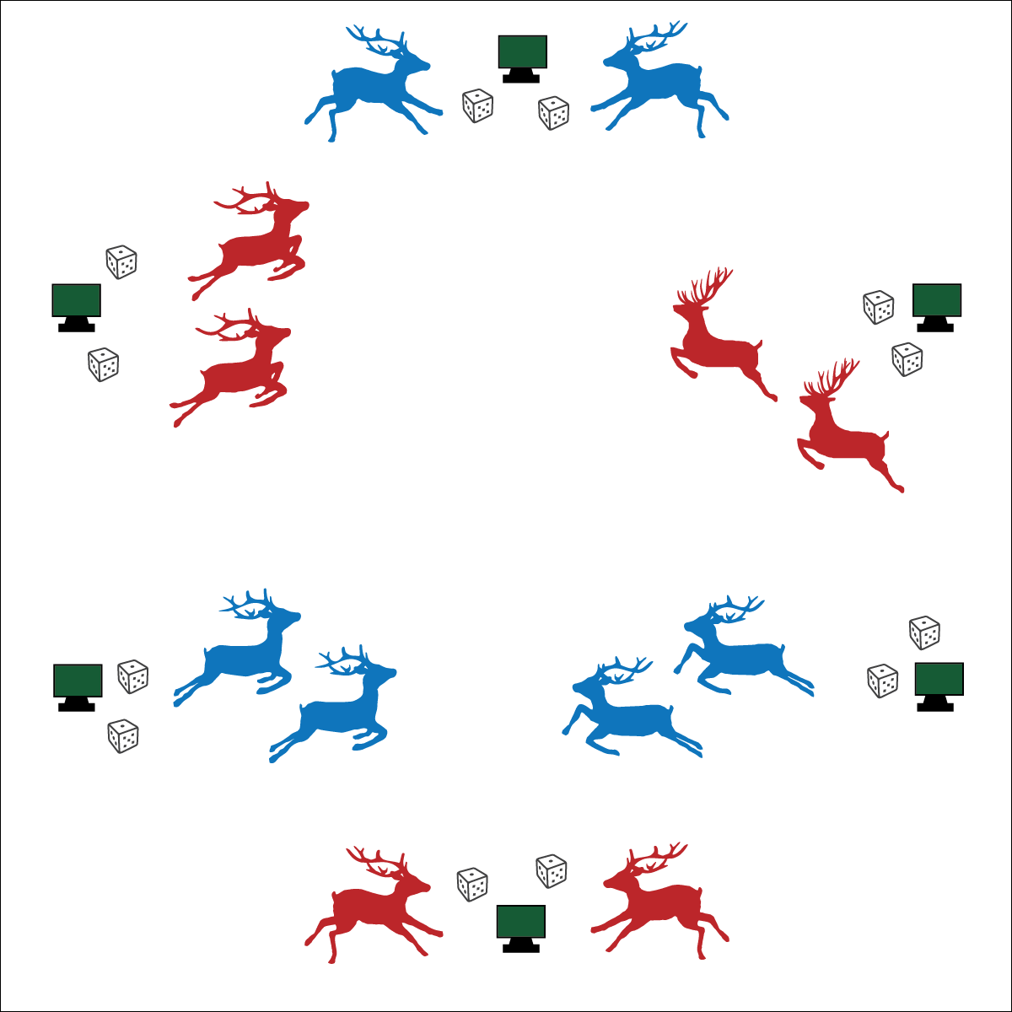



**DOK 1:** How can you recognize positive language?

**DOK 2:** What did you notice when you used positive language with your partner?

**DOK 3:** How is positive language related to building good relationships with friends?



**Values Physical Activity –** **Personal Enjoyment** (K) Identifies physical activities that are enjoyable. (1) Describes positive feelings that result from physical activity participation. (2) Discusses personal reasons for enjoying selected physical activities. (3) Reflects on the reasons for enjoying selected physical activities. (4) Ranks the enjoyment of participating in different physical activities. (5) Analyzes different activity choices for enjoyment and identifies reasons for positive or negative responses. (6) Describes how moving competently creates enjoyment and self-expression. (7) Explains the relationship between self-expression and lifelong enjoyment of physical activity. (8) Discusses ways to increase enjoyment in self-selected physical activities.

**Activity Procedures:**

1. Today we will create Snowflake Maps for the Reindeer to travel when delivering presents.
2. The object of this activity is to create a snowflake map by moving from cone to cone, remembering and then recording your pathway.
3. On the start signal, complete the Snowflake Task on the station card at your cone. Then, roll the dice to see which station you will go to next. For example, if you roll a 4 you will go to Snowflake Station Number 4. Roll again if you roll the number of the station where you currently are.
4. Complete the exercise at the station before rolling the dice at that cone and continuing.
5. Once you and your partner have rolled the dice 12 times, stop and get a snowflake map template and pencil. Now draw a line from cone to cone on the sheet, remembering the path you traveled.
6. When finished, compare maps with others. No 2 maps are the same, just like no 2 snowflakes are the same!

**Modifications:**

* Travel snowflake pathways on scooters.
* Have students create their own Snowflake Station Task Cards.

**Equipment:**

* 6 cones with task tents
* Snowflake Station Cards
* Snowflake Map Sheet and Pencil (1 per pair)
* 12 to 24 Dice

**Set-Up:**

1. Use 6 cones and task tents to create a large circle in the activity area. Place Snowflake Station Cards in task tents.
2. Distribute dice evenly to each cone (2 to 4 dice per cone)
3. Place Map Sheets and Pencils on the perimeter.
4. Pair students. Pairs can begin at any cone.

* Work Cooperatively
* Be Actively Engaged
* Move Safely
* **Fitness:** I will increase my heart rate to improve my fitness.
* **Personal & Social Responsibility:** I will cooperate with my partner and use positive language for communication.