­­

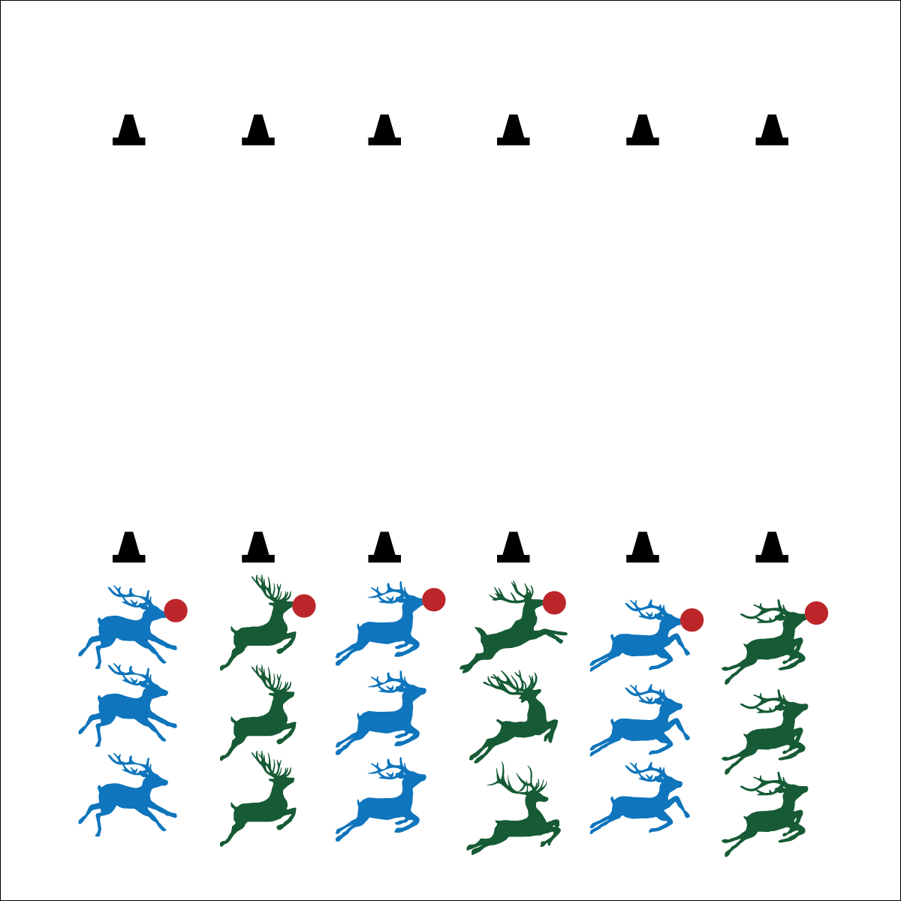

* **Fitness:** I will increase my heart rate to improve my fitness.
* **Personal & Social Responsibility:** I will cooperate with teammates in order to move our red-nose foam ball from cone to cone.



**Demonstrates Responsible Behaviors ­– Working with Others** (K) Shares equipment and space with others. (1) Works independently with others in a variety of class environments. (2) Accepts responsibility for class protocols with personal and cooperative behavior as well as performance actions. (3) Works cooperatively with others. (4) Accepts “players” of all skill levels into the physical activity. (5) Accepts, recognizes, and actively involves others with both higher and lower skill abilities into physical activities and group projects. (6) Accepts differences among classmates in physical development, maturation, and varying skill levels by providing encouragement and positive feedback. (7) Demonstrates cooperation skills by establishing rules and guidelines for resolving conflicts. (8) Responds appropriately to participants’ ethical and unethical behavior during physical activity by using rules and guidelines for resolving conflicts.



**DOK 1:** Give an example of how your team used communication skills in this activity.

**DOK 2:** How did communication affect your team’s ability to move quickly?

**DOK 3:** How is communication related to teamwork?

* Work Cooperatively
* Communicate with Teammates
* Move Safely

**Equipment:**

* 12 cones
* 6 red foam balls

**Set-Up:**

1. Create team relay lines using 6 cones.
2. Place the other 6 cones in a parallel line on the opposite side of the activity area.
3. Divide students into 6 teams; each team at a cone with 1 red foam ball.

**Activity Procedures:**

1. It’s time for a Red Nose Relay! The reindeer in front of your line will have the red ball (Rudolph’s nose). Rudolph’s nose must always stay in the front of the line to light the way for the reindeer.
2. On the start signal, the reindeer at the back of the line will run to the front of the line. The reindeer with Rudolph’s nose will pass it to the new line leader to light the way.
3. As soon as the new line leader has Rudolph’s nose, she/he will yell “GO!” The reindeer at the back of the line will then run to the front.
4. Continue until your team travels down to the chimney (the opposite cone) and back.

**Modifications:**

* Prompt students to travel using a variety of locomotor skills.
* Increase or decrease the distance between cones to match the ability and fitness of your students.