­­

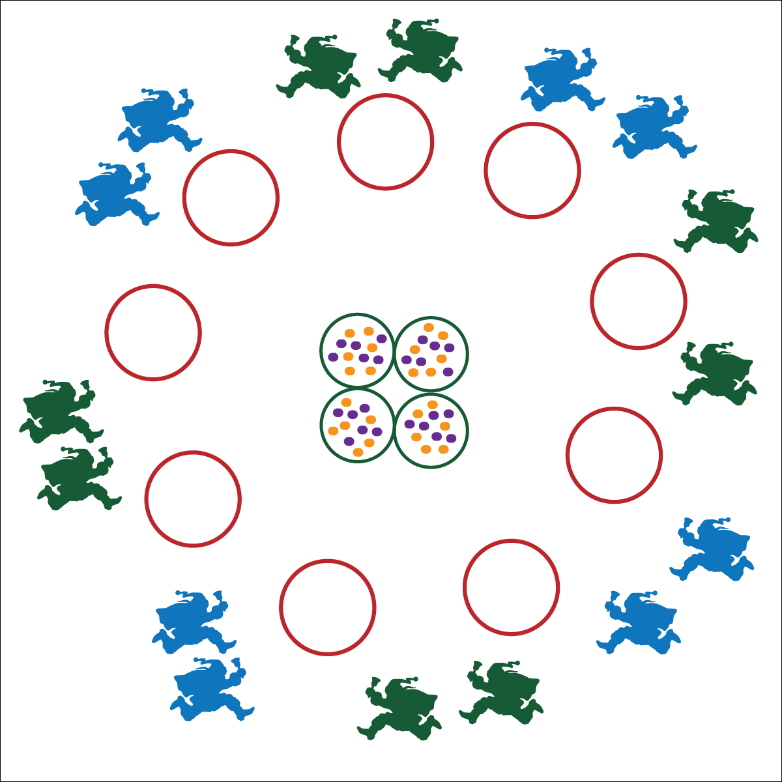



**Values Physical Activity: Social Interaction** (K) Discusses the enjoyment of playing with family and friends. (1) Discusses the reasons for participating in physical activity with friends. (2) Discusses ways to encourage others to be physically active with friends. (3) Describes the positive social interactions that come when engaged with others in physical activity. (4) Describes and compares positive social interactions when engaged in partner, small-group, and large-group physical activities. (5) Describes the social benefits gained from participating in physical activity. (6) Demonstrates respect for self and others in activities and games by following the rules, encouraging others, and playing within the spirit of the game or activity. (7) Demonstrates the importance of social interaction by helping and encouraging others, avoiding trash talk, and providing support to classmates. (8) Demonstrates respect for self by asking for help and helping others in various physical activities.



**DOK 1:** How can you praise the performance of your partner?

**DOK 2:** How does it feel when you receive praise from someone that you respect?

**Activity Procedures:**

1. Before the reindeer can fly to deliver presents, the elves have to feed them a good meal. You and your partner are elves. The object of this game is to take 1 bag of food at a time (tossable objects) and drop them into the reindeer bowls (perimeter hoops).
2. On the start signal, move with your partner to pick up 1 tossable. The partner with the tossable cannot move. Move the food by tossing it to your partner and then moving toward a bowl to receive another toss.
3. Tosses can only be 5 feet in distance (you can only move 5 feet at a time). If you drop the bag of food, you must return it to the center hoops, collect a new bag and then try again.
4. Continue until all bags of food have been delivered to the reindeer bowls (hoops).

**Modifications:**

* Allow younger (or less skilled) students to carry the bags of food cooperatively with no tossing.
* Increase or decrease the distance between hoops to match the ability and fitness of your students.

**Equipment:**

* 13 hoops
* As many tossables (beanbags or foam balls) as available

**Set-Up:**

1. Use 9 hoops to create a large circle around the perimeter of the activity area.
2. Place 4 hoops at the center of the circle.
3. Scatter tossable objects in the 4 center hoops.
4. Pair students. Scatter pairs around the perimeter.

* Praise Your Partner
* Toss When Your Partner is Ready
* Move Safely
* **Fitness:** I will increase my heart rate to improve my fitness.
* **Personal & Social Responsibility:** I will cooperate with my partner by using equipment appropriately and effectively.