­­

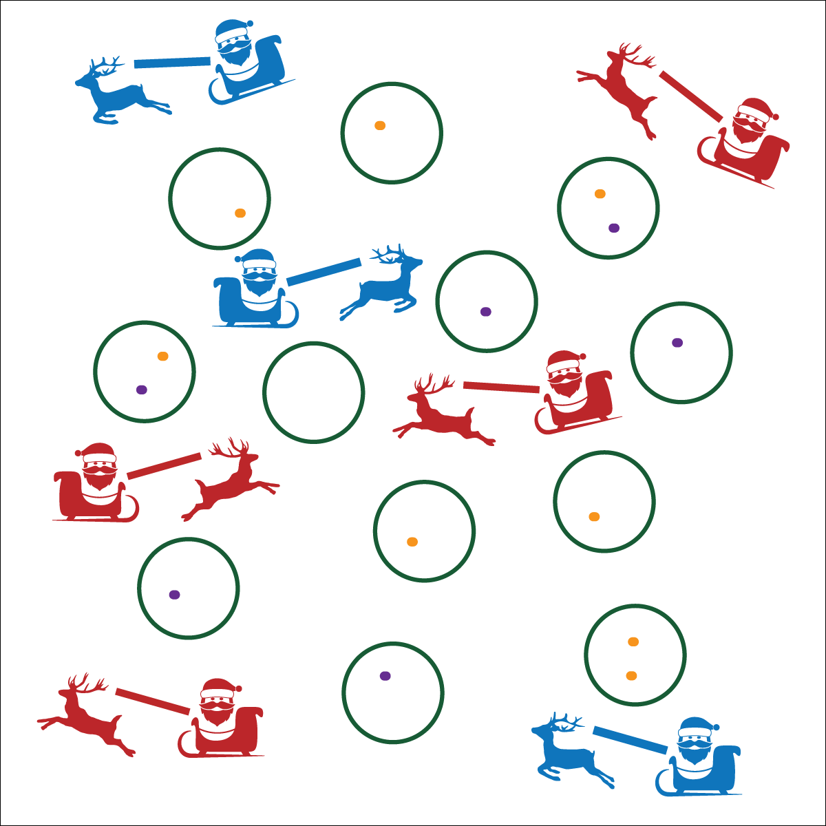

**Activity Procedures:**

1. It’s time to deliver presents! One student is a reindeer, the other student a member of the “Claus” family.
2. The object of this activity is to drop your presents, one at a time, into the chimneys (hoops).
3. On the start signal, one partner will sit on the scooter and hold the beanbags. The other will use the noodle to pull the player on the scooter at a walking pace. Scooters moving faster than a walk will receive a speeding ticket. After 2 tickets your sleigh (scooter) will be impounded, and you’ll have to walk to deliver the presents.
4. After all presents are delivered, stand next to your partner holding your scooter. When the entire class has delivered their presents, we will switch roles and play again.

**Modifications:**

* This activity can be played without scooters. One student leads the other with the noodle while galloping.
* Use a variety of safe objects as presents.



**DOK 1:** How can you recognize responsible decision making in physical education?

**DOK 2:** How does responsible decision making affect safety?

**DOK 3:** Why do you believe class safety is everyone’s responsibility? Can you elaborate on why you feel this way?



**Values Physical Activity –** **Personal Enjoyment** (K) Identifies physical activities that are enjoyable. (1) Describes positive feelings that result from physical activity participation. (2) Discusses personal reasons for enjoying selected physical activities. (3) Reflects on the reasons for enjoying selected physical activities. (4) Ranks the enjoyment of participating in different physical activities. (5) Analyzes different activity choices for enjoyment and identifies reasons for positive or negative responses. (6) Describes how moving competently creates enjoyment and self-expression. (7) Explains the relationship between self-expression and lifelong enjoyment of physical activity. (8) Discusses ways to increase enjoyment in self-selected physical activities.

**Equipment:**

* 12 hoops
* 6 bean bags (or other objects) per pair
* 1 scooter per pair
* 1 or 2 noodles per pair

**Set-Up:**

1. Scatter hoops throughout the activity area.
2. Pair students; each pair with a scooter, 6 bean bags, and noodles.

* Stay at a Safe Speed
* Use Equipment Safely
* Be Aware of Space, Objects, and Classmates
* **Fitness:** I will increase my heart rate to improve my fitness.
* **Personal & Social Responsibility:** I will cooperate with my partner by using equipment appropriately and effectively.