­­

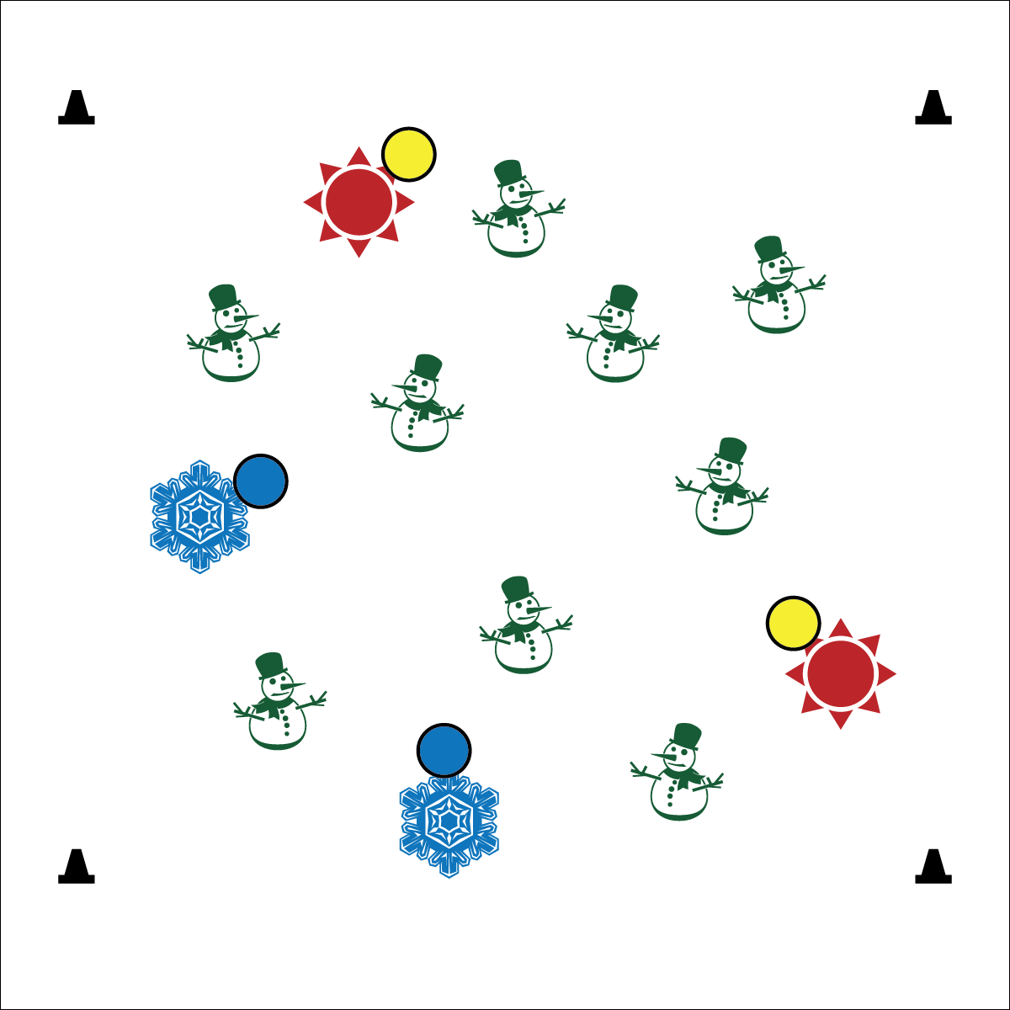



**Demonstrates Responsible Behaviors ­– Working with Others** (K) Shares equipment and space with others. (1) Works independently with others in a variety of class environments. (2) Accepts responsibility for class protocols with personal and cooperative behavior as well as performance actions. (3) Works cooperatively with others. (4) Accepts “players” of all skill levels into the physical activity. (5) Accepts, recognizes, and actively involves others with both higher and lower skill abilities into physical activities and group projects. (6) Accepts differences among classmates in physical development, maturation, and varying skill levels by providing encouragement and positive feedback. (7) Demonstrates cooperation skills by establishing rules and guidelines for resolving conflicts. (8) Responds appropriately to participants’ ethical and unethical behavior during physical activity by using rules and guidelines for resolving conflicts.

**Activity Procedures:**

1. Let’s warm up our bodies for physical education class by playing Snowman & Sunshine Tag.
2. When I say “GO!” we’ll begin at a speed-walking pace. Taggers will do 10 jumping jacks to give you time to move away. The taggers are the “suns” (with a yellow foam ball) looking to melt the snow people of the North Pole (rest of the class).
3. If a snow person is tagged by the sunshine, she/he will stop moving and begin to melt by performing a sun salutation.
4. Continue melting (sun salutation) until a student with a blue ball comes along and refreezes you.
5. Activity will continue until you hear the stop signal. We will change taggers and freezers and begin again.

**Modifications:**

* Modify sun salutation movements to meet the needs of your students.
* Prompt students to use a variety of locomotor skills.



**DOK 1:** What does it look like when a student has good self-control?

**DOK 2:** How do you apply self-control during tag games?

**Equipment:**

* 4 cones to create boundaries
* 2 to 3 yellow foam balls to identify the taggers
* 2 to 3 blue foam balls to identify the freezers

**Set-Up:**

1. Create a large playing area using the 4 cones.
2. Scatter students in the activity area.
3. Identify 2-3 taggers by giving them the yellow foam balls.
4. Identify 2-3 freezers by giving them the blue foam balls.

* Control Your Speed
* Be Aware of Space and Others
* Move and Tag Safely
* **Fitness:** I will increase my heart rate to improve my fitness.
* **Personal & Social Responsibility:** I will work safely by controlling my movement and my behavior.